

Requirement & Design Specification

**Library Management System (LMS)**

**Version: 1.0**

– Hanoi, August 2022 –

# Record of Changes

|  |  |  |  |  |
| --- | --- | --- | --- | --- |
| Version | Date | A*  M, D | In charge | Change Description |
| V1.0 | 7/06/24 | A | Diên, Việt, Phúc, Quang | Create outline |
| V1.0 | 10/06/24 | A | Diên, Việt, Phúc, Quang | Add Functionalities |
| V1.0 | 11/06/24 | A | Diên, Việt, Phúc, Quang | Add User Requirement |
| V1.0 | 14/06/24 | A | Diên, Việt, Phúc, Quang | Screens Flow, Screen description,Screen Authorization, Non-UI function |
| V1.0 | 15/06/24 | A | Diên, Việt, Phúc, Quang | Add System High Level Design |
| V1.0 | 17/06/24 | A | Diên, Việt, Phúc, Quang | Add Requirement Specifications |
| V1.0 | 20/06/24 | A | Diên, Việt, Phúc, Quang | Add Design Specifications (III.1,III.2, III.5 (5.7-5.9)) |
| V1.0 | 20/06/24 | A | Diên, Việt, Phúc, Quang | Add Requirement Specification: (1.1),(1.2),(1.4),(3.9),(3.10),(5.7),(5.8),(5.4),(5.25),(5.26) |
| V1.0 | 25/06/24 | M | Diên, Việt, Phúc, Quang | Overall Functionalities 2.3 |
| V1.0 | 29/06/24 | M | Diên, Việt, Phúc, Quang | View and modify document |
| V1.0 | 01/07/24 | A,M | Diên, Việt, Phúc, Quang | Add and modify (III Design specification) |
| V1.0 | 01/07/24 | A,M | Diên, Việt, Phúc, Quang | IV. Appendix(1,2) |
| V1.0 | 7/07/24 | A,M | Diên, Việt, Phúc, Quang | Add Requirement Specification: (5.9, 5.10)  modify (III Design specification) |
| V1.0 | 10/07/24 | A | Diên, Việt, Phúc, Quang | Add Requirement Specification: (5.21, 5.22, 5.23) |
| V1.0 | 15/07/24 | M | Diên, Việt, Phúc, Quang | Modify Requirement Specification:(3.8, 5.25, 5.26, 7.27, 5.28) |
| V1.0 | 17/07/24 | M | Diên, Việt, Phúc, Quang | Check and complete document |

*A - Added M - Modified D – Deleted

Record of Changes 1

I. Overview 4

1. User Requirements 4

1.1 Actors 4

1.2 Use Cases 4

1.2.1 UCs for Member 5

1.2.2 UCs for Guest 7

1.2.2 UCs for Librarian 7

1.2.3 UCs for Admin 8

1.3 Description 9

2. System Functionalities 18

2.1 Screens Flow 18

2.1.1 Screens Flow for Guest 18

2.1.2 Screens Flow for Member 18

2.1.3 Screens Flow for Librarian 19

2.1.4 Screens Flow for Admin 20

2.2 Screen Authorization 20

2.3 Non-UI Functions 22

3. High Level Design 22

3.1 Database Design 22

3.1.1 Database ERD 22

3.1.1 Database Schema 22

3.1.2 Table Descriptions 24

Author Table 24

Book_Author Table 24

Book Table 24

User Table 24

OTP Table 25

Member_Subscription Table 25

Book_Category Table 25

Book_Copy Table 25

Loan Table 26

Category Table 26

Review Table 26

Sample_Book Table 26

Orders Table 26

Payment Table 27

3.2 Code Packages 27

3.2.1 Package Diagram 27

3.2.2 Package Descriptions 27

II. Requirement Specifications 29

1. Public Feature 30

1.1 UC-1_View Home Page 30

1.2 UC-2_View Book Detail 31

1.3 UC-3_Seach Book 32

1.4 UC-4_Read Demo Book 33

2. Common feature 35

2.1 UC-5_Login 35

2.2 UC-6_LogOut 36

2.3 UC-7_Register 37

2.4 UC-8_Forgot Password 39

2.5 UC-9_Update Profile 40

3. Member feature 42

3.1 UC-10_Borrow Book 42

3.2 UC-11_Send Feedback 43

3.3 UC-12_Get List Book Borrowed 44

3.4 UC-13_Membership 45

4. Admin feature 47

4.1 UC-14 Admin Dashboard 47

4.2 UC-15 View Account List 48

4.3 UC-16 Create User 49

4.4 UC-17 Update User 50

5. Librarian feature 52

5.1 UC-18 Librarian Dashboard 52

5.2 UC-19_View Managed Books 53

5.3 UC-20_Add Book 54

5.4 UC-21_Search Book 55

5.5 UC-22_Update Book 57

5.6 UC-23_Delete Book 58

5.7 UC-24_View Managed Category 59

5.8 UC-25_Add Category 60

5.9 UC-26_Update Category 62

5.10 UC-27_Delete Category 63

5.11 UC-28_View Managed Author 64

5.12 UC-29_Add Author 65

5.13 UC-30_Update Author 67

5.14 UC-31_Delete Author 68

5.15 UC-32_View Managed Book Borrow 69

5.16 UC-33_View Managed Book Return 70

5.17 UC-34_View Managed Membership 72

5.18 UC-35_Add Membership 73

5.19 UC-36_Update Membership 74

5.20 UC-37_Delete Membership 76

III. Functional Requirements 77

1. Authentication 77

1.1 User Login 77

1.2 User Register 79

1.3 Forgot Password 80

1.4 Reset Password 81

2. System Member 81

2.1 Home Page 82

2.2 Search 82

2.3 Book Details 83

2.4 Review Book 83

2.5 Borrow Book 84

2.6 Return Book 85

2.7 Manage rented books 86

2.8 Registration Membership 86

2.9 Update information 87

3. System Administration 87

3.1 Manage Members and Librarian 88

3.1.1 Manager Members and Librarians 88

3.1.2 Add User 88

3.1.3 Edit User 89

3.2 Dashboard 90

4. System Librarian 90

4.1 Manage Categories 91

4.1.1 Manage Categories List 91

4.1.2 Add category 91

4.1.3 Edit category 92

4.1.3 Delete category 93

4.2 Manage Authors 95

4.2.1 Add author 95

4.2.2 Edit author 96

4.2.3 Delete author 97

4.3 Manage Books 98

4.3.1 Add book 99

4.3.2 Edit book 100

4.3.3 Delete book 101

4.4 Manage Request Borrow Book 102

4.5 Manage Request Return Book 103

4.6 CRUD Membership Package 103

4.7 Dashboard 104

IV. Detailed Designs 105

1. Login 105

1.1 Class Diagram 105

1.2 Sequence Diagram(s) 105

nn1.3 Database Queries 106

2. Register 107

2.1 Class Diagram 107

2.2 Sequence Diagram 107

2.3 Database queries 108

3. Reset password 108

3.1 Class Diagram 109

3.2 Sequence Diagram 109

3.3 Database queries 110

4. Add Author 110

4.1 Class Diagram 110

4.2 Sequence Diagram(s) 111

5. Update Author 111

5.1 Class Diagram 111

5.2 Sequence Diagram(s) 112

6. Delete Author 112

6.1 Class Diagram 112

6.2 Sequence Diagram(s) 113

7. Get list Author 114

7.1 Class Diagram 114

7.2 Sequence Diagram(s) 114

8 Get Author By ID 114

8.1 Class Diagram 115

8.2 Sequence Diagram(s) 115

9. Add Category 116

9.1 Class Diagram 116

9.2 Sequence Diagram(s) 117

10. Update Category 118

10.1 Class Diagram 118

10.2 Sequence Diagram(s) 119

11. Delete Category 120

11.1 Class Diagram 120

11.2 Sequence Diagram(s) 121

12. Get list Category 122

12.1 Class Diagram 122

12.2 Sequence Diagram(s) 123

13. Add Review 124

13.1 Class Diagram 124

13.2 Sequence Diagram(s) 125

14. Update Review 126

14.1 Class Diagram 126

14.2 Sequence Diagram(s) 127

15. Delete Review 128

15.1 Class Diagram 128

15.2 Sequence Diagram(s) 129

16. Get list Review 130

16.1 Class Diagram 130

16.2 Sequence Diagram(s) 131

17. Add Book 131

17.1 Class Diagram 131

17.2 Sequence Diagram(s) 132

18. Update Book 133

18.1 Class Diagram 133

18.2 Sequence Diagram(s) 134

19. Delete Book 135

19.1 Class Diagram 135

19.2 Sequence Diagram(s) 136

20. Get list Book 137

20.1 Class Diagram 137

20.2 Sequence Diagram(s) 137

21. Get Book By ID 138

21.1 Class Diagram 138

21.2 Sequence Diagram(s) 138

22. Add User 139

22.1 Class Diagram 139

22.2 Sequence Diagram(s) 140

23. Update User 140

23.1 Class Diagram 140

23.2 Sequence Diagram(s) 141

24. Delete User 141

24.1 Class Diagram 141

24.2 Sequence Diagram(s) 142

25. Get User By ID 142

25.1 Class Diagram 142

25.2 Sequence Diagram(s) 143

26. Get User By Role 143

26.1 Class Diagram 143

26.2 Sequence Diagram(s) 144

28. Get Benefit By ID 145

28.1 Class Diagram 145

28.2 Sequence Diagram(s) 145

29. Get Benefits 146

29.1 Class Diagram 146

29.2 Sequence Diagram(s) 146

30. Add Payment 147

30.1 Class Diagram 147

30.2 Sequence Diagram(s) 147

31. Get Payment By User 148

31.1 Class Diagram 148

31 .2 Sequence Diagram(s) 148

32. Add Membership Package 149

32.1 Class Diagram 149

32 .2 Sequence Diagram(s) 149

33. Update Membership Package 150

33.1 Class Diagram 150

33 .2 Sequence Diagram(s) 150

34. Delete Membership Package 151

34.1 Class Diagram 151

34.2 Sequence Diagram(s) 151

35. Get All Membership Subscription 151

35.1 Class Diagram 152

35.2 Sequence Diagram(s) 152

36. Add Loan 152

36.1 Class Diagram 152

36.2 Sequence Diagram(s) 153

37. Get Loan By User ID and Active 153

37.1 Class Diagram 153

37.2 Sequence Diagram(s) 154

38. Get Loan With Pending State 154

38.1 Class Diagram 154

38.2 Sequence Diagram(s) 155

39. Get Loan With Reject State 156

39.1 Class Diagram 156

39.2 Sequence Diagram(s) 157

40. Get Loan With Return State 158

40.1 Class Diagram 158

40.2 Sequence Diagram(s) 159

41. Approve Loan 160

41.1 Class Diagram 160

41.2 Sequence Diagram(s) 160

42. Reject Loan 161

42.1 Class Diagram 161

42.2 Sequence Diagram(s) 161

43. Returning Loan 162

43.1 Class Diagram 162

43.2 Sequence Diagram(s) 162

44. Return Loan 163

44.1 Class Diagram 163

44.2 Sequence Diagram(s) 163

45. Get Loan With Returning State 164

45.1 Class Diagram 164

45.2 Sequence Diagram(s) 165

46. Get Loan Book By User ID and Status 166

46.1 Class Diagram 166

46.2 Sequence Diagram(s) 166

V. Business Rules 167

# I. Overview

## 1. User Requirements

### 1.1 Actors

|  |  |  |
| --- | --- | --- |
| **#** | **Actor** | **Description** |
| 1 | Guest | A guest is a user who is not logged into the system. They can only access basic functions and limited information of the library. |
| 2 | Administrator | An admin is a user with the authority to manage user information within the system. They do not directly manage books or borrowing activities. |
| 3 | Librarian | A librarian is responsible for managing books and assisting members with borrowing and returning books. |
| 4 | Member | A member is a user who has registered and logged into the system. They can use the library services such as borrowing books and viewing their borrowing history. |

### 1.2 Use Cases

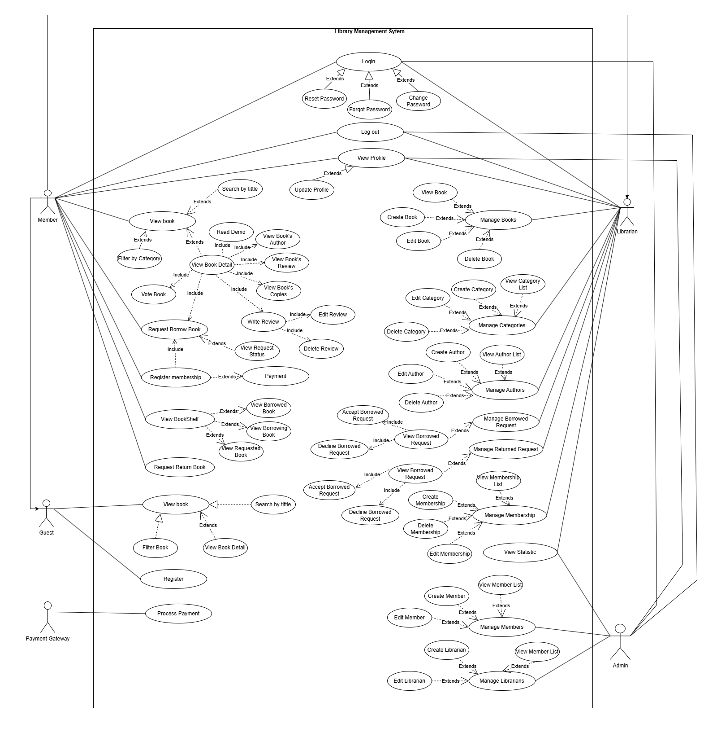

#### 1.2.1 UCs for Member

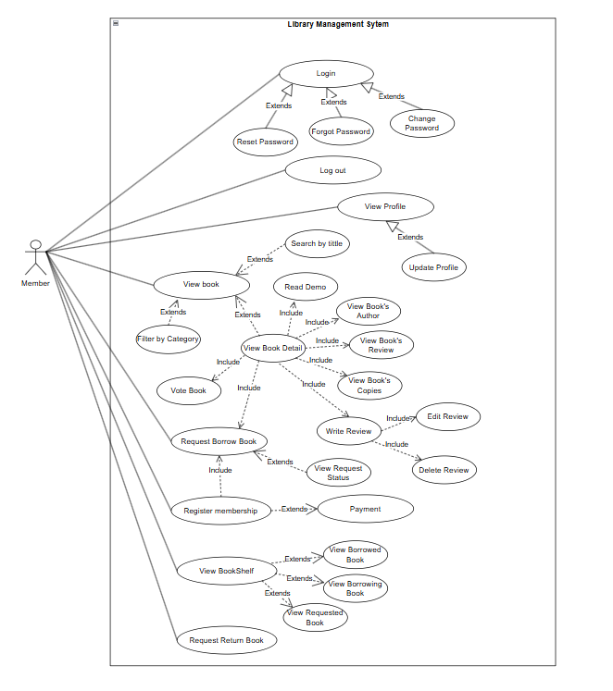

#### 1.2.2 UCs for Guest

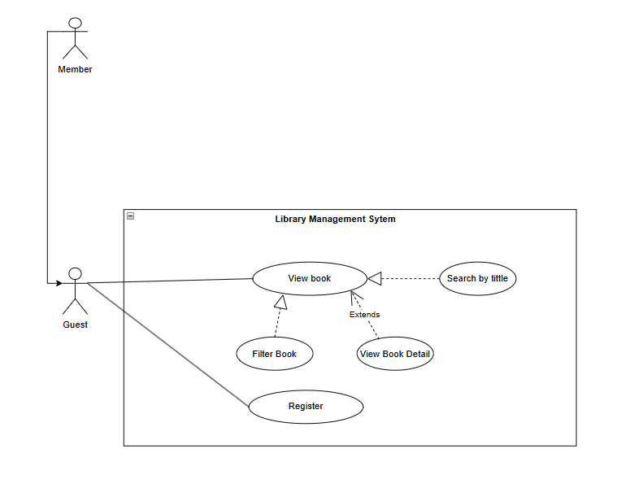

#### 1.2.2 UCs for Librarian

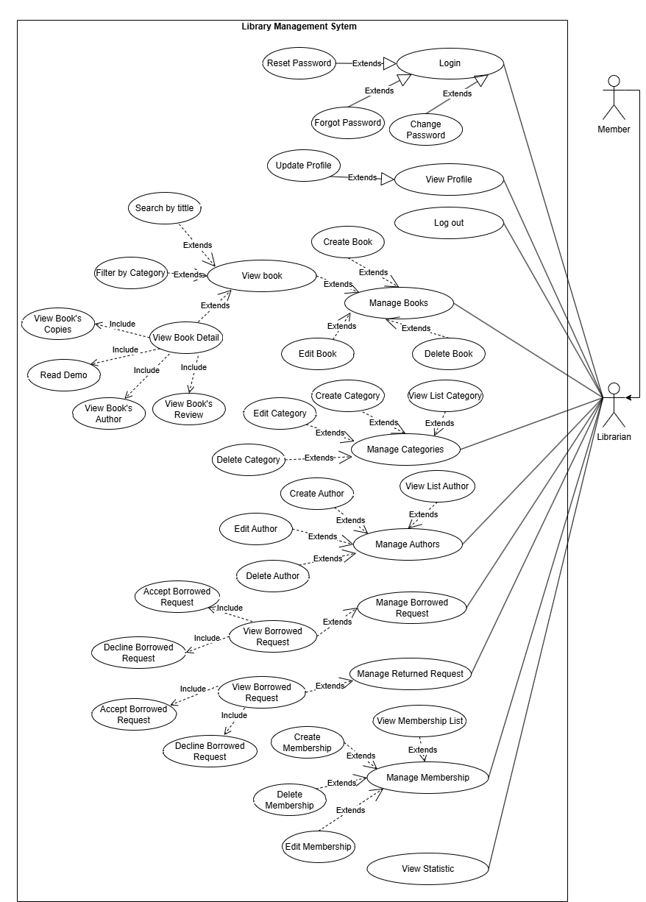

#### 1.2.3 UCs for Admin

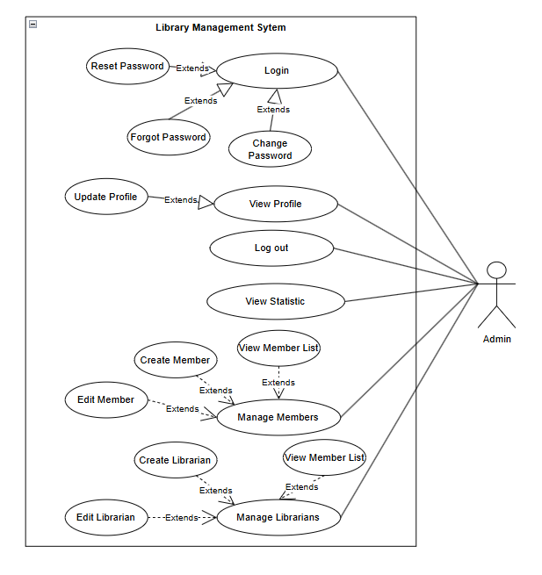

### 1.3 Description

|  |  |  |  |
| --- | --- | --- | --- |
| **ID** | **Feature** | **Use Case** | **Use Case Description** |
| 1 | Authentication | Login | Allow users to log in to the system. |
| 2 | Authentication | Register | Allow guests to register an account. |
| 3 | Authentication | Log Out | Allow users to log out of the system. |
| 4 | Authentication | Change Password | Allow the user to update their password. |
| 5 | Authentication | Forgot Password | Allow users to reset their password when forgotten. |
| 6 | Common | View Book | Allows members to view book information. |
| 7 | Common | Search by Title | Allows members to search for books by title. |
| 8 | Common | Filter by Category | Allows members to filter books by category. |
| 9 | Common | View Book Detail | Allows members to view detailed information about a book. |
| 10 | Common | Read Demo | Allows members to read a sample of the book. |
| 11 | Common | View Book's Author | Allows members to view the author of the book. |
| 12 | Common | View Book's Review | Allows members to view reviews of the book. |
| 13 | Common | View Book's Copies | Allows members to view the number of copies available for a book. |
| 14 | Common | View Profile | Allows members to view their personal information. |
| 15 | Common | Update Profile | Allows members to update their personal information. |
| 16 | Feedback | Vote Book/Write review | Allows members to write feedback and rate a book. |
| 17 | Feedback | Delete review | Allows member to delete reviews of a book they review. |
| 18 | Feedback | Edit Review | Allows member to edit reviews of a book they review. |
| 19 | Request | Request Borrow Book | Allows members to request to borrow a book. |
| 20 | Request Status | View Request Status | Allows members to view the status of their book borrowing/returning request. |
| 21 | Request | Request Return Book | Allows members to request to return a book. |
| 22 | Bookshelf | View Borrowed Books | Allows members to view a list of books they have borrowed. |
| 23 | Bookshelf | View Borrowing Book | Allows members to view details of a book they are currently borrowing. |
| 24 | Bookshelf | View Requesting Book | Allows members to view their list of requested to borrow books. |
| 25 | Membership | Register Membership | Allows guests to register for membership. |
| 26 | Book Management | View Book | Allow the librarians to view a list of books and also do actions such as view book detail, read demo,... |
| 27 | Book Management | Create Book | Allows librarians to create a new book. |
| 28 | Book Management | Edit Book | Allows librarians to edit book information. |
| 29 | Book Management | Delete Book | Allows librarians to delete a book. |
| 30 | Membership Management | View Membership List | Allow the librarians to view a list of memberships. |
| 31 | Membership Management | Create Membership | Allows librarians to create a new membership. |
| 32 | Membership Management | Edit Membership | Allows librarians to edit a membership. |
| 33 | Membership Management | Delete Membership | Allows librarians to delete a membership. |
| 34 | Category Management | View Category List | Allow the librarians to view a list of categories. |
| 35 | Category Management | Create Category | Allows librarians to create a new book category. |
| 36 | Category Management | Edit Category | Allows librarians to edit a book category. |
| 37 | Category Management | Delete Category | Allows librarians to delete a book category. |
| 38 | Author Management | View Author List | Allow the librarians to view a list of authors. |
| 39 | Author Management | Edit Author | Allows librarians to edit author information. |
| 40 | Author Management | Delete Author | Allows librarians to delete an author. |
| 41 | Author Management | Create Author | Allows librarians to create a new author. |
| 42 | Manage Request | View Borrowed/ Returned Request | Allows librarians to view lists of a book borrowing/returning request. |
| 43 | Manage Request | Accept Borrowed/ Returned Request | Allows librarians to accept a book borrowing/returning request. |
| 44 | Manage Request | Decline Borrowed/ Returned Request | Allows librarians to decline a book borrowing/returning request. |
| 45 | Statistic | View Statistic | Allows librarians to view system statistics. |
| 46 | Member Management | View Member List | Allow the administrators to view a list of members. |
| 47 | Member Management | Create Member | Allows administrators to create a new member account. |
| 48 | Member Management | Edit Member | Allows administrators to edit member information. |
| 49 | Librarian Management | View Librarian List | Allow the administrators to view a list of librarians. |
| 50 | Librarian Management | Create Librarian | Allows administrators to create a new librarian account. |
| 51 | Librarian Management | Edit Librarian | Allows administrators to edit librarian information. |
| 52 | Statistic | View Statistic | Allows administrators to view system statistics. |

## 2. System Functionalities

### 2.1 Screens Flow

### 2.1.1 Screens Flow for Guest

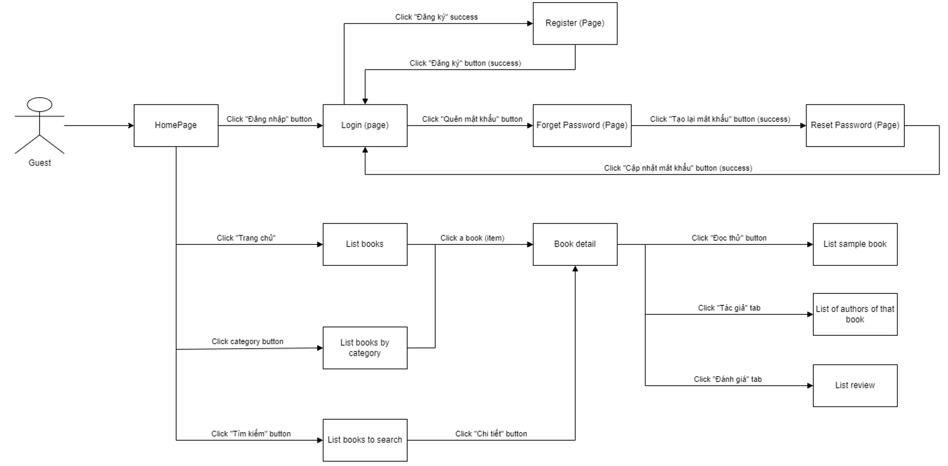

### 2.1.2 Screens Flow for Member

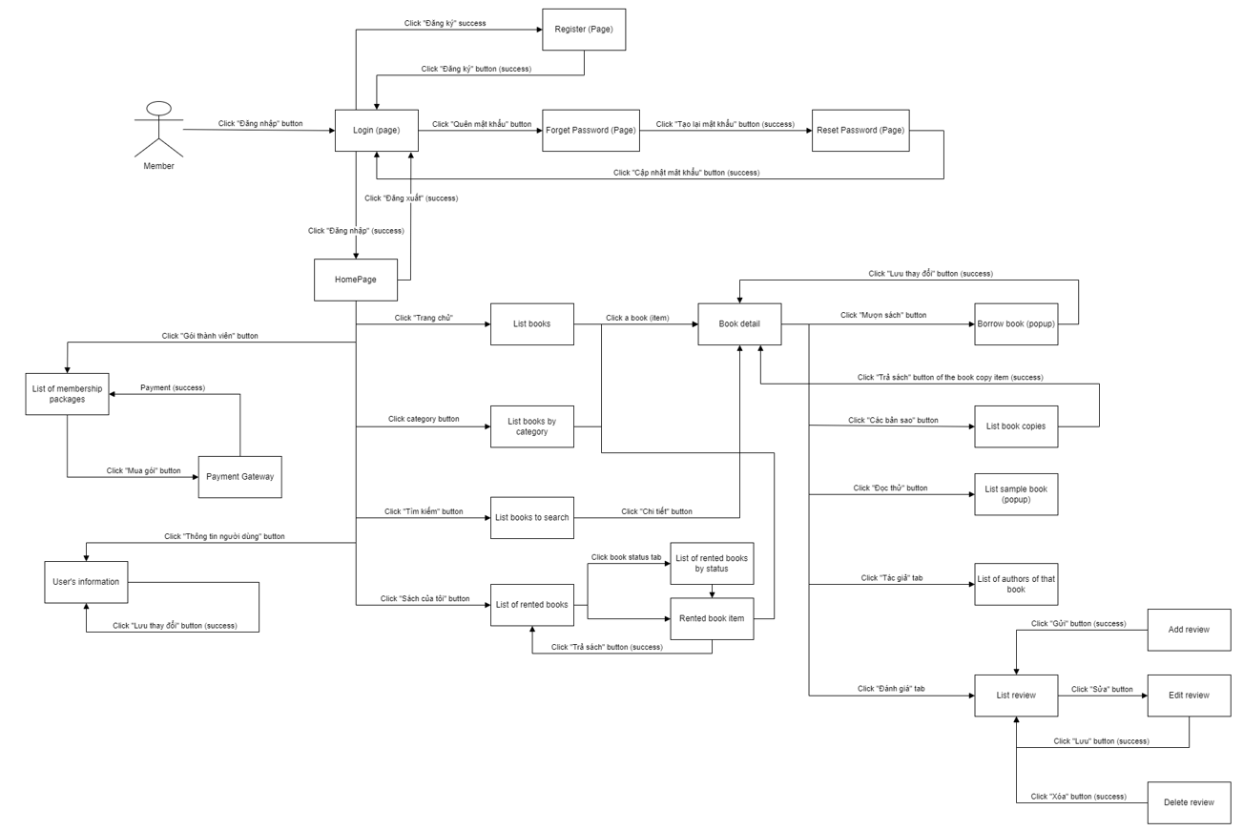

### 2.1.3 Screens Flow for Librarian

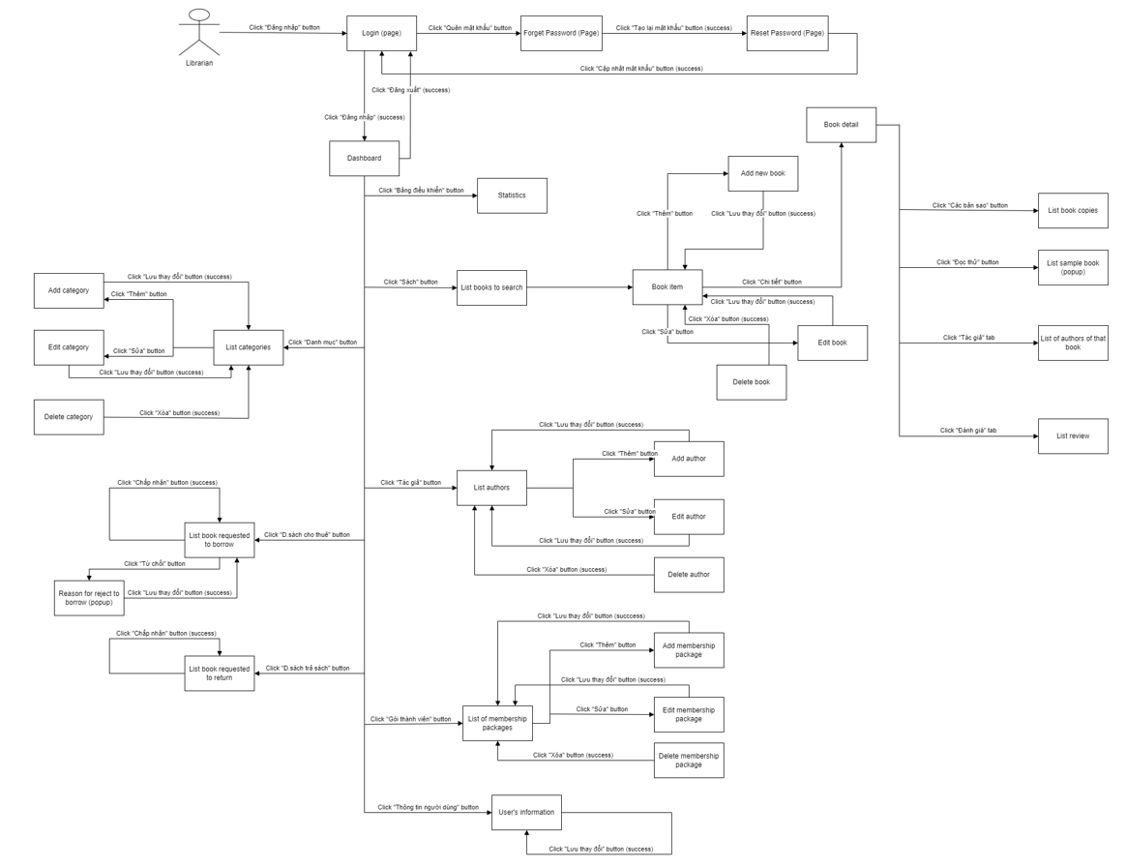

### 2.1.4 Screens Flow for Admin

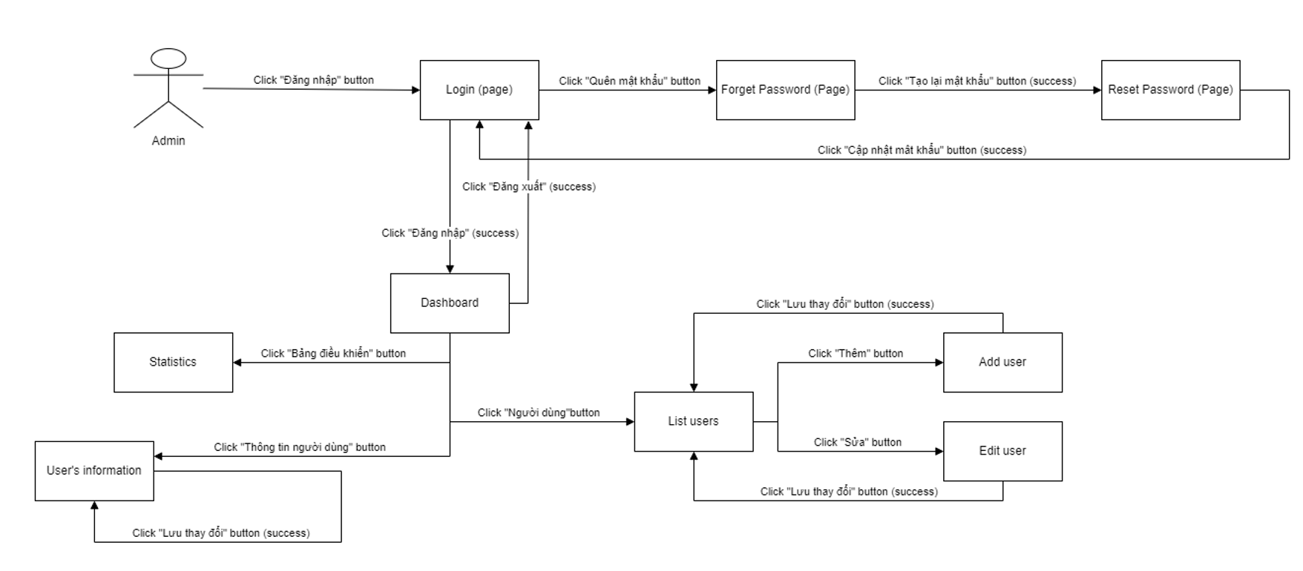

### 2.2 Screen Authorization

|  |  |  |  |  |
| --- | --- | --- | --- | --- |
| Screen | Admin | Librarian | Member | Guest |
| User Login | x | x | x | x |
| Reset Password | x | x | x | x |
| User Register |  |  |  | x |
| User Profile | x | x | x | x |
| Change password | x | x | x | x |
| Dashboard | x | x |  |  |
| Manage Users | x |  |  |  |
| Manage Books |  | x |  |  |
| Manage Categories |  | x |  |  |
| Manage Authors |  | x |  |  |
| Manage Librarians |  | x |  |  |
| Manage Membership Package |  | x |  |  |
| Manage Book Borrow Requests |  | x |  |  |
| Manage Book Return Requests |  | x |  |  |
| Book Details |  | x | x | x |
| Newest Books |  | x | x | x |
| Books List |  | x | x | x |
| Search Book |  | x | x | x |
| Book Copies List |  |  | x |  |
| Sample Book |  | x | x | x |
| Reviews List |  | x | x | x |
| Write Review |  |  | x |  |
| Number of Rating Books |  | x | x | x |
| Rating Books |  |  | x |  |
| Payment |  |  | x |  |
| Borrow Book |  |  | x |  |
| Return Book |  |  | x |  |
| Books Loan List |  |  | x |  |
| Registration Membership |  |  | x |  |

### 2.3 Non-UI Functions

|  |  |  |  |
| --- | --- | --- | --- |
| # | Feature | System Function | Description |
| 1 | Payment | Membership fees | Users need to pay fees to register for membership packages |
| 2 | Security | System security requirements | Security is the security requirements in the process of using the system. From accessing, performing operations, to logging out of the system |
| 3 | Authorization | Clear role assignment requirements | Implementation of authorization mechanism in the system, including the specify the role of logged-in user, his/her authorised page links (building the displayed menu items (in the front end) and preventing unauthorised access via enter the links directly). |
| 4 | User-friendly Interface | Usability Requirements | The system must have an easy-to-use and user-friendly interface. |

## 3. High Level Design

### 3.1 Database Design

#### 3.1.1 Database ERD

#### 3.1.1 Database Schema

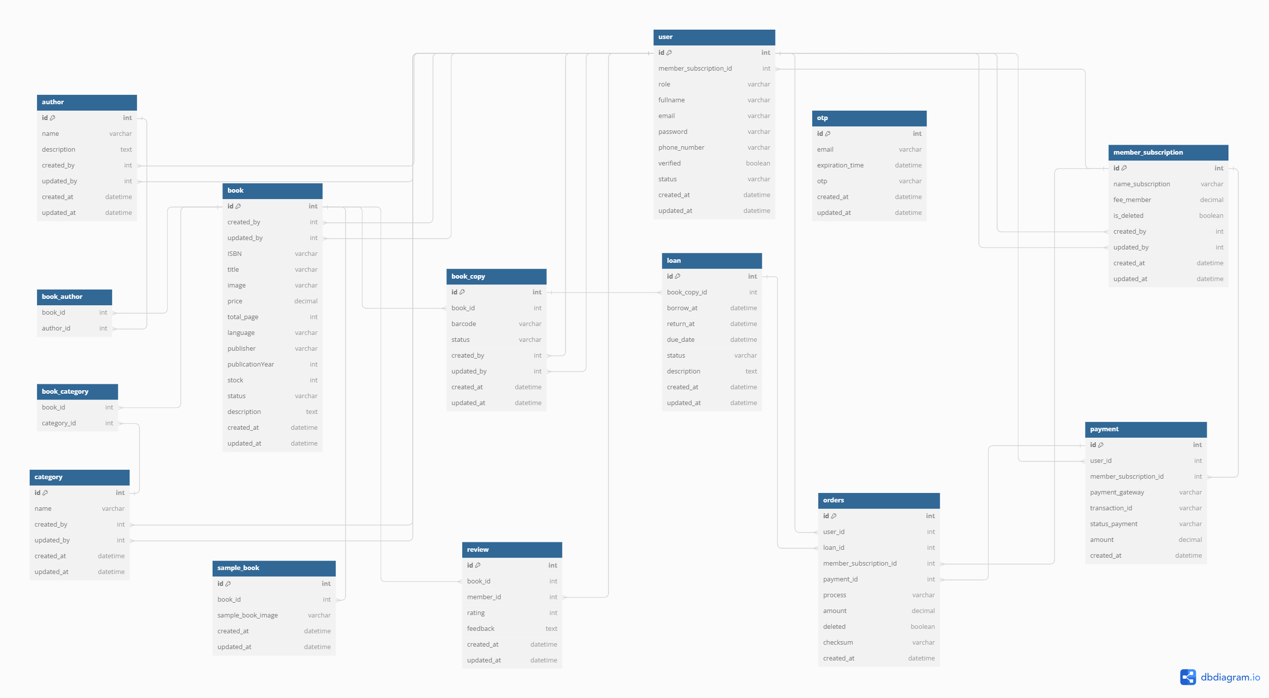

#### 3.1.2 Table Descriptions

### **Author Table**

* **id**: Primary key. Unique identifier for each author.
* **name**: Name of the author.
* **description**: Description or biography of the author.
* **created_by**: Foreign key. Reference to the user who created this author entry.
* **updated_by**: Foreign key. Reference to the user who last updated this author entry.
* **created_at**: Timestamp when the author entry was created.
* **updated_at**: Timestamp when the author entry was last updated.

### **Book_Author Table**

* **book_id**: Foreign key. Reference to the book in the book table.
* **author_id**: Foreign key. Reference to the author in the author table.

### **Book Table**

* **id**: Primary key. Unique identifier for each book.
* **created_by**: Foreign key. Reference to the user who created this book entry.
* **updated_by**: Foreign key. Reference to the user who last updated this book entry.
* **ISBN**: International Standard Book Number for the book.
* **title**: Title of the book.
* **image**: Image URL or path of the book cover.
* **price**: Price of the book.
* **total_page**: Total number of pages in the book.
* **language**: Language in which the book is written.
* **publisher**: Publisher of the book.
* **publicationYear**: Year the book was published.
* **stock**: Number of copies available in the library.
* **status**: Availability status of the book.
* **description**: Description or summary of the book.
* **created_at**: Timestamp when the book entry was created.
* **updated_at**: Timestamp when the book entry was last updated.

### **User Table**

* **id**: Primary key. Unique identifier for each user.
* **member_subscription_id**: Foreign key. Reference to the membership subscription of the user.
* **role**: Role of the user (e.g., librarian, member).
* **fullname**: Full name of the user.
* **email**: Email address of the user.
* **password**: Encrypted password of the user.
* **phone_number**: Phone number of the user.
* **verified**: Verification status of the user's email.
* **status**: Active/inactive status of the user.
* **created_at**: Timestamp when the user entry was created.
* **updated_at**: Timestamp when the user entry was last updated.

### **OTP Table**

* **id**: Primary key. Unique identifier for each OTP entry.
* **email**: Email address associated with the OTP.
* **expiration_time**: Expiration time of the OTP.
* **otp**: One-time password.
* **created_at**: Timestamp when the OTP was created.
* **updated_at**: Timestamp when the OTP was last updated.

### **Member_Subscription Table**

* **id**: Primary key. Unique identifier for each subscription.
* **name_subscription**: Name of the subscription plan.
* **fee_member**: Membership fee for the subscription.
* **is_deleted**: Deletion status of the subscription.
* **created_by**: Foreign key. Reference to the user who created this subscription entry.
* **updated_by**: Foreign key. Reference to the user who last updated this subscription entry.
* **created_at**: Timestamp when the subscription entry was created.
* **updated_at**: Timestamp when the subscription entry was last updated.

### **Book_Category Table**

* **book_id**: Foreign key. Reference to the book in the book table.
* **category_id**: Foreign key. Reference to the category in the category table.

### **Book_Copy Table**

* **id**: Primary key. Unique identifier for each book copy.
* **book_id**: Foreign key. Reference to the book in the book table.
* **barcode**: Unique barcode for the book copy.
* **status**: Availability status of the book copy.
* **created_by**: Foreign key. Reference to the user who created this book copy entry.
* **updated_by**: Foreign key. Reference to the user who last updated this book copy entry.
* **created_at**: Timestamp when the book copy entry was created.
* **updated_at**: Timestamp when the book copy entry was last updated.

### **Loan Table**

* **id**: Primary key. Unique identifier for each loan.
* **book_copy_id**: Foreign key. Reference to the book copy being loaned.
* **borrow_at**: Timestamp when the book was borrowed.
* **return_at**: Timestamp when the book was returned.
* **due_date**: Due date for returning the book.
* **status**: Status of the loan (e.g., borrowed, returned, overdue).
* **description**: Additional information or description of the loan.
* **created_at**: Timestamp when the loan entry was created.
* **updated_at**: Timestamp when the loan entry was last updated.

### **Category Table**

* **id**: Primary key. Unique identifier for each category.
* **name**: Name of the category.
* **created_by**: Foreign key. Reference to the user who created this category entry.
* **updated_by**: Foreign key. Reference to the user who last updated this category entry.
* **created_at**: Timestamp when the category entry was created.
* **updated_at**: Timestamp when the category entry was last updated.

### **Review Table**

* **id**: Primary key. Unique identifier for each review.
* **book_id**: Foreign key. Reference to the book being reviewed.
* **member_id**: Foreign key. Reference to the member who wrote the review.
* **rating**: Rating given by the member.
* **feedback**: Feedback or comments by the member.
* **created_at**: Timestamp when the review entry was created.
* **updated_at**: Timestamp when the review entry was last updated.

### **Sample_Book Table**

* **id**: Primary key. Unique identifier for each sample book.
* **book_id**: Foreign key. Reference to the book.
* **sample_book_image**: Image URL or path for the sample book.
* **created_at**: Timestamp when the sample book entry was created.
* **updated_at**: Timestamp when the sample book entry was last updated.

### **Orders Table**

* **id**: Primary key. Unique identifier for each order.
* **user_id**: Foreign key. Reference to the user who placed the order.
* **loan_id**: Foreign key. Reference to the loan associated with the order.
* **member_subscription_id**: Foreign key. Reference to the member subscription associated with the order.
* **payment_id**: Foreign key. Reference to the payment associated with the order.
* **process**: Processing status of the order.
* **amount**: Total amount for the order.
* **deleted**: Deletion status of the order.
* **checksum**: Checksum for verifying the integrity of the order.
* **created_at**: Timestamp when the order entry was created.

### **Payment Table**

* **id**: Primary key. Unique identifier for each payment.
* **user_id**: Foreign key. Reference to the user who made the payment.
* **member_subscription_id**: Foreign key. Reference to the member subscription associated with the payment.
* **payment_gateway**: Payment gateway used for the transaction.
* **transaction_id**: Transaction ID for the payment.
* **status_payment**: Payment status (e.g., completed, pending, failed).
* **amount**: Amount paid.
* **created_at**: Timestamp when the payment entry was created.

### 3.2 Code Packages

#### 3.2.1 Package Diagram

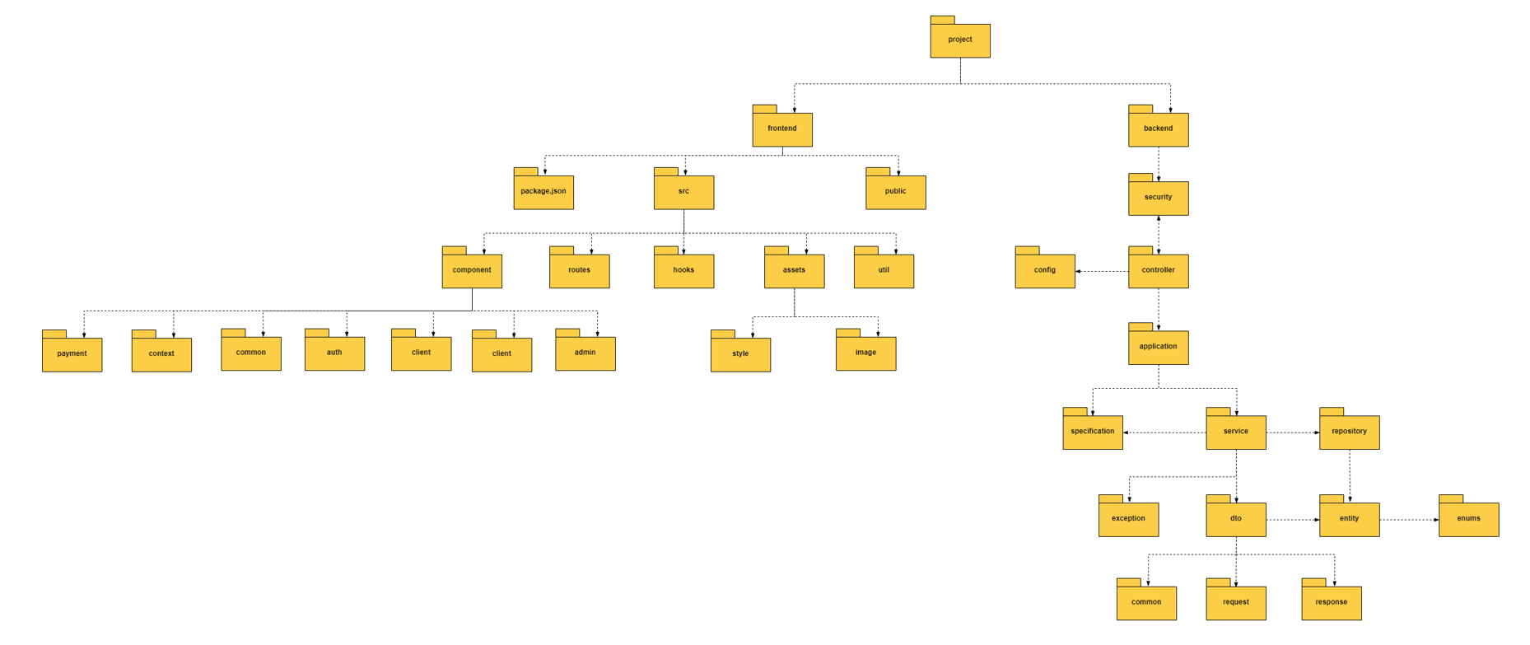

#### 3.2.2 Package Descriptions

|  |  |  |
| --- | --- | --- |
| No | Package | Description |
| 1 | config | This package contains classes and configuration files for the application. It can include settings for email, payments, and other app-wide configurations. |
| 2 | controller | This package holds the REST controllers or web controllers for handling HTTP requests and defining the endpoints. They typically interact with the service layer to process incoming requests and generate responses. |
| 3 | domain | Encapsulates the business logic and core entities of the application. |
| 4 | common | Contains common DTOs shared across different parts of the application. |
| 5 | request | DTOs specifically for incoming requests, such as form submissions or API calls. |
| 6 | response | DTOs for outgoing responses to clients. |
| 7 | entity | Defines the JPA entities or domain objects that map to the database tables. |
| 8 | enums | Contains enumeration types used across the application for predefined sets of constants. |
| 9 | exception | Includes custom exception classes and exception handling mechanisms, centralizing the handling of application-specific errors and exceptions. |
| 10 | repository | Contains repository interfaces for data access, typically extending Spring Data JPA repositories to provide CRUD operations on the entities. |
| 11 | security | Deals with security configurations and components such as authentication, authorization, user roles, and security filters. |
| 12 | application | Contains the core business logic and specifications of the application. |
| 13 | service | Contains service interfaces and their implementations. |
| 14 | implements | This sub-package contains the actual implementations of the service interfaces. The implementations |
| 15 | specification | Contains specifications or criteria for querying the database using Spring Data JPA Specifications, allowing for complex queries and dynamic filtering. |
| 16 | style | Contains global styles, CSS files, and styling-related assets. |
| 17 | image | Contains image assets used across the application. |
| 18 | admin | Components related to admin functionalities. |
| 19 | auth | Components related to authentication (login, registration, etc.). |
| 20 | client | Components related to client/user functionalities. |
| 21 | common | Shared or reusable components used across different parts of the application. |
| 22 | context | React Context components for managing global state. |
| 23 | payment | Components related to payment functionalities. |
| 24 | hooks | Custom React hooks for managing state and side effects. |
| 25 | routes | Components or configurations for defining application routes and navigation. |
| 26 | service | Service files for handling API calls and business logic. |
| 27 | util | Utility functions and helper methods used throughout the application. |

# II. Requirement Specifications

## 1. Public Feature

### 1.1 UC-1_View Home Page

|  |  |  |  |
| --- | --- | --- | --- |
| UC ID and Name: | UC1_View Home Page | | |
| Created By: | Nguyen Van Dien | Date Created: | 24/05/2024 |
| Primary Actor: | Guest | Secondary Actors: | Member |
| Trigger: | The user accesses the My Book Shelf | | |
| Description: | This use case describes when a customer or guest views the home page of the application or website. | | |
| Preconditions: | PRE-1: The application or website is accessible.  PRE-2: The user may or may not be logged in. | | |
| Postconditions: | POST-1: The home page is displayed to the user. | | |
| Normal Flow: | 1.The member opens the My Book Shelf.  2.The system loads and displays the general home page.  3.The home page includes relevant content, such as featured books, seach books, the books that user borrows, or membership. | | |
| Alternative Flows: | 1. When the Guest clicks on homepage, search, their book, membership the system will direct the user to that function | | |
| Exceptions: | E1: If there are technical issues preventing the display of the home page, an error message is shown. | | |
| Priority: | High, Must Have | | |
| Frequency of Use: | Regularly | | |
| Business Rules: | Homepage content is dynamically generated based on common interests and trending items. | | |
| Other Information: | The home page can include interactive elements such as sliders, buttons, and links to navigate to other parts of the application. | | |
| Assumptions: | AS-1 | | |

### 1.2 UC-2_View Book Detail

|  |  |  |  |
| --- | --- | --- | --- |
| UC ID and Name: | UC-2 View Book Detail | | |
| Created By: | Nguyen Van Dien | Date Created: | 06/06/2024 |
| Primary Actor: | Member; Guest | Secondary Actors |  |
| Trigger: | A member wants to know more information about books on the online My Book Shelf website | | |
| Description: | A member accesses the My Book Shelf website, selects a books and views about the author, category, price, language….. | | |
| Preconditions: | PRE-1: The member has entered the home page  PRE-02: Member has selected a book to view its details | | |
| Postconditions: | POST-1: The member has viewed detail of books and make decision to borrow books | | |
| Normal Flow | 1.The member clicking on book to view detail  2.The website displays the book details :author, title, category, publisher…. | | |
| Alternative Flows: | 1. Members can borrow book after view detail about book and complete their purchase if they are logged in | | |
| Exceptions: | 1. If the website is unavailable, the member will be unable to view the book detail | | |
| Priority: | High | | |
| Frequency of Use: | Very Frequent | | |
| Business Rules: | N/A | | |
| Other Information: | The book details should include title, category, author… | | |
| Assumptions: | AS-1 | | |

### 1.3 UC-3_Seach Book

|  |  |  |  |
| --- | --- | --- | --- |
| ID and Name: | UC-3 Search Book | | |
| Created By: | Cao Viet Quang | Created Date: | 06/06/2024 |
| Primary Actor: | Guest | Secondary Actors | Member |
| Description: | Users can search for book they want to buy | | |
| Trigger: | Guest and Member find specific books on the website by entering keywords to the search bar. | | |
| Preconditions: | PRE-1. Search Criteria: The user should provide search criteria, such as keywords to initiate the search. | | |
| Postconditions: | POST-1. Search Results Displayed: After the search is initiated, the system should display a list of books that match the provided search criteria.  POST-2. Book Details: The user can click on a product listing to view more details about a book | | |
| Normal Flow: | 1. User navigates to the course search feature.  2. User provides search criteria, which may include:  + Keywords of title  + Category  3. The user starts a search by clicking the "Search" button or pressing the "Enter" key.  4. The system processes search criteria and retrieves books that match the criteria  5. The system displays a list of books matching the search criteria, | | |
| Alternative Flows: | The user can click on page numbers buttons to navigate through multiple pages of search results | | |
| Exceptions: | The system finds no courses that match the provided search criteria, it displays a message indicating that no book was found. | | |
| Priority: | High | | |
| Frequency of Use: | Very Frequent | | |
| Business Rules: | N/A | | |
| Other Information: | AS-1 | | |

### 1.4 UC-4_Read Demo Book

|  |  |  |  |
| --- | --- | --- | --- |
| UC ID and Name: | UC4_Read Demo Book | | |
| Created By: | Nguyen Van Dien | Date Created: | 10/07/2024 |
| Primary Actor: | Guest, Librarian, Member | Secondary Actors: |  |
| Trigger: | User want to read demo of the book before they want to borrow. | | |
| Description: | User click the book want to read, after that click the button "Read demo" so that they can view the content of the book | | |
| Preconditions: | PRE-1: User is logged into their account.  PRE-2: User choose the book they want to read demo | | |
| Postconditions: | POST-1: User successfully choose the book they want to read demo  POST-2: The system display few page of the book for the user | | |
| Normal Flow: | 1. User clicks on the "Read demo" on the Book detail page.  2. Website displays few page of the book for user. | | |
| Exceptions: | E1: If there are technical issues preventing the display of the read demo book, an error message is shown. | | |
| Priority: | High, Must Have | | |
| Frequency of Use: | Regularly | | |
| Business Rules: | N/A | | |
| Other Information: | N/A | | |
| Assumptions: | AS-1 | | |

## 2. Common feature

### 2.1 UC-5_Login

|  |  |  |  |
| --- | --- | --- | --- |
| UC ID and Name: | UC-5_Login | | |
| Created By: | Nguyen Van Dien | Date Created: | 16/06/2023 |
| Primary Actor: | Member, Admin , Librarian | Secondary Actors: | None |
| Trigger: | The member, admin, librarian wants to access their account and utilise personalised features on the My Book Shelf website. | | |
| Description: | Users access the My Book Shelf website and log in to their account to access their function. | | |
| Preconditions: | PRE-1:The user has already registered an account on the website | | |
| Postconditions: | POST-1:User logs in the system successfully | | |
| Normal Flow | 1.The users navigate to the website's login page by clicking on the "Login" button  2.User input email and password  3.User clicks the Login button  4.The website verifies the credentials and if they are correct, the user's account is authenticated, and they are granted access to their account  5.System allows user to access their functions | | |
| Alternative Flows: | 1. The user entered incorrect password or email  2. The system will report an error asking the user re-enter the login information | | |
| Exceptions: | If the user account has been banned by management, the user cannot log in | | |
| Priority: | High | | |
| Frequency of Use: | Very Frequent | | |
| Business Rules: | BR1,BR2,BR3,BR4,BR5 | | |
| Other Information: | The login process includes security measures such as encryption and strong secure password to ensure the privacy and protection of user information. | | |
| Assumptions: | AS-1  AS-11 | | |

### 2.2 UC-6_LogOut

|  |  |  |  |
| --- | --- | --- | --- |
| UC ID and Name: | UC-6 Logout | | |
| Created By: | Nguyen Van Dien | Date Created: | 16/06/2024 |
| Primary Actor: | Member, Admin , Manager | Secondary Actors: | None |
| Trigger: | The user’s action of clicking on the option “Log out” on the menu. | | |
| Description: | This fundamental use case allows logged in users to log out and terminate their authenticated session system. | | |
| Preconditions: | PRE-1: The user has already logged in the system. | | |
| Postconditions: | POST-1:The user's session is successfully terminated, and they are no longer authenticated within the application.  POST-2:The system redirects to the home page. | | |
| Normal Flow: | 1.Click on the “Logout” option on the navbar.  2.The system will remove the user on the session and redirect to the Home page | | |
| Alternative Flows: | N/A | | |
| Exceptions: | N/A | | |
| Priority: | High | | |
| Frequency of Use: | Very Frequent | | |
| Business Rules: | N/A | | |
| Other Information: | N/A | | |
| Assumptions: | AS-1 | | |

### 2.3 UC-7_Register

|  |  |  |  |
| --- | --- | --- | --- |
| UC ID and Name: | UC-7 Register | | |
| Created By: | Nguyen Van Dien | Date Created: | 16/06/2024 |
| Primary Actor: | Guest | Secondary Actors: |  |
| Trigger: | The user intends to create a new account within the system | | |
| Description: | A guest accesses the My Book Shelf website and registers as a new user to create an account, allowing them to access personalized features | | |
| Preconditions: | PRE-1:The user is not already registered with the system using the same credentials | | |
| Postconditions: | POST-1:The member has successfully completed the registration process and has a user account on the website | | |
| Normal Flow | 1.The user navigates to the registration page.  2.The user enters their personal information, including a full of name, email and password.  3.The user clicks the "Register" button.  4.The system validates the entered information to ensure it meets the necessary criteria.  5.If the information is valid, the system creates a new user account and stores it in the system's database.  6.The system redirects the user to the home page. | | |
| Alternative Flows: | N/A | | |
| Exceptions: | **Username have existed**  1.System shows an error message that the username has existed.  2.Return register page for users register  **Email have existed**  1.System shows an error message that the email has existed.  2.Return register page for users register  **Repeat Password have not equaled Password**  1.System shows an error message that repeat password has not equaled password.  2.Return register page for users register | | |
| Priority: | High | | |
| Frequency of Use: | Very Frequent | | |
| Business Rules: | BR1, BR2 | | |
| Other Information: | The registration process should include necessary security measures, such as password encryption | | |
| Assumptions: | AS-1 | | |

### 2.4 UC-8_Forgot Password

|  |  |  |  |
| --- | --- | --- | --- |
| UC ID and Name: | UC-7 Forgot Password | | |
| Created By: | Nguyen Van Dien | Date Created: | 16/06/2024 |
| Primary Actor: | Member | Secondary Actors: |  |
| Trigger: | The member has forgotten their password and needs to reset it | | |
| Description: | A member who has forgotten their password attempts to reset it through the "Forgot Password" feature | | |
| Preconditions: | PRE-1:The member must have registered an account on the website. | | |
| Postconditions: | POST-1: The member has successfully reset their password and can now access their account | | |
| Normal Flow | 1.The member clicks on the "Forgot Password" on the website's login page.  2.The website displays a password reset form, the customer enters their email address and submits the form.  3.The website sends an OTP code to the customer's registered email.  4. The customer input OTP code in the website's input OTP form.  5. If the user enters the correct OTP code, the user can enter a new password | | |
| Alternative Flows: | 1. If the member does not receive the password reset email, they can check their spam or junk folder | | |
| Exceptions: | E1: If the member enters an incorrect or unregistered email address, no OTP code has been sent | | |
| Priority: | High | | |
| Frequency of Use: | Frequent | | |
| Business Rules: | BR1, BR5 | | |
| Other Information: | N/A | | |
| Assumptions: | AS-1  The member has previously registered an account on the website  The registered email address provided by the member is accessible | | |

### 2.5 UC-9_Update Profile

|  |  |  |  |
| --- | --- | --- | --- |
| UC ID and Name: | UC-12 Update Profile | | |
| Created By: | Nguyen Van Dien | Date Created: | 16/06/2024 |
| Primary Actor: | Member | Secondary Actors: |  |
| Trigger: | A member wants to change their personal information | | |
| Description: | A member wants to change personal information | | |
| Preconditions: | PRE-1:The user must have already registered on the website.  PRE-2:The user must be logged in to their account. | | |
| Postconditions: | POST-1:The user's profile information is updated with the new data provided during the use case  POST-2:The user can continue to use their account with the updated profile information. | | |
| Normal Flow | 1.The user logs in to their account on the website  2.After login,user access on their profile page  3.The user selects the option to edit/update their profile information  4.After making the desired changes, the user submits the updated profile information.  5.The system validates the submitted data to ensure it meets the required criteria  6.The system displays a confirmation message to the user | | |
| Alternative Flows: | 1. If the user enters incorrect information or does not satisfy the requirements, an error will be displayed and the user will be asked to re-enter | | |
| Exceptions: | None | | |
| Priority: | High | | |
| Frequency of Use: | Frequent | | |
| Business Rules: | BR5 | | |
| Other Information: | If the user chooses to cancel the update, they can navigate away from the edit profile page without making any changes. | | |
| Assumptions: | AS-1 | | |

## 3. Member feature

### 3.1 UC-10_Borrow Book

|  |  |  |  |
| --- | --- | --- | --- |
| UC ID and Name: | UC-10_Borrow Book | | |
| Created By: | Cao Viet Quang | Date Created: | 24/05/2024 |
| Primary Actor: | Member | Secondary Actors: |  |
| Trigger: | The user accesses the My Book Shelf to borrow the book | | |
| Description: | This use case describes when a member want to borrow the book after login into the website | | |
| Preconditions: | PRE-1: Member is logged into the system.  PRE-2:Member choose the book they want to borrow. | | |
| Postconditions: | POST-1: User have to input all the field before want to borrow the book, eg: borrow date, return date,... | | |
| Normal Flow: | 1.The member opens the My Book Shelf.  2. User choose the book they want to borrow  3.Input all field before click the button “save” | | |
| Alternative Flows: | N/A | | |
| Exceptions: | E1: Cannot borrow if they don’t input all field in borrow form. | | |
| Priority: | High, Must Have | | |
| Frequency of Use: | Regularly | | |
| Business Rules: | The return date can not smaller than borrow date. | | |
| Other Information: | N/A | | |
| Assumptions: | AS-1 | | |

### 3.2 UC-11_Send Feedback

|  |  |  |  |
| --- | --- | --- | --- |
| ID and Name: | UC-11: Send Feedback | | |
| Created By: | Le Van Viet | Date Created: | 06/06/2024 |
| Primary Actor: | Member | Secondary Actors: |  |
| Description: | Member can offer feedback and reviews for the book. | | |
| Trigger: | A member has logged into the system and sent the feedback. | | |
| Preconditions: | PRE-1: The member register and login to My Book Shelf PRE-2: The member borrowed a book . | | |
| Postconditions: | POST-1:The member receives a confirmation of their feedback submission. | | |
| Normal Flow: | 1.The member fills in the required fields, providing detailed and specific feedback. The member submits the feedback form.  2. The website validates the information provided by the member and stores the feedback in a database.  3.Display feedback about books that member have purchased. | | |
| Alternative Flows: | 1. User can delete or update previous feedback. | | |
| Exceptions: | N/A | | |
| Priority: | High | | |
| Business Rules: | Member need to be respectful and polite when sending feedback | | |
| Other Information: | Ensure that the feedback submission form is user-friendly and includes relevant fields. | | |
| Assumptions: | AS-1 | | |

### 3.3 UC-12_Get List Book Borrowed

|  |  |  |  |
| --- | --- | --- | --- |
| ID and Name: | UC-12: Get List Book Borrowed | | |
| Created By: | Cao Viet Quang | Date Created: | 06/06/2024 |
| Primary Actor: | Member | Secondary Actors: |  |
| Description: | Member can see list book that they borrowed | | |
| Trigger: | A member has logged into the system and view the list book that they borrowed | | |
| Preconditions: | PRE-1: The member register and login to My Book Shelf PRE-2: The member chooses the “Book Borrowed” on the side bar to view . | | |
| Postconditions: | POST-1: The member has viewed the list book that they borrowed. | | |
| Normal Flow: | 1.The member clicking on “Book borrowed” on the sidebar  2.The website displays list of books that member borrowed. | | |
| Alternative Flows: | N/A | | |
| Exceptions: | N/A | | |
| Priority: | High | | |
| Business Rules: | N/A | | |
| Other Information: | N/A | | |
| Assumptions: | AS-1 | | |

### 3.4 UC-13_Membership

|  |  |  |  |
| --- | --- | --- | --- |
| UC ID and Name: | UC-13_Membership | | |
| Created By: | Cao Viet Quang | Date Created: | 10/07/2024 |
| Primary Actor: | Member | Secondary Actors: |  |
| Trigger: | Customer wants to purchase a membership to receive special discounts and benefits. | | |
| Description: | Customer visits the e-commerce website, selects a suitable membership plan, provides payment information, and completes the transaction. | | |
| Preconditions: | PRE-1: Customer is logged into their account.  PRE-2: Customer has viewed the details of the membership plans and selected the desired plan. | | |
| Postconditions: | POST-1: Customer has successfully paid and is upgraded to the selected membership plan.  POST-2: The system records the transaction and updates the customer's membership information. | | |
| Normal Flow: | 1. Customer clicks on the "Buy Now" or similar button on the membership plan page.  2. Website displays details of the membership plan and payment methods.  3. Customer selects a payment method and enters payment information. | | |
| Exceptions: | E1: If there are technical issues preventing the display of the membership, an error message is shown. | | |
| Priority: | High, Must Have | | |
| Frequency of Use: | Regularly | | |
| Business Rules: | Member can not borrow book if he/she does not get a membership | | |
| Other Information: | Membership plans and benefits may change over time. | | |
| Assumptions: | AS-1 | | |

## 4. Admin feature

### 4.1 UC-14 Admin Dashboard

|  |  |  |  |
| --- | --- | --- | --- |
| UC ID and Name: | UC-13_Admin Dashboard | | |
| Created By: | Nguyen Van Dien | Date Created: | 10/07/2024 |
| Primary Actor: | Admin | Secondary Actors: |  |
| Trigger: | The admin accesses the My Book Shelf | | |
| Description: | This use case describes the dashboard of the admin to control the borrow book request, return book request, the number of member,... | | |
| Preconditions: | PRE-1: Admin is logged into their account.  PRE-2: The admin may or may not be logged in. | | |
| Postconditions: | POST-1: The dashboard is displayed to the admin. | | |
| Normal Flow: | 1.The admin opens the My Book Shelf.  2.The system loads and displays the dashboard.  3.The dashboard includes relevant content, such as borrow book request, return book request, the number of member, the book that member borrow today,.... | | |
| Exceptions: | E1: If there are technical issues preventing the display of the home page, an error message is shown. | | |
| Priority: | High, Must Have | | |
| Frequency of Use: | Regularly | | |
| Business Rules: | The dashboard only show by admin. | | |
| Other Information: | N/A | | |
| Assumptions: | AS-1 | | |

### 4.2 UC-15 View Account List

|  |  |  |  |
| --- | --- | --- | --- |
| ID and Name: | UC-15 View Account List | | |
| Created By: | Nguyen Van Dien | Date Created: | 21/05/2024 |
| Primary Actor: | Admin | Secondary Actors: |  |
| Description: | This use case provides administrators with the ability to view a list of registered accounts on the website for administrative purposes. | | |
| Trigger: | Admin wants to view the list of accounts. | | |
| Preconditions: | PRE-1: Admin must be logged into the system.  PRE-2:The system has stored information about the account | | |
| Postconditions: | POST-1:The list of accounts is displayed on the Admin's interface. | | |
| Normal Flow: | 1. The admin logs into their admin account.  2. The system will display the account lists of members and librarians.  3. Admin can choose to view the list of members or librarians. | | |
| Alternative Flows: | 1. If no accounts are found, the system displays a no-data message, and there are no further steps in the main flow. | | |
| Exceptions: | E1: If Admin cannot log into the system or if the system encounters an error while querying the account list, return login page | | |
| Priority: | High | | |
| Frequency of Use: | Frequent | | |
| Business Rules: | N/A | | |
| Other Information: | N/A | | |
| Assumptions: | AS-1 | | |

### 4.3 UC-16 Create User

|  |  |  |  |
| --- | --- | --- | --- |
| ID and Name: | UC-16 Create User | | |
| Created By: | Nguyen Van Dien | Date Created: | 06/07/2024 |
| Primary Actor: | Admin | Secondary Actors: |  |
| Description: | This use case allows admin to add a new user | | |
| Trigger: | When a admin initiates the process to add a new user. | | |
| Preconditions: | PRE-1: The manager must be logged into the My Book Shelf. | | |
| Postconditions: | POST-1: New user is successfully added, and relevant details are saved in the system. | | |
| Normal Flow: | 1**.** Admin selects the option to create a new user.  2. System displays a form for entering user details (e.g.,email, password,...).  3. Admin uploads user.  4. System validates the information and saves new user. | | |
| Alternative Flows: | 1. If provided information is invalid, the system prompts for correction. | | |
| Exceptions: | E1: If the admin fails to provide valid login credentials. | | |
| Priority: | Frequent, as new user are regularly added. | | |
| Frequency of Use: | When admin want to add a new user. | | |
| Business Rules: | BR-4 | | |
| Other Information: | N/A | | |
| Assumptions: | AS-1 | | |

### 4.4 UC-17 Update User

|  |  |  |  |
| --- | --- | --- | --- |
| UC ID and Name: | UC-17 Update User | | |
| Created By: | Nguyen Van Dien | Date Created: | 16/06/2024 |
| Primary Actor: | Admin | Secondary Actors: |  |
| Trigger: | A admin wants to change user account. | | |
| Description: | A admin wants to change user account. | | |
| Preconditions: | PRE-1:The admin must be logged into their account. | | |
| Postconditions: | POST-1:The user's account is updated with the new data provided during the use case | | |
| Normal Flow | 1.The admin logs in to their account on the website  2.After login, admin can choose the user’s account to update.  3. Admin update with available fields, such as: email and password of user’s account. | | |
| Alternative Flows: | 1. If the admin enters incorrect information or does not satisfy the requirements, an error will be displayed and the user will be asked to re-enter | | |
| Exceptions: | None | | |
| Priority: | High | | |
| Frequency of Use: | Frequent | | |
| Business Rules: | BR5 | | |
| Other Information: | If the admin chooses to cancel the update, they can navigate away from the update user’s account without making any changes. | | |
| Assumptions: | AS-1 | | |

## 5. Librarian feature

### 5.1 UC-18 Librarian Dashboard

|  |  |  |  |
| --- | --- | --- | --- |
| UC ID and Name: | UC-18_Librarian Dashboard | | |
| Created By: | Nguyen Van Dien | Date Created: | 10/07/2024 |
| Primary Actor: | Librarian | Secondary Actors: |  |
| Trigger: | The librarian accesses the My Book Shelf | | |
| Description: | This use case describes the dashboard of the librarian to control the borrow book request, return book request, the number of member,... | | |
| Preconditions: | PRE-1: Librarian is logged into their account.  PRE-2: The librarian may or may not be logged in. | | |
| Postconditions: | POST-1: The dashboard is displayed to the librarian. | | |
| Normal Flow: | 1.The librarian opens the My Book Shelf.  2.The system loads and displays the dashboard.  3.The dashboard includes relevant content, such as borrow book request, return book request, the number of member, the book that member borrow today,.... | | |
| Exceptions: | E1: If there are technical issues preventing the display of the home page, an error message is shown. | | |
| Priority: | High, Must Have | | |
| Frequency of Use: | Regularly | | |
| Business Rules: | The dashboard only show by librarian. | | |
| Other Information: | N/A | | |
| Assumptions: | AS-1 | | |

### 5.2 UC-19_View Managed Books

|  |  |  |  |
| --- | --- | --- | --- |
| ID and Name: | UC-19 View Managed Book | | |
| Created By: | Cao Viet Quang | Date Created: | 06/07/2024 |
| Primary Actor: | Libarian | Secondary Actors: |  |
| Description: | This use case allows librarian to view the book list | | |
| Trigger: | Librarian wants to view the list of the book. | | |
| Preconditions: | PRE-1: The librarian must be logged into the system. | | |
| Postconditions: | POST-1: The librarian views the managed book list. | | |
| Normal Flow: | 1.Navigating to the “Book” section.  2.List of books that they manage has shown on the screen. | | |
| Alternative Flows: | N/A | | |
| Exceptions: | E1: If the librarian fails to provide valid login credentials. | | |
| Priority: | High | | |
| Frequency of Use: | Frequently, so that librarians can keep track of the business. | | |
| Business Rules: | BR4 | | |
| Other Information: | None | | |
| Assumptions: | AS-1 | | |

### 5.3 UC-20_Add Book

|  |  |  |  |
| --- | --- | --- | --- |
| ID and Name: | UC-20 Add Book | | |
| Created By: | Cao Viet Quang | Date Created: | 06/07/2024 |
| Primary Actor: | Librarian | Secondary Actors: |  |
| Description: | This use case allows librarians to add a new book | | |
| Trigger: | When a librarian initiates the process to add a new book to the inventory. | | |
| Preconditions: | PRE-1: The librarian must be logged into the My Book Shelf book with appropriate permissions. | | |
| Postconditions: | POST-1: The new book is successfully added to the inventory, and relevant details are saved in the system | | |
| Normal Flow: | 1**.** Librarian selects the option to create a new book.  2. System displays a form for entering book details (e.g.,isbn, title, author, category, price, description,...).  3. Librarian uploads book.  4. System validates the information and saves the new book to the inventory. | | |
| Alternative Flows: | 1. If provided information is invalid, the system prompts for correction. | | |
| Exceptions: | E1: If the librarian fails to provide valid login credentials. | | |
| Priority: | Frequent, as new books are regularly introduced to the inventory. | | |
| Frequency of Use: | Moderate Use, Librarian update | | |
| Business Rules: | BR-4 | | |
| Other Information: | Consider including an option to upload book images for visual representation. | | |
| Assumptions: | AS-1 | | |

### 5.4 UC-21_Search Book

|  |  |  |  |
| --- | --- | --- | --- |
| UC ID and Name: | UC-21 Search Book | | |
| Created By: | Cao Viet Quang | Date Created: | 06/07/2024 |
| Primary Actor: | Librarian | Secondary Actors |  |
| Trigger: | Librarian wants to search for the books. | | |
| Description: | This use case allows the librarian to search books on the list of books. | | |
| Preconditions: | PRE-1: Librarian must be logged into the system and is authorised..  PRE-2: Librarian has the necessary privileges to search books.  PRE-3: The system is operational and accessible. | | |
| Postconditions: | POST-1: Search results are displayed: After starting the search, the system will display a list of books that match the provided search criteria. These results may include book category, book title. | | |
| Normal Flow | 1. Librarian navigates to the "Book" section  2. librarian selects and enters filter criteria (e.g., title, category).  3. The system processes the search query for relevant books.  4. The system displays a list of books that match the applied filters. | | |
| Alternative Flows: | N/A | | |
| Exceptions: | E1: If the Librarian cannot log into the system or if the system encounters an error while searching books, reload & log in again. | | |
| Priority: | High | | |
| Frequency of Use: | Frequent. | | |
| Business Rules: | BR4 | | |
| Other Information: | Librarian can use paging filter | | |
| Assumptions: | AS-1 | | |

### 5.5 UC-22_Update Book

|  |  |  |  |
| --- | --- | --- | --- |
| ID and Name: | UC-22 Update Book | | |
| Created By: | Cao Viet Quang | Date Created: | 06/07/2024 |
| Primary Actor: | Librarian | Secondary Actors: |  |
| Description: | This use case allows librarians to edit books. | | |
| Trigger: | When a librarian initiates the process to update books | | |
| Preconditions: | PRE-1: The librarian must be logged into the system with appropriate permissions. | | |
| Postconditions: | POST-1: The new book is successfully edited to the inventory or deleted from inventory and relevant details are saved in the system. | | |
| Normal Flow: | 1. Librarian selects the option Book to update  2. System displays a form for entering Book updating  3. Librarian fix and fill out the form and save changes.  4. System validates the new information and saves the new book to the inventory. | | |
| Alternative Flows: | N/A | | |
| Exceptions: | E1: If the librarian fails to provide valid login credentials. | | |
| Priority: | High | | |
| Frequency of Use: | Frequent | | |
| Business Rules: | BR4 | | |
| Other Information: | Consider including an option to update book images for visual representation. | | |
| Assumptions: | AS-1 | | |

### 5.6 UC-23_Delete Book

|  |  |  |  |
| --- | --- | --- | --- |
| ID and Name: | UC-23 Delete Book | | |
| Created By: | Cao Viet Quang | Date Created: | 06/07/2024 |
| Primary Actor: | Librarian | Secondary Actors: |  |
| Description: | This use case allows librarians to delete books. | | |
| Trigger: | When a librarian initiates the process to delete books | | |
| Preconditions: | PRE-1: The librarian must be logged into the system with appropriate permissions. | | |
| Postconditions: | POST-1: The book is existed in the system, cannot delete the book not exist. | | |
| Normal Flow: | 1. The librarian selects the "Book" option to delete.  2. Click the button “Delete”.  3. The book successfully deleted from the system. | | |
| Alternative Flows: | N/A | | |
| Exceptions: | E1: If the librarian fails to provide valid login credentials. | | |
| Priority: | High | | |
| Frequency of Use: | Frequent | | |
| Business Rules: | BR4 | | |
| Other Information: | N/A | | |
| Assumptions: | AS-1 | | |

### 5.7 UC-24_View Managed Category

|  |  |  |  |
| --- | --- | --- | --- |
| UC ID and Name: | UC-24 View Manage Category | | |
| Created By: | Le Van Viet | Date Created: | 22/05/2024 |
| Primary Actor: | Librarian | Secondary Actors |  |
| Trigger: | The librarian initiates the action to view and manage different categories of books on the website | | |
| Description: | This use case outlines the steps involved when a librarian wants to view and manage various categories of books on the website, each identified by a specific type (e.g., politics, program, music,...). | | |
| Preconditions: | PRE-1:The librarian is logged into their account.  PRE-2:Librarian stay in Librarian Category page  PRE-3:Book categories must be displayed normally | | |
| Postconditions: | POST-1:The librarian reviews the details of managed book categories. | | |
| Normal Flow | 1. The librarian accesses the administrative panel or dashboard.  2. The system provides a dedicated section for managing book categories.  3. The librarian views a list of defined book categories, each associated with a specific category  4. For each book category, the system displays relevant details, including:  - Type name (e.g., Computer Science)  - Parent Category (e.g., Computer & Technology) | | |
| Alternative Flows: | 1. The system may provide quick links to related actions, such as creating a new book category or modifying existing ones. | | |
| Exceptions: | E1. If there are technical issues preventing the display of book category information, an error message is shown. | | |
| Priority: | High | | |
| Frequency of Use: | Occasional | | |
| Business Rules: | N/A | | |
| Other Information: | N/A | | |
| Assumptions: | AS-1 | | |

### 5.8 UC-25_Add Category

|  |  |  |  |
| --- | --- | --- | --- |
| UC ID and Name: | UC-25_Add Category | | |
| Created By: | Le Van Viet | Date Created: | 22/05/2024 |
| Primary Actor: | Librarian | Secondary Actors |  |
| Trigger: | The librarian initiates the action to add a new book category on the website. | | |
| Description: | This use case describes the steps involved when a librarian wants to create a new book category. | | |
| Preconditions: | PRE-1:The Librarian is logged into their account.  PRE-2:Librarian stay in Add Category page | | |
| Postconditions: | POST-1:A new book category is created. | | |
| Normal Flow | 1. The librarian accesses the administrative panel or dashboard.  2. The system provides a dedicated section for managing book categories.  3. The librarian selects the option to create a new book category.  4. The system prompts the librarian to enter details for the new book category(Name Type and Parent Category).  5. The librarian submits the information for the new book category.  6. The manager receives confirmation of the successful creation of the new book category. | | |
| Alternative Flows: | 1. If the book category is already in the database or the book category is empty , the system will send an error message to the user and request re-entry. | | |
| Exceptions: | E1: If there are technical issues preventing the creation of the new book category, an error message is shown. | | |
| Priority: | High | | |
| Frequency of Use: | Occasional | | |
| Business Rules: | N/A | | |
| Other Information: | N/A | | |
| Assumptions: | AS-1 | | |

### 5.9 UC-26_Update Category

|  |  |  |  |
| --- | --- | --- | --- |
| UC ID and Name: | UC-26 Update Category | | |
| Created By: | Le Van Viet | Date Created: | 16/06/2024 |
| Primary Actor: | Librarian | Secondary Actors |  |
| Trigger: | The librarian wants to modify the name of a book category in the My Book Shelf. | | |
| Description: | This use case describes the process of editing the name of a book category or parent category in the My Book Shelf. | | |
| Preconditions: | 1. The user must be authenticated as an librarian.  2. The system must contain at least one existing book category. | | |
| Postconditions: | The name of the specified book category is successfully updated in the system. | | |
| Normal Flow | 1. The librarian accesses the system and navigates to the book category management section.  2. The system presents a list of existing book categories.  3. The librarian selects the book category they wish to edit.  4. The system displays the details of the selected book category, including its current name.  5. The librarian modifies the name of the book category.  6. The librarian confirms the changes.  7. The system updates the book category with the new name. | | |
| Alternative Flows: | 1. If the librarian decides not to make any changes after selecting the book category, they can cancel the operation, and the system remains unchanged. | | |
| Exceptions: | E1: If the specified book category does not exist in the system or name of type duplicate, the operation cannot proceed, and the system notifies the user. | | |
| Priority: | High | | |
| Frequency of Use: | Moderate | | |
| Business Rules: | BR4 | | |
| Other Information: | N/A | | |
| Assumptions: | AS-2, AS-6, AS-7, AS-9, AS-11 | | |

### 5.10 UC-27_Delete Category

|  |  |  |  |
| --- | --- | --- | --- |
| ID and Name: | UC-27 Delete Category | | |
| Created By: | Le Van Viet | Date Created: | 06/07/2024 |
| Primary Actor: | Librarian | Secondary Actors: |  |
| Description: | This use case allows librarians to delete categories. | | |
| Trigger: | When a librarian initiates the process to delete categories | | |
| Preconditions: | PRE-1: The librarian must be logged into the system with appropriate permissions. | | |
| Postconditions: | POST-1: The category is existed in the system, cannot delete the category is not exist. | | |
| Normal Flow: | 1. The librarian selects the "Category" option to delete.  2. Click the button “Delete”.  3. The category successfully deleted from the system. | | |
| Alternative Flows: | N/A | | |
| Exceptions: | E1: If the librarian fails to provide valid login credentials. | | |
| Priority: | High | | |
| Frequency of Use: | Frequent | | |
| Business Rules: | BR4 | | |
| Other Information: | N/A | | |
| Assumptions: | AS-1 | | |

### 5.11 UC-28_View Managed Author

|  |  |  |  |
| --- | --- | --- | --- |
| UC ID and Name: | UC-28 View Manage Author | | |
| Created By: | Le Van Viet | Date Created: | 22/05/20224 |
| Primary Actor: | Librarian | Secondary Actors |  |
| Trigger: | Librarian wants to manage authors. | | |
| Description: | This use case describes how a librarian manages authors in the system. | | |
| Preconditions: | PRE-1: Librarian must be logged into the system with the Librarian role. | | |
| Postconditions: | POST-1: A new author is created, the author information is successfully updated into the database. | | |
| Normal Flow | 1. Librarian navigates to the "Author" section.  2. The system displays a list of existing authors.  3. Librarians can add a new author, select authors to update information. | | |
| Alternative Flows: | N/A | | |
| Exceptions: | E1: If the librarians fail to provide valid login credentials. | | |
| Priority: | High | | |
| Frequency of Use: | Frequent | | |
| Business Rules: | BR4 | | |
| Other Information: | N/A | | |
| Assumptions: | AS-1 | | |

### 5.12 UC-29_Add Author

|  |  |  |  |
| --- | --- | --- | --- |
| UC ID and Name: | UC-29 Add Author | | |
| Created By: | Le Van Viet | Date Created: | 22/05/2024 |
| Primary Actor: | Librarian | Secondary Actors |  |
| Trigger: | Librarian wants to create new authors.  (Librarian click button Add Author) | | |
| Description: | This use case describes how a librarian creates a new author to the system. | | |
| Preconditions: | PRE-1: Librarian must be logged into the system with the Librarian role.  PRE-2: Librarian stay at Manage Author Form | | |
| Postconditions: | POST-1: A new author is successfully created and saved to the database.  POST-2: Show an error message if the system can’t save a new author. | | |
| Normal Flow | 1. Librarian navigates to the "Add Author" section.  2. The system shows a add new author form  3. Librarian enters input information.  4. Librarian clicks the “Save” button.  5. The system creates the new author and saves it to the database. | | |
| Alternative Flows: | N/A | | |
| Exceptions: | E1: If the librarian fails to provide valid login credentials. | | |
| Priority: | High | | |
| Frequency of Use: | Frequent | | |
| Business Rules: | BR4 | | |
| Other Information: | N/A | | |
| Assumptions: | AS-1 | | |

### 5.13 UC-30_Update Author

|  |  |  |  |
| --- | --- | --- | --- |
| UC ID and Name: | UC-30 Update Author | | |
| Created By: | Le Van Viet | Date Created: | 22/05/2024 |
| Primary Actor: | Librarian | Secondary Actors |  |
| Trigger: | Librarian wants to edit the author. (Librarian click button Update). | | |
| Description: | This use case describes how a librarian updates authors to the system. | | |
| Preconditions: | PRE-1: Librarian must be logged into the system with the Librarian role.  PRE-2: Librarian stay at Manage Author Form  PRE-3: The author to be edited exists in the system. | | |
| Postconditions: | POST-1: Author is successfully updated and saved to the database. | | |
| Normal Flow | 1. The librarian navigates to the "Update Author" section.  2. The system shows a update author form  3. Librarian enters input information  4. Librarian clicks the “Save” button.  5. The system updates the author with the new information. | | |
| Alternative Flows: | 1. If the librarian leaves it blank, the information will not be updated | | |
| Exceptions: | E1: If the librarian fails to provide valid login credentials. | | |
| Priority: | High | | |
| Frequency of Use: | Frequent | | |
| Business Rules: | BR4 | | |
| Other Information: | N/A | | |
| Assumptions: | AS-1 | | |

### 5.14 UC-31_Delete Author

|  |  |  |  |
| --- | --- | --- | --- |
| ID and Name: | UC-31 Delete Author | | |
| Created By: | Le Van Viet | Date Created: | 06/07/2024 |
| Primary Actor: | Librarian | Secondary Actors: |  |
| Description: | This use case allows librarians to delete authors. | | |
| Trigger: | When a librarian initiates the process to delete authors | | |
| Preconditions: | PRE-1: The librarian must be logged into the system with appropriate permissions. | | |
| Postconditions: | POST-1: The author is existed in the system, cannot delete the author is not exist. | | |
| Normal Flow: | 1. The librarian selects the "Author" option to delete.  2. Click the button “Delete”.  3. The author successfully deleted from the system. | | |
| Alternative Flows: | N/A | | |
| Exceptions: | E1: If the librarian fails to provide valid login credentials. | | |
| Priority: | High | | |
| Frequency of Use: | Frequent | | |
| Business Rules: | BR4 | | |
| Other Information: | N/A | | |
| Assumptions: | AS-1 | | |

### 5.15 UC-32_View Managed Book Borrow

|  |  |  |  |
| --- | --- | --- | --- |
| UC ID and Name: | UC-32 View Manage Book Borrow | | |
| Created By: | Cao Viet Quang | Date Created: | 22/05/20224 |
| Primary Actor: | Librarian | Secondary Actors |  |
| Trigger: | Librarian wants to manage book borrow. | | |
| Description: | This use case describes how a librarian manages book borrowed in the system. | | |
| Preconditions: | PRE-1: Librarian must be logged into the system with the Librarian role. | | |
| Postconditions: | POST-1: A new book borrow request is created, the book borrow request information is successfully updated into the database. | | |
| Normal Flow | 1. Librarian navigates to the "Book Borrow" section.  2. The system displays a list of existing book borrow request.  3. Librarians can approve or reject request of borrowing book from member. | | |
| Alternative Flows: | N/A | | |
| Exceptions: | E1: If the librarians fail to provide valid login credentials. | | |
| Priority: | High | | |
| Frequency of Use: | Frequent | | |
| Business Rules: | BR4 | | |
| Other Information: | N/A | | |
| Assumptions: | AS-1 | | |

### 5.16 UC-33_View Managed Book Return

|  |  |  |  |
| --- | --- | --- | --- |
| UC ID and Name: | UC-33 View Manage Book Return | | |
| Created By: | Cao Viet Quang | Date Created: | 22/05/20224 |
| Primary Actor: | Librarian | Secondary Actors |  |
| Trigger: | Librarian wants to manage book return. | | |
| Description: | This use case describes how a librarian manages book return request in the system. | | |
| Preconditions: | PRE-1: Librarian must be logged into the system with the Librarian role. | | |
| Postconditions: | POST-1: A new book return request is created, the book return request information is successfully updated into the database. | | |
| Normal Flow | 1. Librarian navigates to the "Book Return" section.  2. The system displays a list of existing book return request.  3. Librarians can approve or reject request of returning book from member. | | |
| Alternative Flows: | N/A | | |
| Exceptions: | E1: If the librarians fail to provide valid login credentials. | | |
| Priority: | High | | |
| Frequency of Use: | Frequent | | |
| Business Rules: | BR4 | | |
| Other Information: | N/A | | |
| Assumptions: | AS-1 | | |

### 5.17 UC-34_View Managed Membership

|  |  |  |  |
| --- | --- | --- | --- |
| UC ID and Name: | UC-34 View Manage Membership | | |
| Created By: | Le Van Viet | Date Created: | 22/05/20224 |
| Primary Actor: | Librarian | Secondary Actors |  |
| Trigger: | Librarian wants to manage membership. | | |
| Description: | This use case describes how a librarian manages memberships in the system. | | |
| Preconditions: | PRE-1: Librarian must be logged into the system with the Librarian role. | | |
| Postconditions: | POST-1: A new membership is created, the membership information is successfully updated into the database. | | |
| Normal Flow | 1. Librarian navigates to the "Membership" section.  2. The system displays a list of existing memberships.  3. Librarians can add a new membership, select membership to update information or delete. | | |
| Alternative Flows: | N/A | | |
| Exceptions: | E1: If the librarians fail to provide valid login credentials. | | |
| Priority: | High | | |
| Frequency of Use: | Frequent | | |
| Business Rules: | BR4 | | |
| Other Information: | N/A | | |
| Assumptions: | AS-1 | | |

### 5.18 UC-35_Add Membership

|  |  |  |  |
| --- | --- | --- | --- |
| UC ID and Name: | UC-35 Add Membership | | |
| Created By: | Cao Viet Quang | Date Created: | 22/05/2024 |
| Primary Actor: | Librarian | Secondary Actors |  |
| Trigger: | Librarian wants to create new membership.  (Librarian click button Add membership) | | |
| Description: | This use case describes how a librarian creates a new membership to the system. | | |
| Preconditions: | PRE-1: Librarian must be logged into the system with the Librarian role.  PRE-2: Librarian stay at Manage Membership Form | | |
| Postconditions: | POST-1: A new membership is successfully created and saved to the database.  POST-2: Show an error message if the system can’t save a new membership. | | |
| Normal Flow | 1. Librarian navigates to the "Add Membership" section.  2. The system shows a add new membership form  3. Librarian enters input information.  4. Librarian clicks the “Save” button.  5. The system creates the new membership and saves it to the database. | | |
| Alternative Flows: | N/A | | |
| Exceptions: | E1: If the librarian fails to provide valid login credentials. | | |
| Priority: | High | | |
| Frequency of Use: | Frequent | | |
| Business Rules: | BR4 | | |
| Other Information: | N/A | | |
| Assumptions: | AS-1 | | |

### 5.19 UC-36_Update Membership

|  |  |  |  |
| --- | --- | --- | --- |
| UC ID and Name: | UC-36 Update Membership | | |
| Created By: | Cao Viet Quang | Date Created: | 22/05/2024 |
| Primary Actor: | Librarian | Secondary Actors |  |
| Trigger: | Librarian wants to edit the membership. (Librarian click button Update). | | |
| Description: | This use case describes how a librarian updates memberships to the system. | | |
| Preconditions: | PRE-1: Librarian must be logged into the system with the Librarian role.  PRE-2: Librarian stay at Manage Membership Form  PRE-3: The membership to be edited exists in the system. | | |
| Postconditions: | POST-1: Membership is successfully updated and saved to the database. | | |
| Normal Flow | 1. The librarian navigates to the "Update Membership" section.  2. The system shows a update membership form  3. Librarian enters input information  4. Librarian clicks the “Save” button.  5. The system updates the membership with the new information. | | |
| Alternative Flows: | 1. If the librarian leaves it blank, the information will not be updated | | |
| Exceptions: | E1: If the librarian fails to provide valid login credentials. | | |
| Priority: | High | | |
| Frequency of Use: | Frequent | | |
| Business Rules: | BR4 | | |
| Other Information: | N/A | | |
| Assumptions: | AS-1 | | |

### 5.20 UC-37_Delete Membership

|  |  |  |  |
| --- | --- | --- | --- |
| ID and Name: | UC-37 Delete Membership | | |
| Created By: | Cao Viet Quang | Date Created: | 06/07/2024 |
| Primary Actor: | Librarian | Secondary Actors: |  |
| Description: | This use case allows librarians to delete memberships. | | |
| Trigger: | When a librarian initiates the process to delete memberships | | |
| Preconditions: | PRE-1: The librarian must be logged into the system with appropriate permissions. | | |
| Postconditions: | POST-1: The membership is existed in the system, cannot delete the membership is not exist. | | |
| Normal Flow: | 1. The librarian selects the "Membership" option to delete.  2. Click the button “Delete”.  3. The membership successfully deleted from the system. | | |
| Alternative Flows: | N/A | | |
| Exceptions: | E1: If the librarian fails to provide valid login credentials. | | |
| Priority: | High | | |
| Frequency of Use: | Frequent | | |
| Business Rules: | BR4 | | |
| Other Information: | N/A | | |
| Assumptions: | AS-1 | | |

# III. Functional Requirements

## 1. Authentication

### 1.1 User Login

* This screen allows user to be authenticated to the system screens/functionalities.
* Function trigger: This use case starts when user clicks the “Đăng nhập” button on the Menu
* Function description: User login into the system.
* Screen layout:

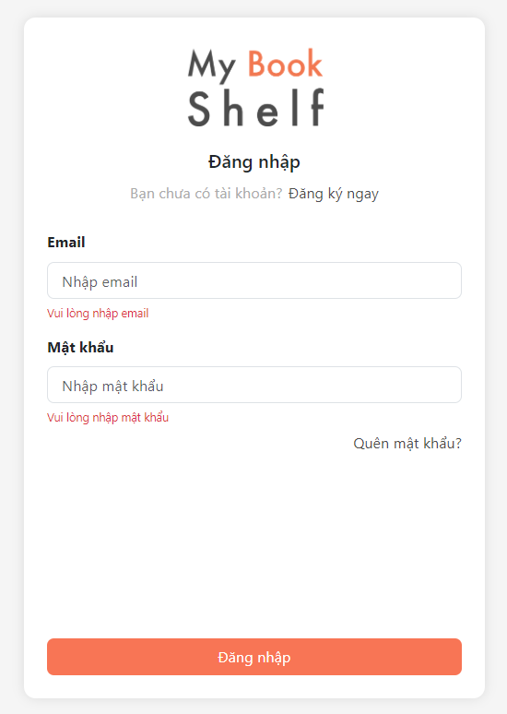

|  |
| --- |
|  |
|  |
|  |
|  |

* Function details:
* The system prompts the user to enter email and password
* The user enters email and password, the system validates the input after the user clicks “Đăng nhập”. If the email is associated with an account in the system and the password is correct with the entered email, the system lets the user login
* If a user does not have an account in the system, the user can click “Đăng ký” either at the Menu or login page. One the account is created; the user can consider logging in to the system with the created account. See “Login” use case.
* User forgets password: If the user forgets password, the user can click on “Quên mật khẩu” below the password field to reset password using the email which user used to create the account.

### 1.2 User Register

* Function trigger: This function is triggered when the guest goes to login and click “Đăng ký ngay” button to register
* Function description: Create an account.
* Screen layout:

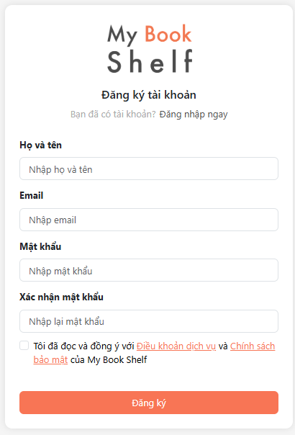

* Function details:
* This is a pop-up screen which allows the user to register himself/herself to the system by input following information: full name, email, password;
* User then needs to verify by clicking the link sent via email to him/her before being able to access the system.

### 1.3 Forgot Password

* Function Trigger: The user clicks the "Tạo lại mật khẩu" button after entering their email address.
* Function Detail: This function sends a otp code to the user's provided email address.
* Screen layout:

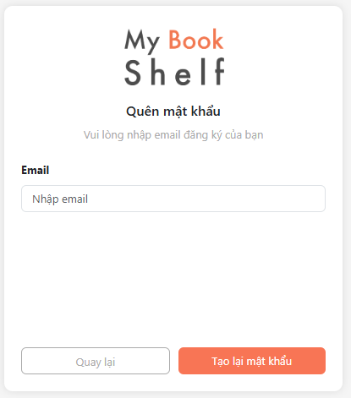

* Function Description:
* This function allows users to reset their password if they have forgotten it.
* The user enters their email address, and the system sends an email with a link to reset their password.
* The link typically leads to a page where the user can create a new password.

### 1.4 Reset Password

* Function trigger: User click “Tạo lại mật khẩu” in Forget password page
* Function description: User want reset password
* Screen layout:

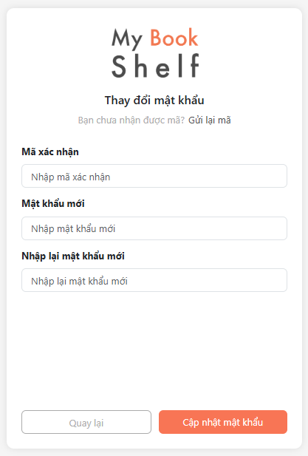

* Function detail:
* This function allows users to enter the OTP code sent via the previous user's email address and reset a new password.
* Click the "Tạo lại mật khẩu" button, if the otp code is checked correctly, the new password will be successfully set and redirected to the login page.

## 2. System Member

### 2.1 Home Page

* “My Book Shelf” in the browser
* Function description:
* Show all books including new books or books by category
* Screen layout:

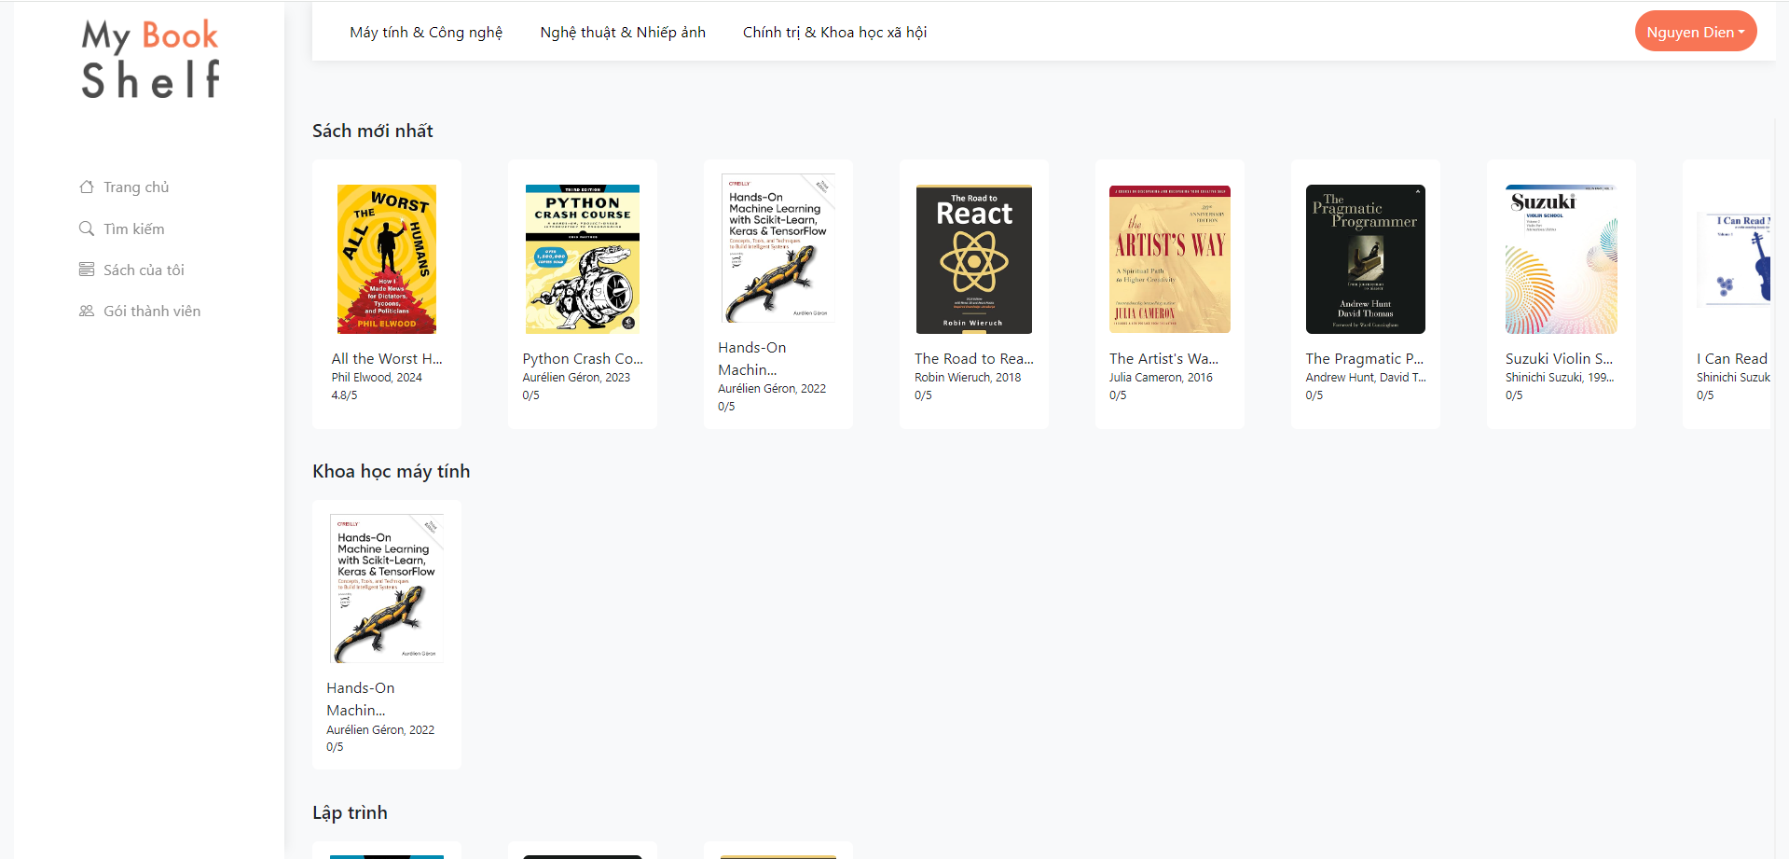

### 2.2 Search

* Function trigger: This use case starts when a user clicks the "Tìm kiếm" button on the homepage screen.
* Function description: User can search for books with search by title or filter by category.
* Screen layout:

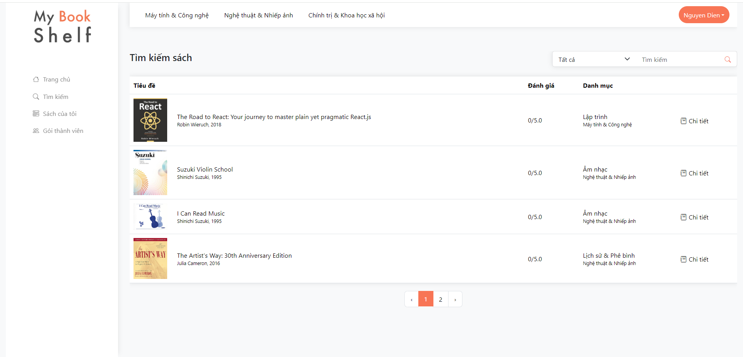

### 2.3 Book Details

* Function Trigger: View details of a book
* Function Detail:
* Users click on a book on the home page or click the "Chi tiết" button on the search page and details of a book will appear.
* Screen Layout:

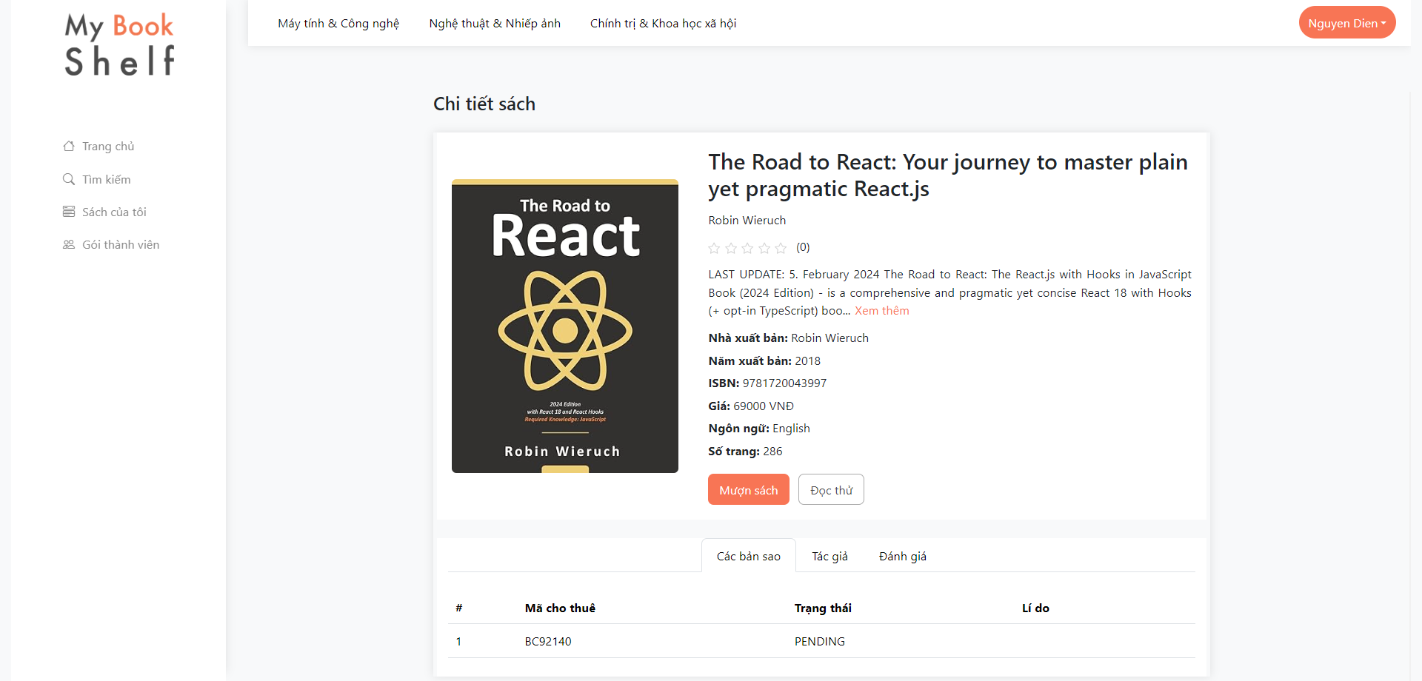

### 2.4 Review Book

* Function Trigger: The user clicks the "Gửi" button after writing a review and rating the book.
* Function Detail: This function saves the user's review and rating to the database and updates the book's overall rating.
* Screen Layout:

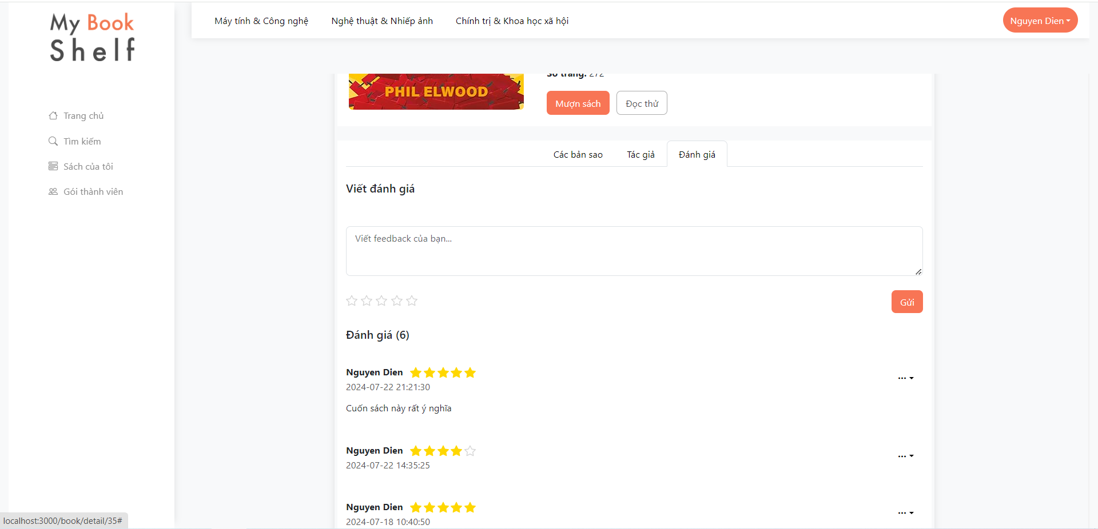

* Function Description: This function allows users to provide feedback on a book they have read. The user can write a text review and give a star rating. The system then saves this information and updates the book's average rating. This helps other users get a better understanding of the book's quality and content.

### 2.5 Borrow Book

* Function Trigger: User clicks the "Lưu thay đổi" button after filling in the information on the form.
* Function Description: Checks the validity of user input (borrow at, return at) for borrowing.
* Screen Layout:

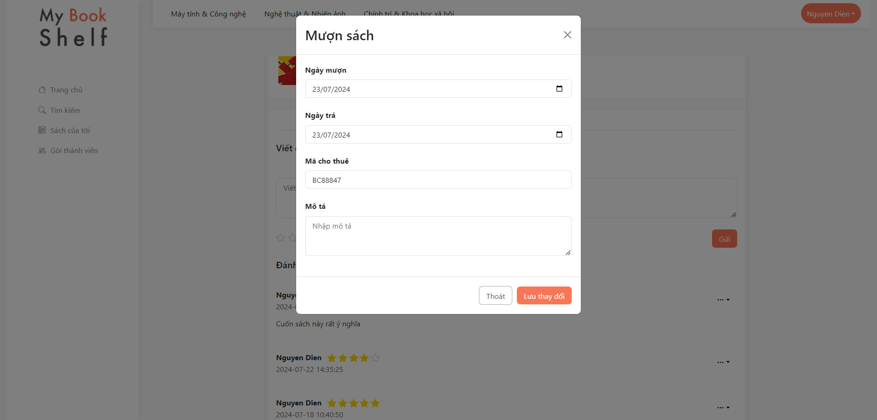

* Function Detail:
* Retrieves information from the input fields on the form.
* Checks if required fields are filled.
* If the information is valid, send a request to the librarian to confirm permission to borrow the book
* If the information is invalid, it displays an error message to the user.

### 2.6 Return Book

* Function Trigger: User clicks the "Trả sách" button.
* Screen Layout:

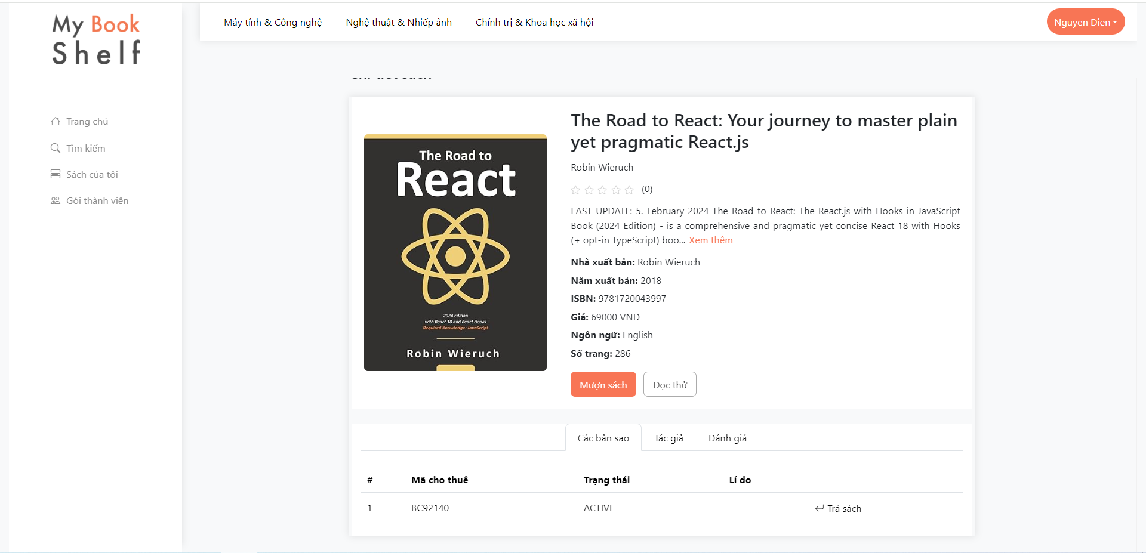

* Function Detail:
* The user clicks the "Return Book" button to ask the librarian to confirm that the book is returning.

### 2.7 Manage rented books

* Function Trigger: User clicks the "Sách của tôi" button.
* Function Description: Users can view books that have been rented
* Screen Layout:

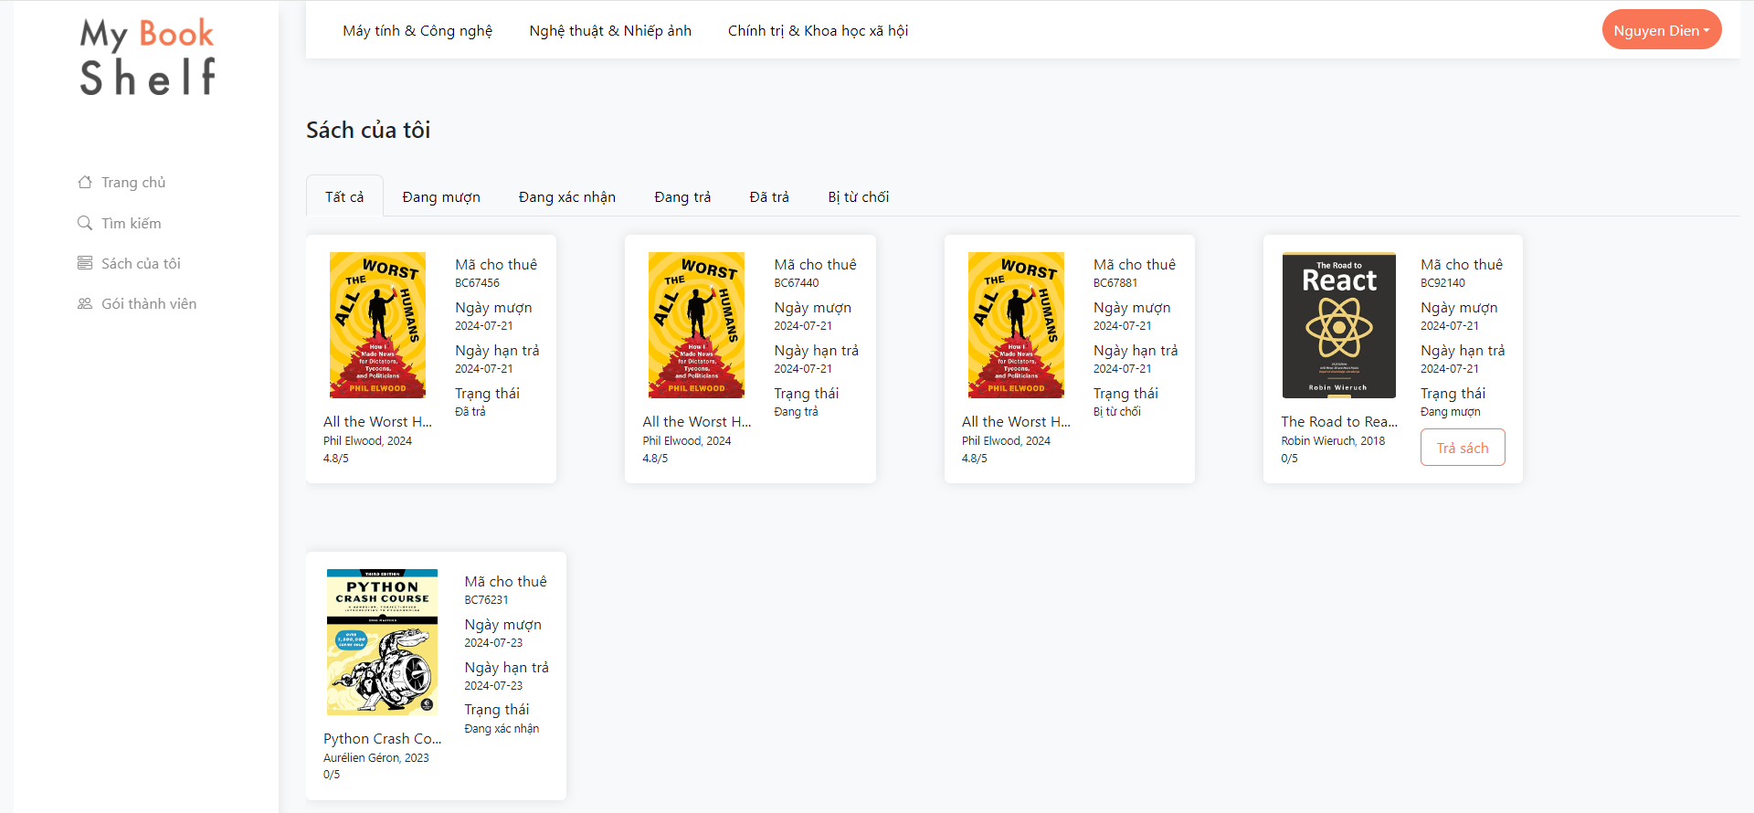

* Function Detail:
* Users can know the status of a book they have rented.
* Users can click "Trả sách" to send a request to the librarian to return the books

### 2.8 Registration Membership

* Function Trigger: User clicks the "Gói thành viên" button.
* Function Description: Users are given membership packages that they can choose to purchase.
* Screen Layout:

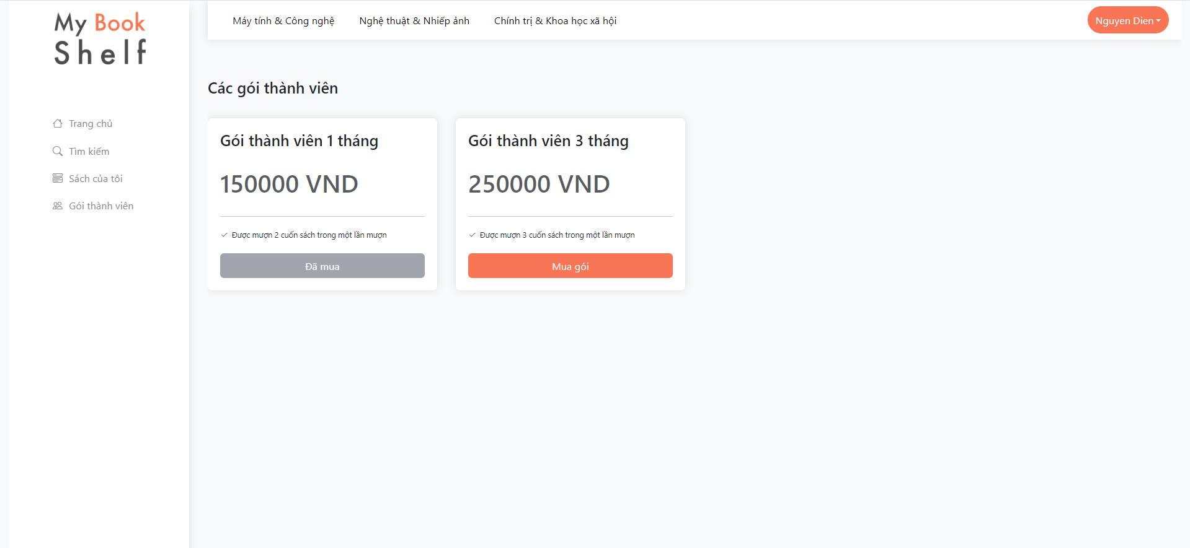

* Function Detail:
* Users are required to purchase a package before they can borrow books and enjoy the benefits of the package.

### 2.9 Update information

* Function Trigger: The user clicks the "Thông tin người dùng" button on the top nav.
* Function Description: Users update their personal information.
* Screen Layout:

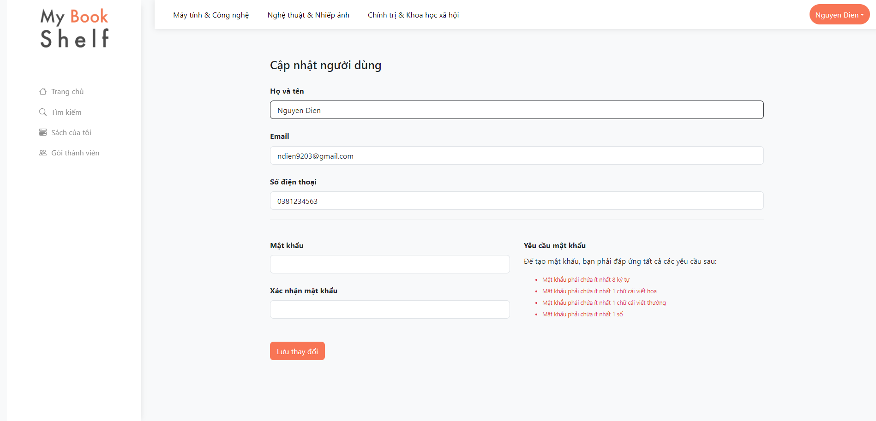

* Function Detail:
* Users can update only their information or password or both

## 3. System Administration

### 3.1 Manage Members and Librarian

#### 3.1.1 Manager Members and Librarians

This is for the administrator to manage member and librarian. On the screen, s/he can also add or update member or librarian as s/he wants.

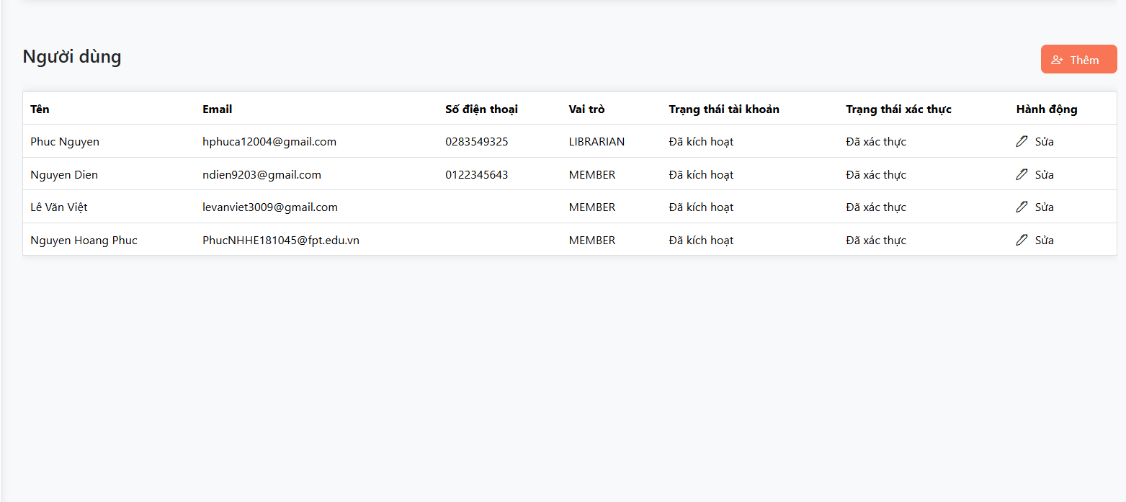

#### 3.1.2 Add User

* Function Trigger: The user (possibly an administrator) clicks the "Lưu thay đổi " button at the bottom of the form.
* Function Description: Adds a new user to the system with the information provided in the form.

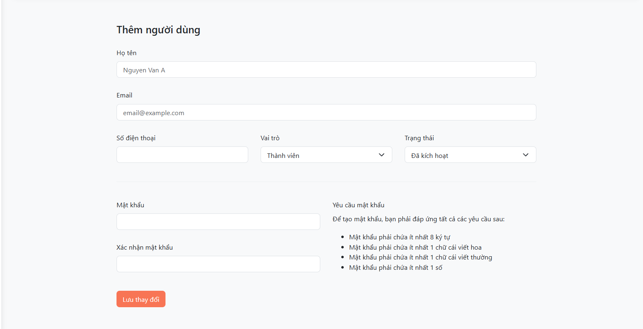

* Function Details:
* Data Collection:
* Get information from the input fields: Full Name, Email, Phone Number, Role.
* Validate the data:
  + Full Name cannot be empty.
  + Email must be in a valid format.
  + Phone Number must be in a valid format (if applicable).
  + Roles must be selected.
* Data Processing:
  + Hash the password (if there is a password field).
  + Create a new user record in the database with the collected information.
* Notification:
  + Display a success message to the user.
  + Optionally redirect the user to the user list page or the details page of the newly created user.
* Error Handling:
  + If any errors occur during the process (e.g., invalid data, database connection error), display an appropriate error message to the user.

#### 3.1.3 Edit User

* Function Trigger: Admin clicks the "Sửa" (Edit) button next to a user's information.
* Function Description: Allows the admin to modify the user's details, such as name, email, phone number, or role.

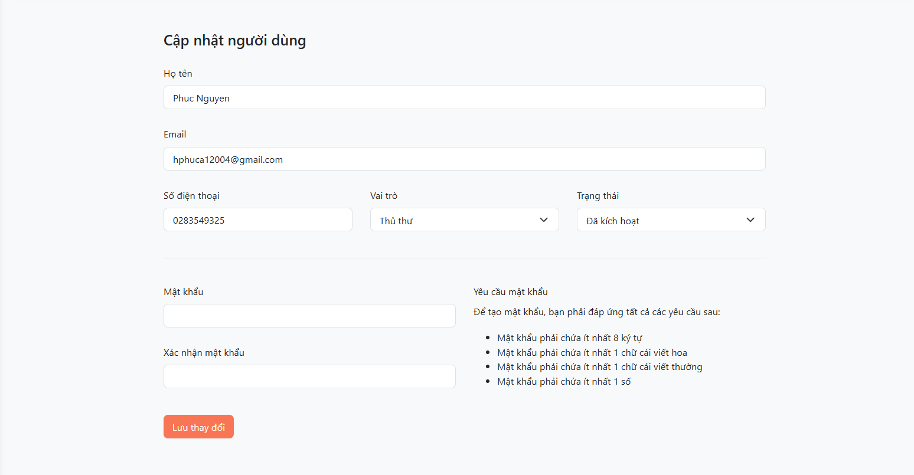

* Function Details:
* Retrieve the user ID associated with the clicked button.
* Fetch the user's current information from the database.
* Display an edit form pre-filled with the user's data.
* Validate and save the updated information to the database upon submission.

### 3.2 Dashboard

* Function Trigger : The function is triggered when a admin accesses the dashboard page in the library management system's user interface.
* Function Description: To fetch and display statistics related to borrowing and returning requests, approvals, rejections, and user statistics.
* Screen Layout:

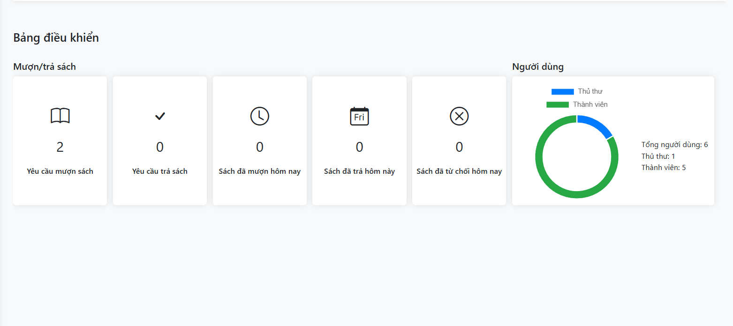

* Function Details:
* The dashboard provides an overview of the library's operational statistics, including book borrowing and returning requests, approved and rejected requests, and user statistics.
* It helps Admin manage and monitor library activities effectively.

## 4. System Librarian

### 4.1 Manage Categories

#### 4.1.1 Manage Categories List

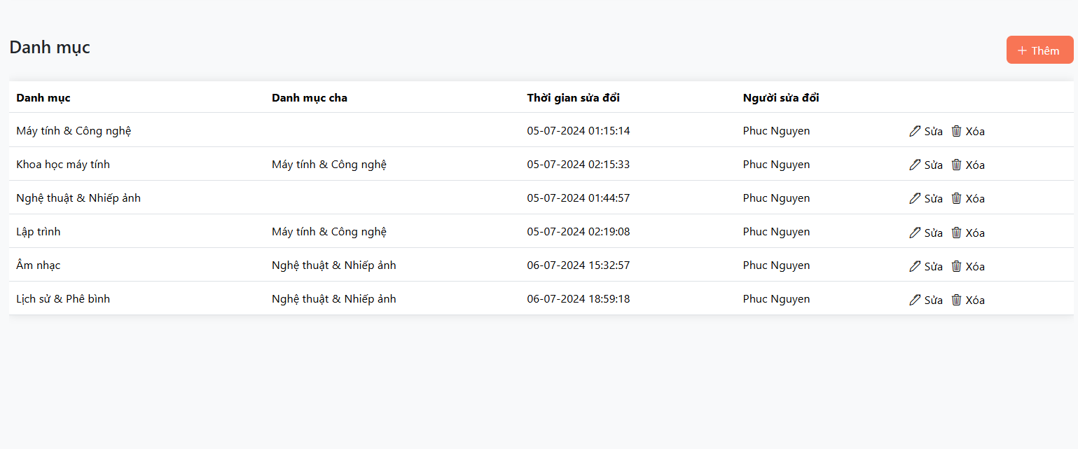

* Data Collection:
* Retrieve a list of all categories from the database.
* For each category, retrieve its parent category (if applicable).
* Retrieve the last modification timestamp for each category.
* Retrieve the user who last modified each category.
* Data Display:
* Display the list of categories in a table format.
* Include columns for:
* Category name
* Parent category name
* Last modification timestamp
* User who last modified the category
* Provide actions for each category:
* "Sửa" (Edit) button to allow users to modify the category's name and parent category.
* "Xóa" (Delete) button to allow users to delete the category.

#### 4.1.2 Add category

* Function Trigger: The user (possibly an administrator) clicks the "Lưu thay đổi" button after filling out the form.
* Function Description: Adds a new category to the system with the information provided in the form.

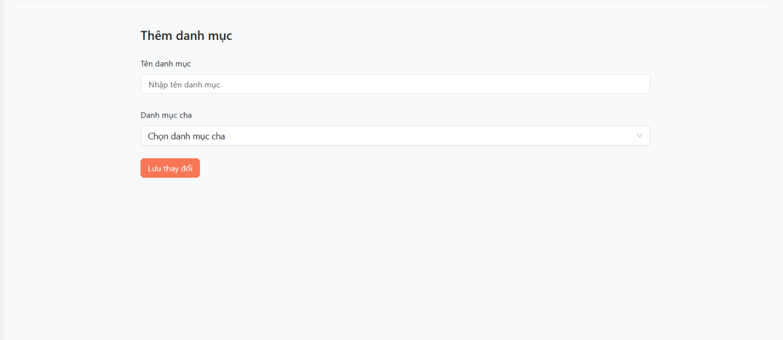

* Function Details:
* Data Collection:
* Get information from the input fields: Category Name, Category Description, Parent Category.
* Validate the data:
* Category Name cannot be empty and must be unique.
* Category Description can be empty.
* Parent Category can be empty (if it's a top-level category).
* Data Processing:
* Create a new category record in the database with the collected information.
* If a parent category is specified, establish a relationship between the new category and the parent category in the database.
* Notification:
* Display a success message to the user.
* Optionally redirect the user to the category list page or the details page of the newly created category.
* Error Handling:
* If any errors occur during the process (e.g., invalid data, database connection error), display an appropriate error message to the user.

#### 4.1.3 Edit category

* Function Trigger: The user clicks the "Lưu thay đổi" (Save Changes) button after modifying the category information.
* Function Description: Updates an existing category in the system with the new information provided in the form.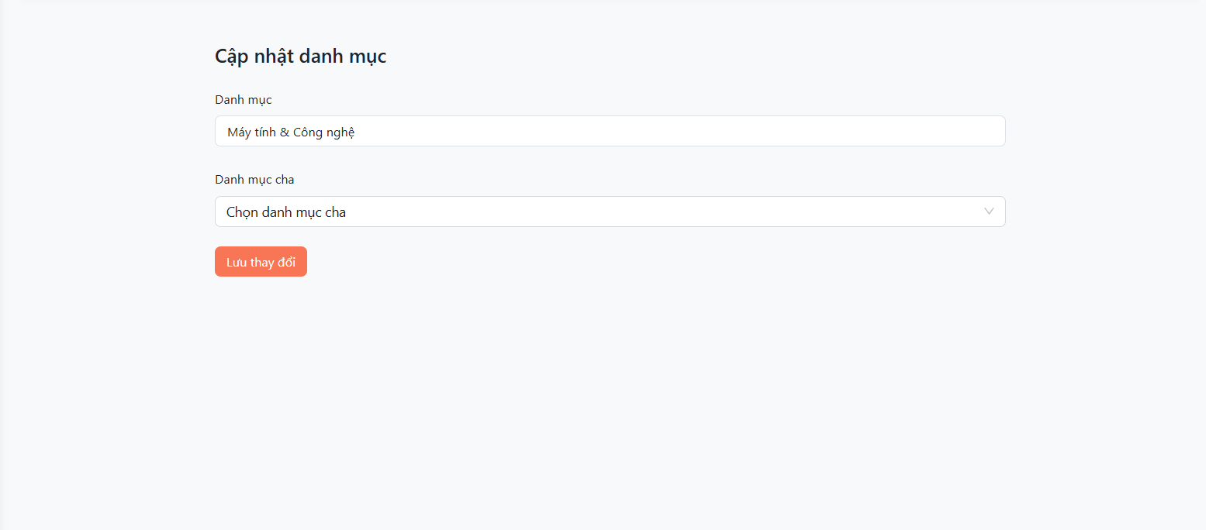
* Function Details:
* Data Collection: Get information from the input fields: Category Name, Category Description, Parent Category.
* Validate the data:
* Category Name cannot be empty and must be unique (excluding the current category being updated).
* Category Description can be empty.
* Parent Category can be empty (if it's a top-level category) or a valid existing category.
* Data Processing:
* Identify the category to be updated (likely based on a hidden ID field or passed through the URL).
* Retrieve the existing category data from the database.
* Update the category record in the database with the new information.
* If the Parent Category has changed, update the relationship between the category and its parent in the database.
* Notification:
* Display a success message to the user ("Category updated successfully!").
* Optionally redirect the user to the category list page or the updated category's detail page.
* Error Handling:
* If any errors occur during the process (e.g., invalid data, database connection error), display an appropriate error message to the user.

#### 4.1.3 Delete category

* Function Trigger: The user clicks the "Xóa" (Delete) button next to a category, which then opens a confirmation dialog. The function is executed when the user clicks the "Lưu thay đổi" (Save Changes) button in the confirmation dialog.
* Function Description: Deletes an existing category from the system.

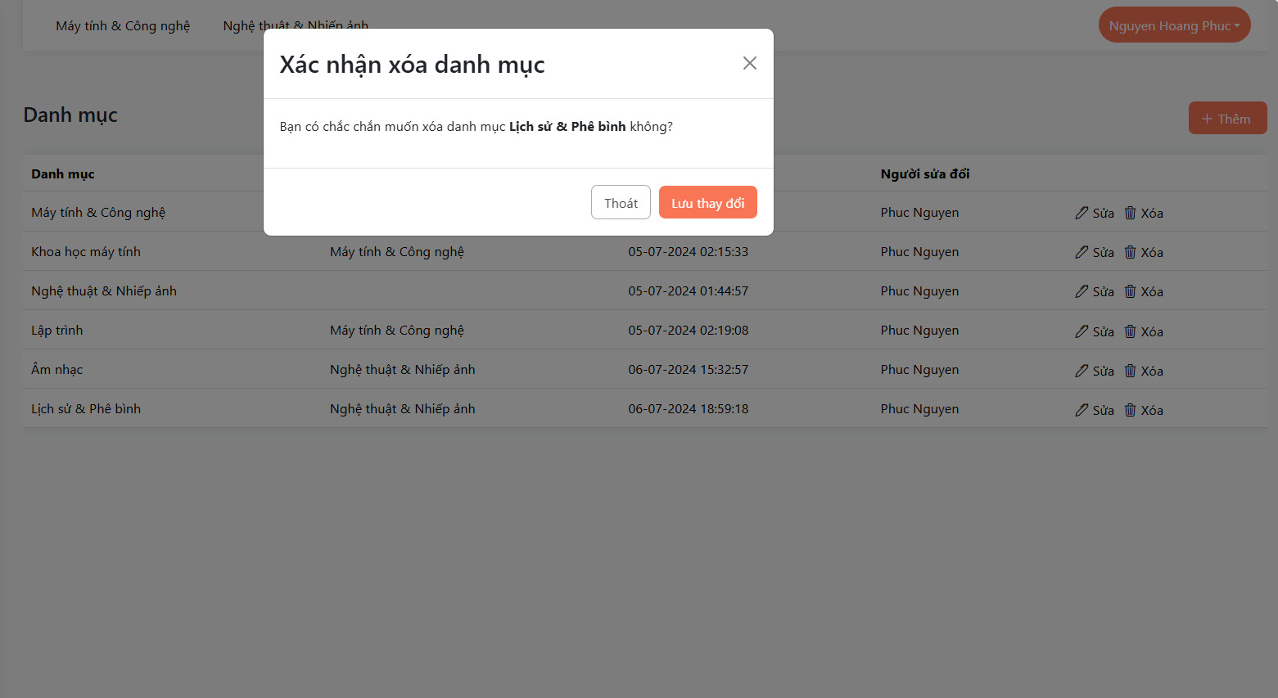

* Function Details:
* Confirmation:
* When the user clicks the "Xóa" (Delete) button, a confirmation dialog appears asking the user to confirm the deletion.
* The dialog may display a warning message about the consequences of deleting the category (e.g., it may affect associated products or subcategories).
* Data Processing:
* If the user confirms the deletion, the system identifies the category to be deleted (likely based on a hidden ID field or passed through the URL).
* The system checks for dependencies:
* If the category has subcategories or associated products, the system may either prevent the deletion or provide options to handle these dependencies (e.g., move subcategories to a different parent category, delete associated products).
* If there are no dependencies, the system proceeds with the deletion.
* The system deletes the category record from the database.
* Notification:
* Display a success message to the user ("Danh mục đã được xóa thành công").
* Refresh the category list to reflect the changes.
* Error Handling:
* If any errors occur during the process (e.g., database connection error, dependencies cannot be resolved), display an appropriate error message to the user.

### 4.2 Manage Authors

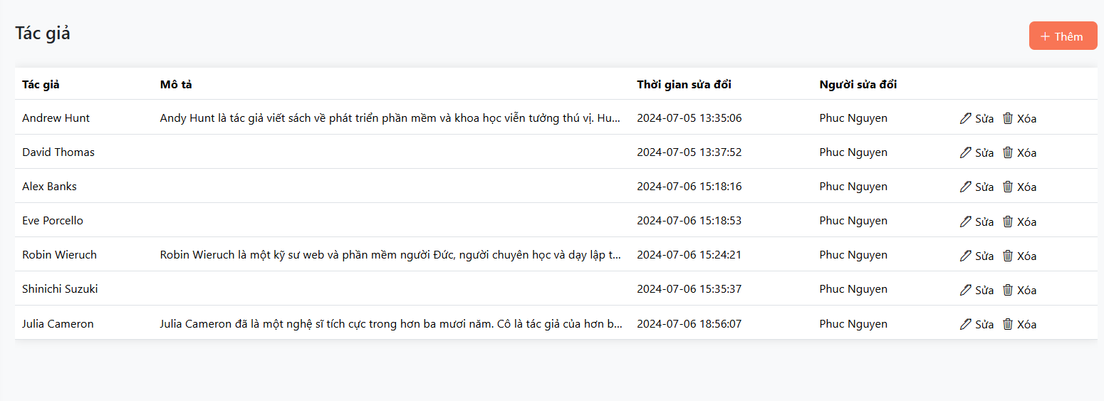

* Data Collection:
* Retrieve a list of all authors from the database.
* For each author, retrieve their description.
* Retrieve the last modification timestamp for each author.
* Retrieve the user who last modified each author.
* Data Display:
* Display the list of authors in a table format.
* Include columns for:
* Author name
* Author description
* Last modification timestamp
* User who last modified the author
* Provide actions for each author:
* "Sửa" (Edit) button to allow users to modify the author's description.
* "Xóa" (Delete) button to allow users to delete the author.

#### 4.2.1 Add author

* Function Trigger: The user clicks the "Lưu thay đổi" (Save Changes) button after filling out the form.
* Function Description: Adds a new author to the system with the information provided in the form.

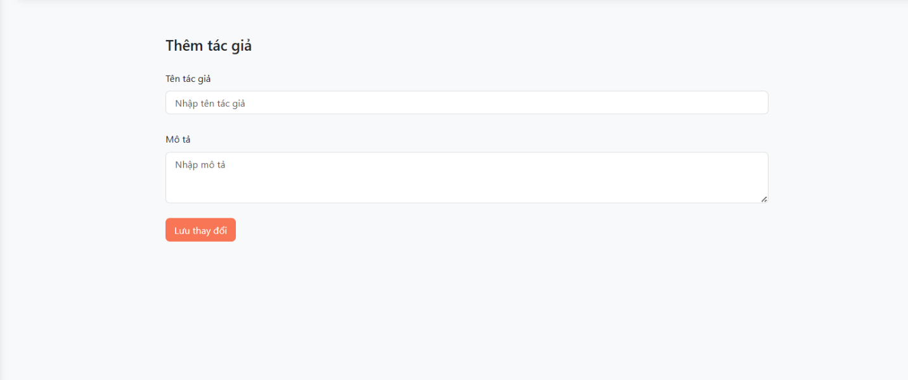

* Function Details:
* Data Collection:
* Get information from the input fields:
* Tên tác giả (Author Name)
* Nhiều hơn về tác giả (More about the author) - This seems to be a free-text field for additional details.
* Validate the data:
* Author Name cannot be empty.
* Consider adding validation for the "More about the author" field, depending on the specific requirements (e.g., length restrictions, allowed characters).
* Data Processing:
* Create a new author record in the database with the collected information.
* Notification:
* Display a success message to the user ("Author added successfully!").
* Optionally redirect the user to the author list page or the newly created author's detail page.
* Error Handling:
* If any errors occur during the process (e.g., invalid data, database connection error), display an appropriate error message to the user.

#### 4.2.2 Edit author

* Function Trigger: The user clicks the "Lưu thay đổi" (Save Changes) button after modifying the author information.
* Function Description: Updates an existing author in the system with the new information provided in the form.

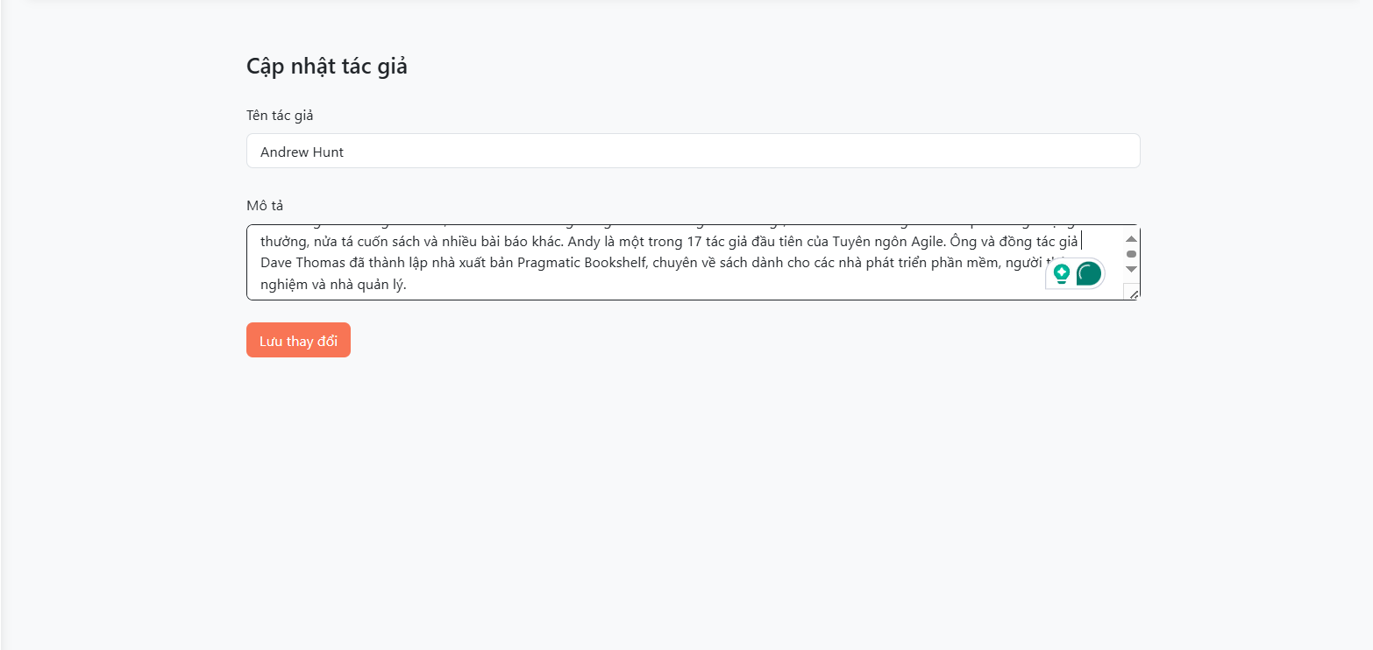

* Function Details:
* Data Collection:

Get information from the input fields:

Tên tác giả (Author Name)

Nhiều hơn về tác giả (More about the author)

* Validate the data:
* Author Name cannot be empty.
* Consider adding validation for the "More about the author" field, depending on the specific requirements (e.g., length restrictions, allowed characters).
* Data Processing:
* Identify the author to be updated (likely based on a hidden ID field or passed through the URL).
* Retrieve the existing author data from the database.
* Update the author record in the database with the new information.
* Notification:
* Display a success message to the user ("Cập nhật tác giả thành công!").
* Optionally redirect the user to the author list page or the updated author's detail page.
* Error Handling:
* If any errors occur during the process (e.g., invalid data, database connection error), display an appropriate error message to the user.

#### 4.2.3 Delete author

* Function Trigger: The user clicks the "Xóa" (Delete) button next to an author's name, which opens a confirmation dialog. The function is executed when the user clicks the "Lưu thay đổi" (Save Chnages) button in the confirmation dialog.
* Function Description: Deletes an existing author from the system.

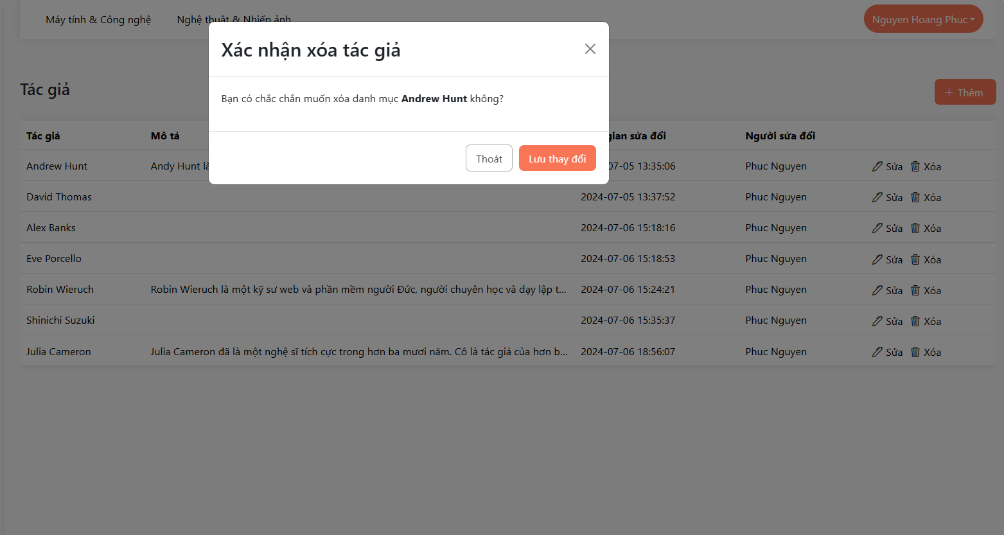

* Function Details:
* Confirmation:
* When the user clicks the "Xóa" (Delete) button, a confirmation dialog appears asking the user to confirm the deletion ("Bạn có chắc chắn muốn xóa tác giả [Author Name] không?").
* The dialog may display a warning message about the consequences of deleting the author (e.g., it may affect associated books).
* Data Processing:
* If the user confirms the deletion, the system identifies the author to be deleted (likely based on a hidden ID field or passed through the URL).
* The system checks for dependencies:
* If the author has associated books, the system may either prevent the deletion or provide options to handle these dependencies (e.g., reassign books to a different author, delete associated books).
* If there are no dependencies, the system proceeds with the deletion.
* The system deletes the author record from the database.
* Notification:
* Display a success message to the user ("Tác giả đã được xóa thành công!").
* Refresh the author list to reflect the changes.
* Error Handling:
* If any errors occur during the process (e.g., database connection error, dependencies cannot be resolved), display an appropriate error message to the user.

### 4.3 Manage Books

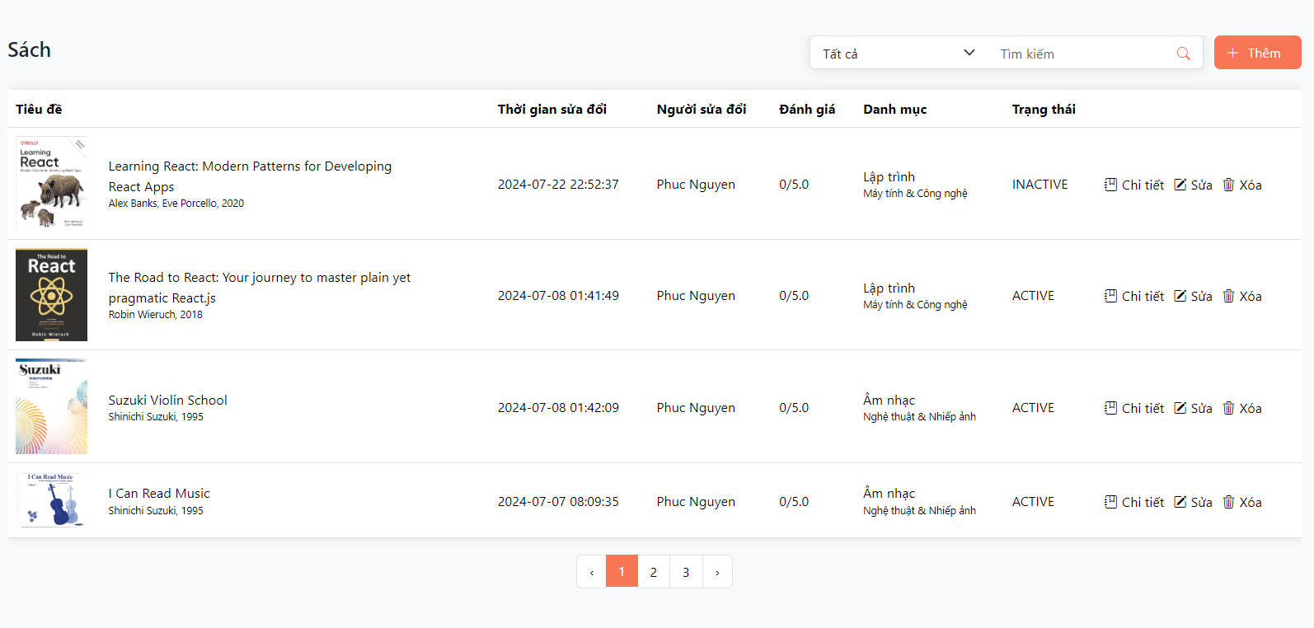

* Data Collection:
* Retrieve a list of all books from the database.
* For each book, retrieve its title, cover image, author(s), publication date, category, - rating, availability, and last modification timestamp.
* Retrieve the user who last modified each book.
* Data Display:
* Display the list of books in a table format.
* Include columns for:
* Book title (with cover image)
* Last modification timestamp
* User who last modified the book
* Book rating
* Book category
* Book availability
* Book status (e.g., "ACTIVE", "INACTIVE")
* Provide actions for each book:
* "Chi tiết" (Details) button to navigate to the book's detail page.
* "Sửa" (Edit) button to allow users to modify the book's information.
* "Xóa" (Delete) button to allow users to delete the book.

#### 4.3.1 Add book

* Function Trigger: The user clicks the "Lưu Thay Đổi" (Save Changes) button after filling out the form.
* Function Description: Adds a new book to the system with the information provided in the form.

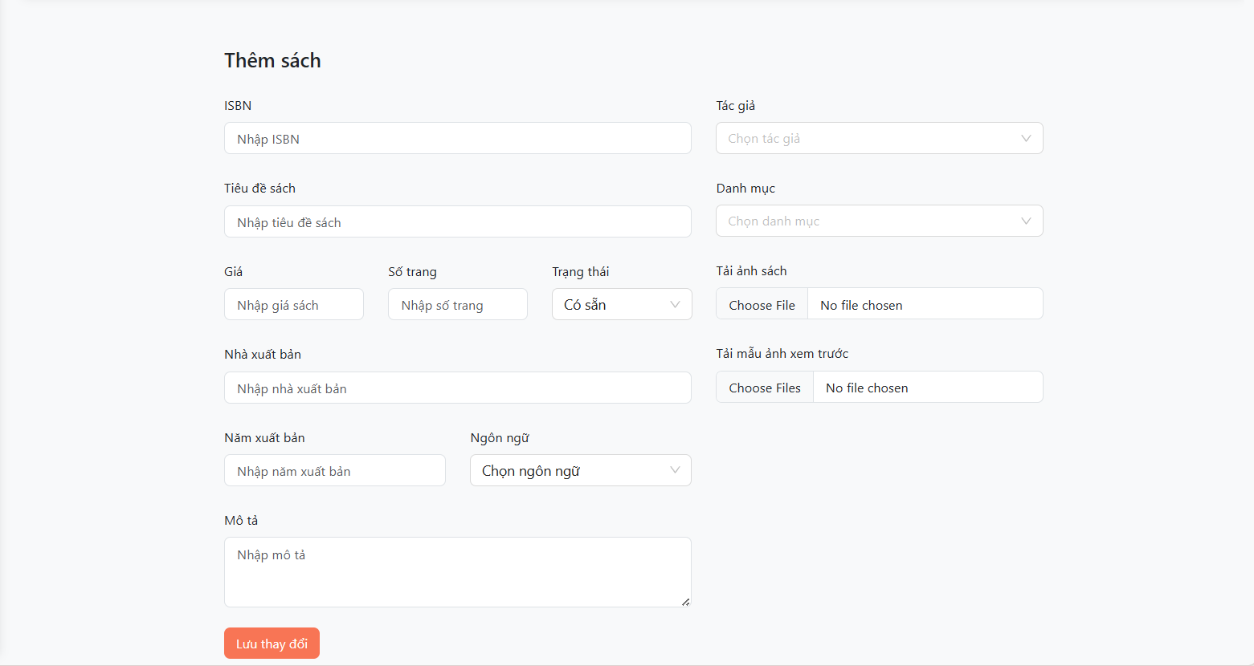

* Function Details:
* Validate the data:
* ISBN, Book Title, Author, Category, Price, and Quantity are required fields.
* ISBN should be unique and in a valid format (e.g., ISBN-10 or ISBN-13).
* Price and Quantity should be numeric values.
* Image and Attached Documents (if provided) should be valid file types and sizes.
* Data Processing:
* Store the book information in the database.
* Create a new record in the "books" table (or equivalent).
* Store the file paths or references for the uploaded Image and Attached Documents.
* Notification:
* Display a success message to the user ("Thêm sách thành công!").
* Optionally redirect the user to the book list page or the newly created book's detail page.
* Error Handling:
* If any errors occur during validation or data processing (e.g., invalid data, database connection error, file upload failure), display an appropriate error message to the user.

#### 4.3.2 Edit book

* Function Trigger: The user clicks the "Lưu Thay Đổi" (Save Changes) button after modifying the book information in the form.
* Function Description: Updates an existing book's information in the system based on the changes made in the form.

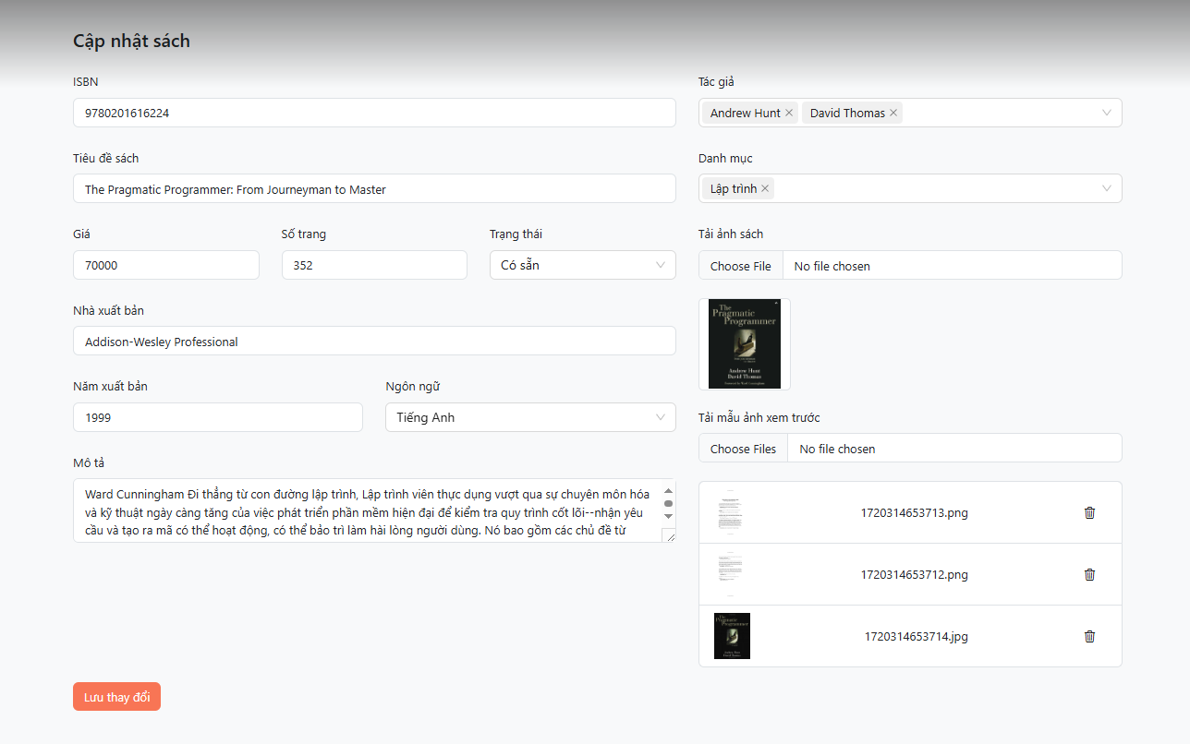

* Function Details:
* Data Validation:
* ISBN should be a valid format and match the existing book's ISBN.
* Book Title, Author, Category, Price, and Quantity are required fields.
* Price and Quantity should be numeric values.
* Image and Attached Documents (if provided) should be valid file types and sizes.
* Data Processing:
* Update the book information in the database.
* Update the corresponding record in the "books" table (or equivalent) using the ISBN as the primary key.
* If the Author or Category has been changed, update the corresponding records in the respective tables.
* Update the file paths or references for the uploaded Image and Attached Documents (if any).
* Optionally, remove old files if they are replaced with new ones.
* Notification:
* Display a success message to the user ("Cập nhật sách thành công").
* Optionally redirect the user to the book list page or the updated book's detail page.
* Error Handling:
* If any errors occur during validation or data processing (e.g., invalid data, database connection error, file upload failure), display an appropriate error message to the user.

#### 4.3.3 Delete book

* Function Trigger: The user clicks the "Lưu thay đổi" button on the confirmation modal after selecting the "Xóa" button on the book list.
* Function Description: Deletes a book from the system based on the user's confirmation.

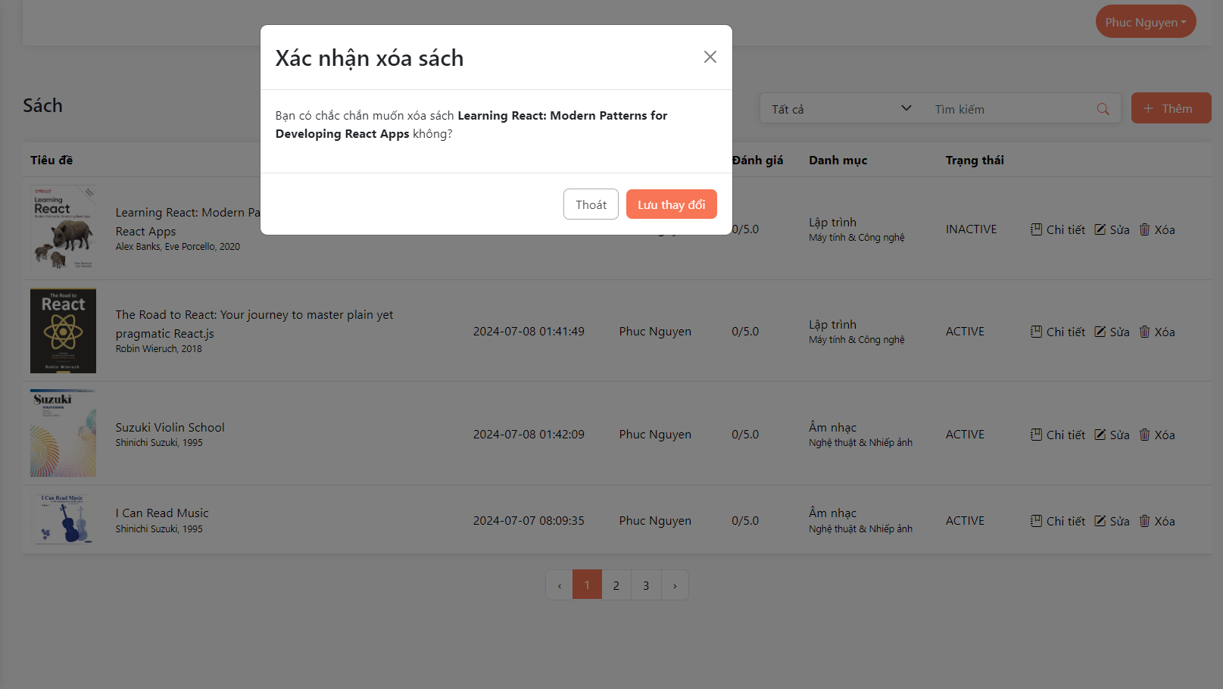

* Function Details:
* Data Collection: Get the book's ID (or ISBN) from the book list entry where the "Xóa" button was clicked.
* Data Validation: None, as the system should already have validated the book ID when displaying the book list.
* Data Processing:
* Delete the book record from the database.
* Delete the corresponding record in the "books" table (or equivalent) using the book's ID (or ISBN) as the primary key.
* Optionally, delete associated files (cover image, attached documents) if the system is configured to do so.
* Notification:
* Remove the deleted book from the book list displayed on the page.
* Optionally, display a success message to the user ("Xóa sách thành công!").
* Error Handling:
* If any errors occur during data processing (e.g., database connection error, file deletion failure), display an appropriate error message to the user.

### 4.4 Manage Request Borrow Book

* Function Trigger : The function is triggered by a click event on either the "Chấp nhận" or "Từ chối" button associated with a borrow book request in the library management system's user interface.
* Function Description: To process borrow book requests by either accepting or rejecting them and providing appropriate feedback to the member.
* Screen Layout:

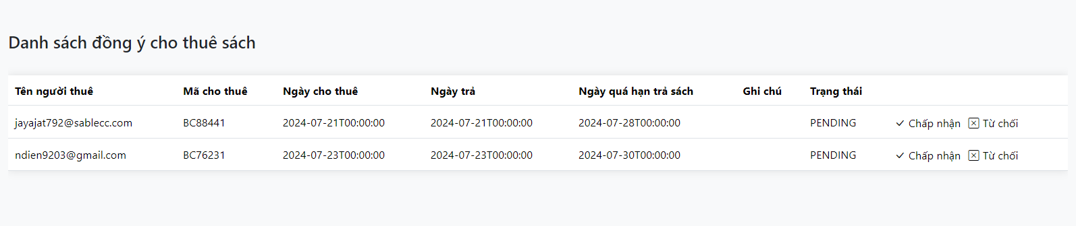

* Function Details:
* The borrow book request management function allows librarian to either accept or reject a member's request to borrow a book.
* Upon acceptance, the member is permitted to borrow the requested book.
* If the request is rejected, the librarian must provide a reason for the rejection, which is then communicated to the member.

### 4.5 Manage Request Return Book

* Function Trigger : The function is triggered by a click event on the "Accept" button associated with a return book request in the library management system's user interface.
* Function Description: To process return book requests by accepting them and providing appropriate feedback to the member.
* Screen Layout:

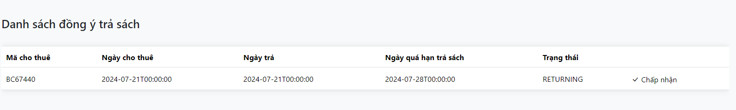

* Function Details:
* The return book request management function allows librarian to either accept a member's request to return a book.
* Upon acceptance, the member is permitted to return the borrowed book.

### 4.6 CRUD Membership Package

* Function Trigger : The function is triggered by user actions in the library management system's user interface, such as creating a new membership package, viewing details of a package, updating a package, or deleting a package.
* Function Description: To handle CRUD operations for membership packages, including specifying benefits for each package.
* Screen Layout:

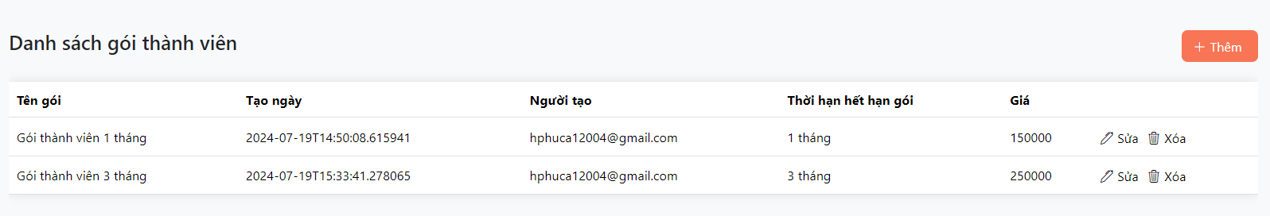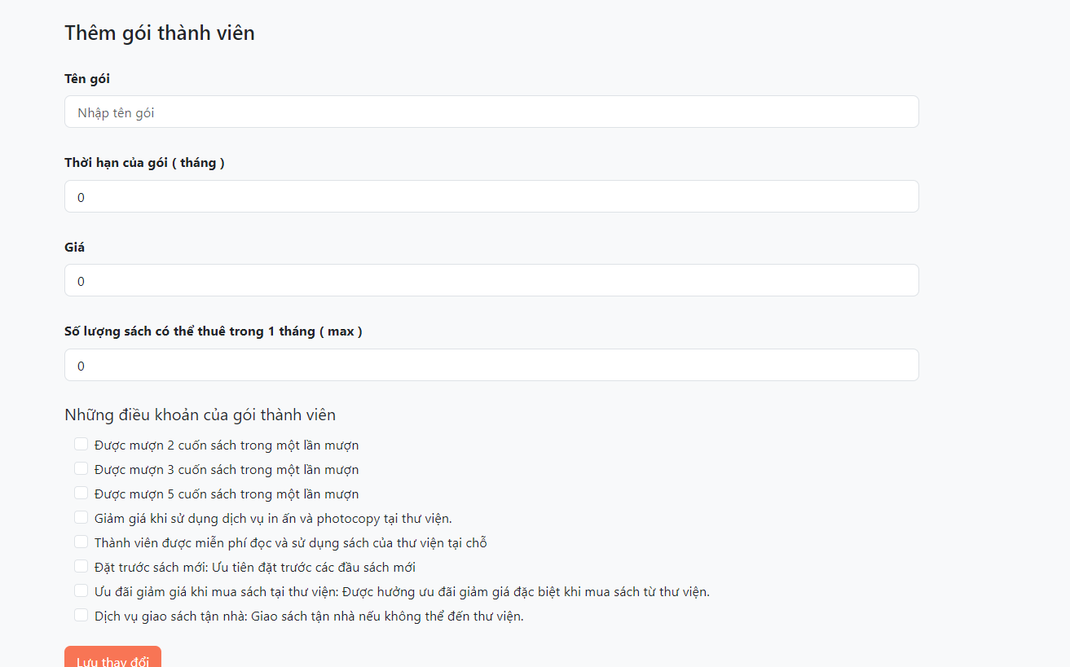

* Function Details:
* The CRUD membership package function allows librarian to create, read, update, and delete membership packages.
* Each package includes specific benefits suitable for different subscription tiers

### 4.7 Dashboard

* Function Trigger : The function is triggered when a librarian accesses the dashboard page in the library management system's user interface.
* Function Description: To fetch and display statistics related to borrowing and returning requests, approvals, rejections, and user statistics.
* Screen Layout:

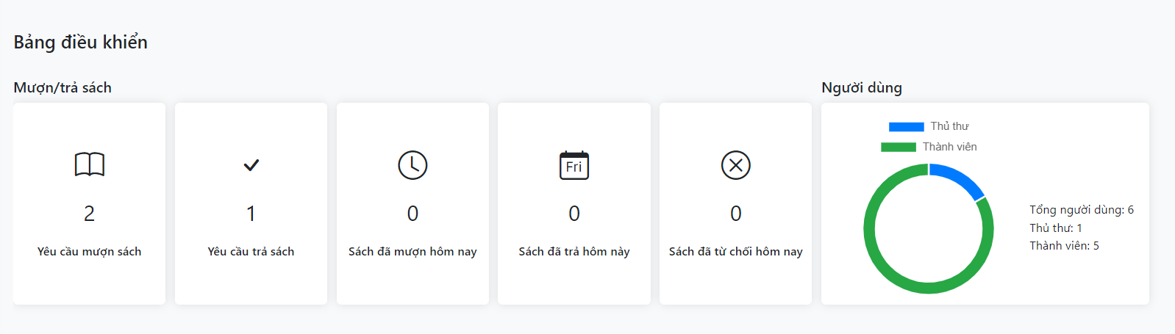

* Function Details:
* The dashboard provides an overview of the library's operational statistics, including book borrowing and returning requests, approved and rejected requests, and user statistics.
* It helps librarians manage and monitor library activities effectively.

# IV. Detailed Designs

## 1. Login

### 1.1 Class Diagram

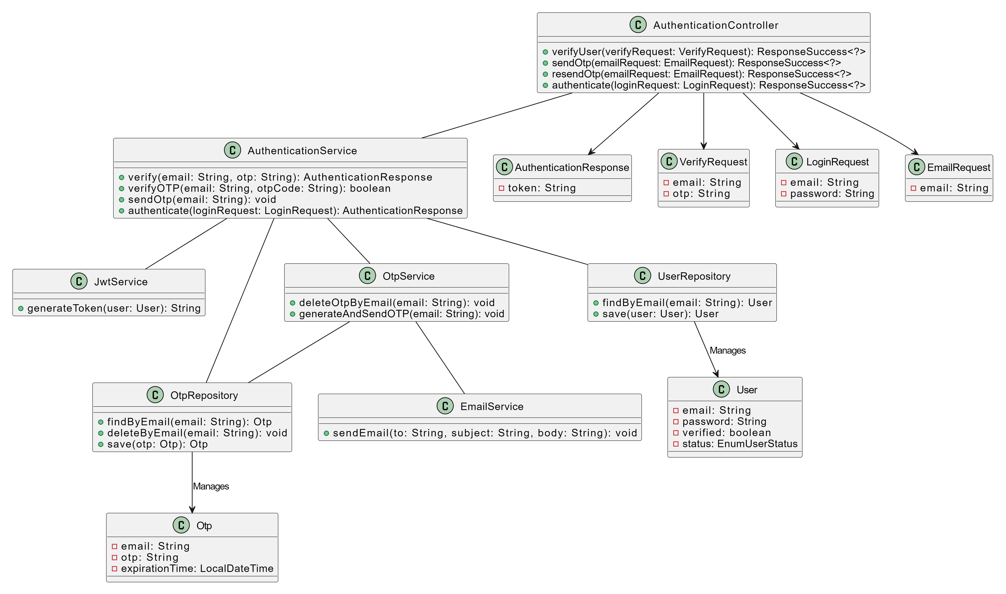

### 1.2 Sequence Diagram(s)

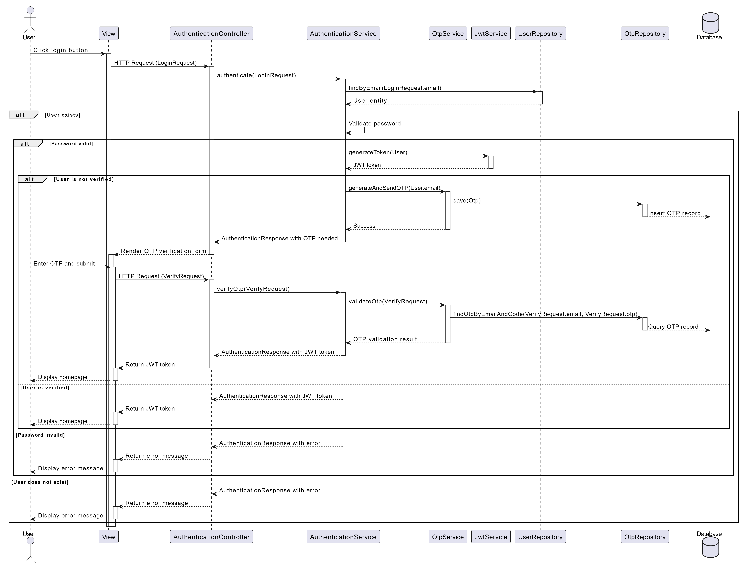

### nn1.3 Database Queries

* Find User by Email and Password: SELECT email, password, verified, status FROM users WHERE email = ? AND password = ?;
* Check if User is Verified: SELECT verified FROM users WHERE email = ?;
* Check if User is Active : SELECT status FROM users WHERE email = ?;

## 2. Register

### 2.1 Class Diagram

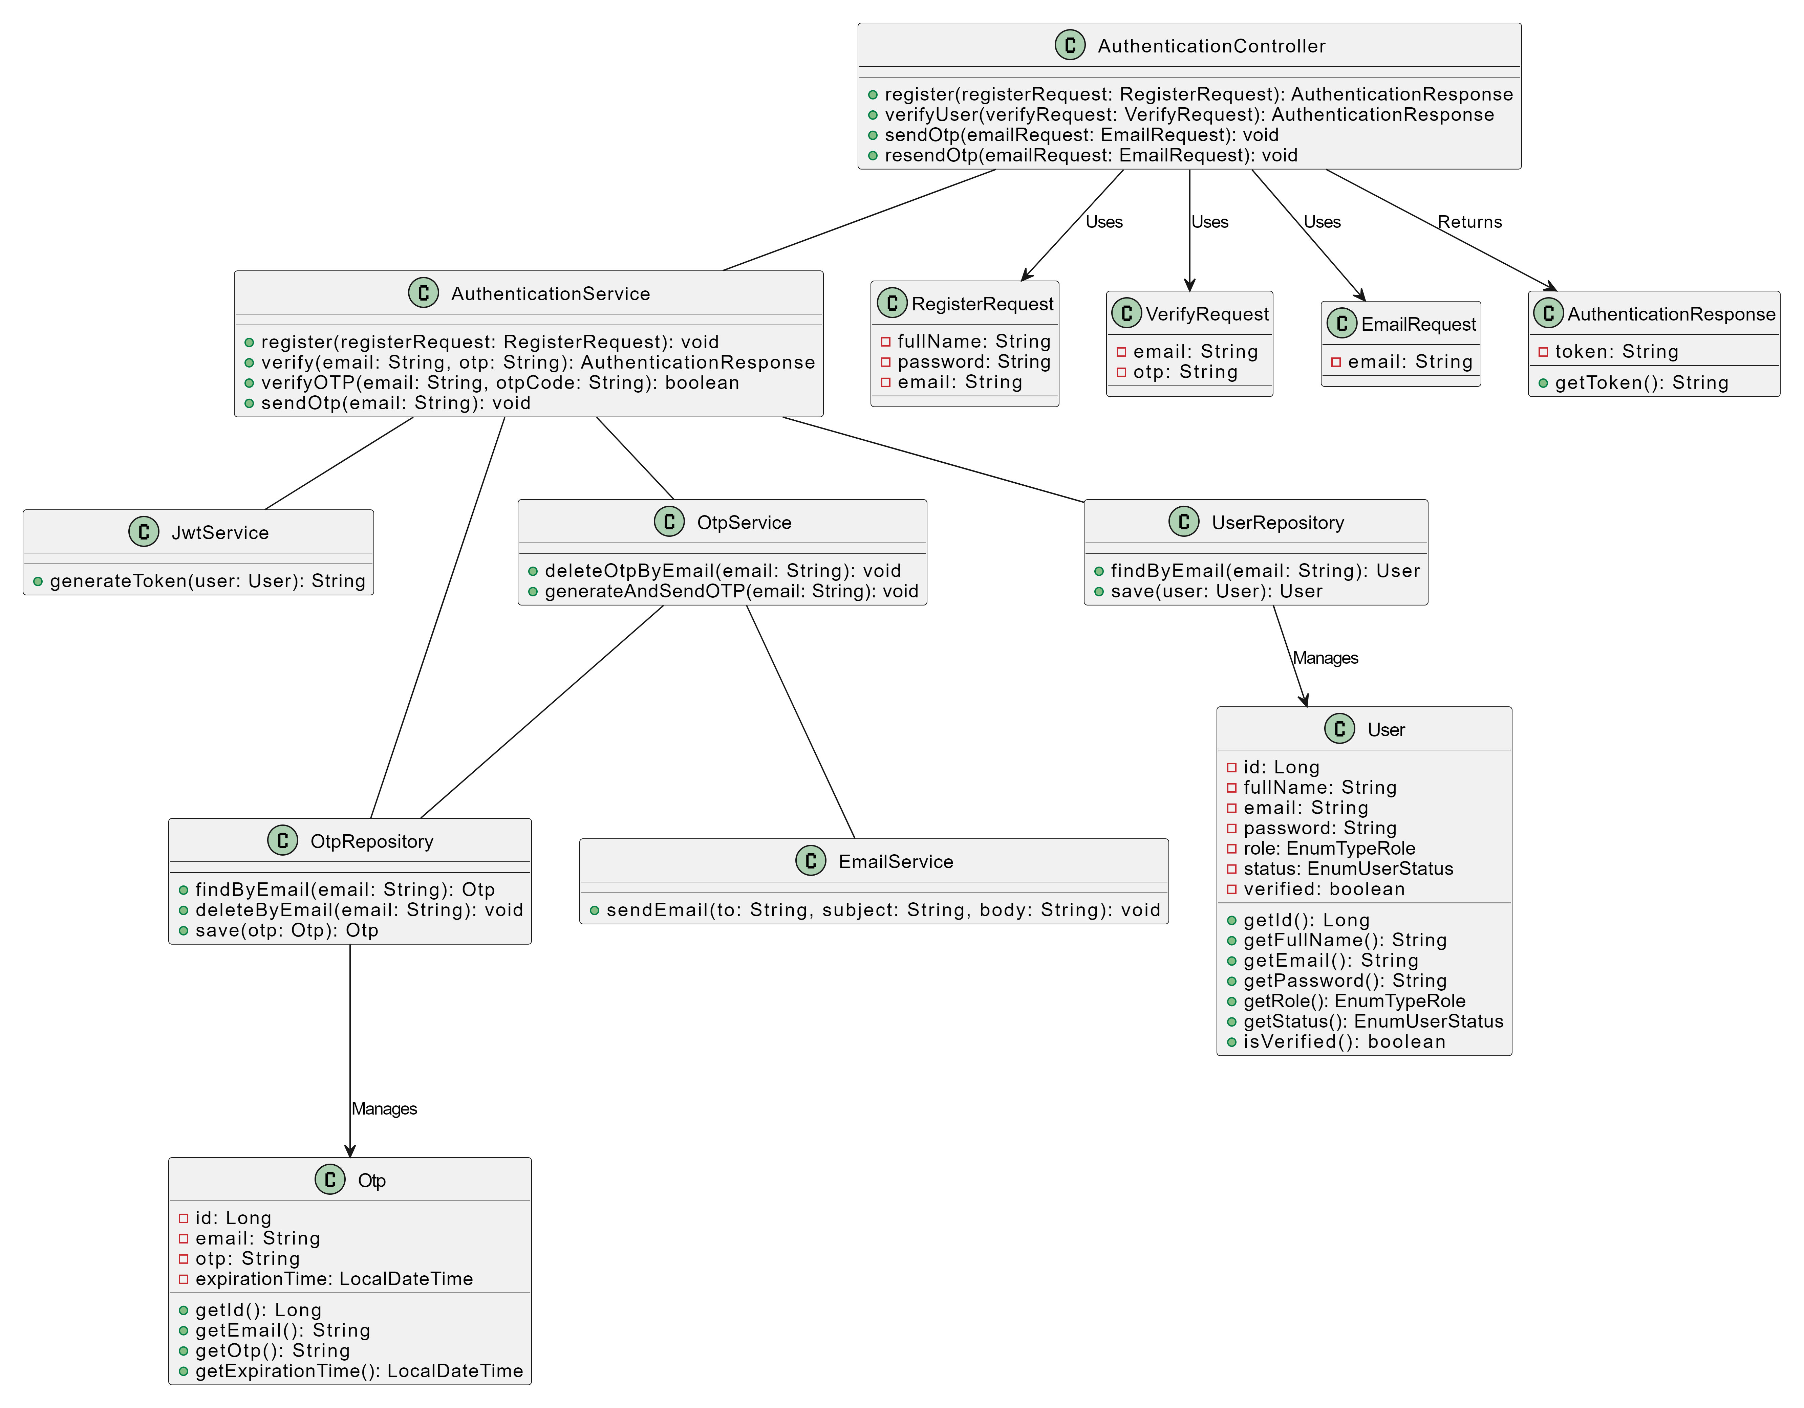

### 2.2 Sequence Diagram

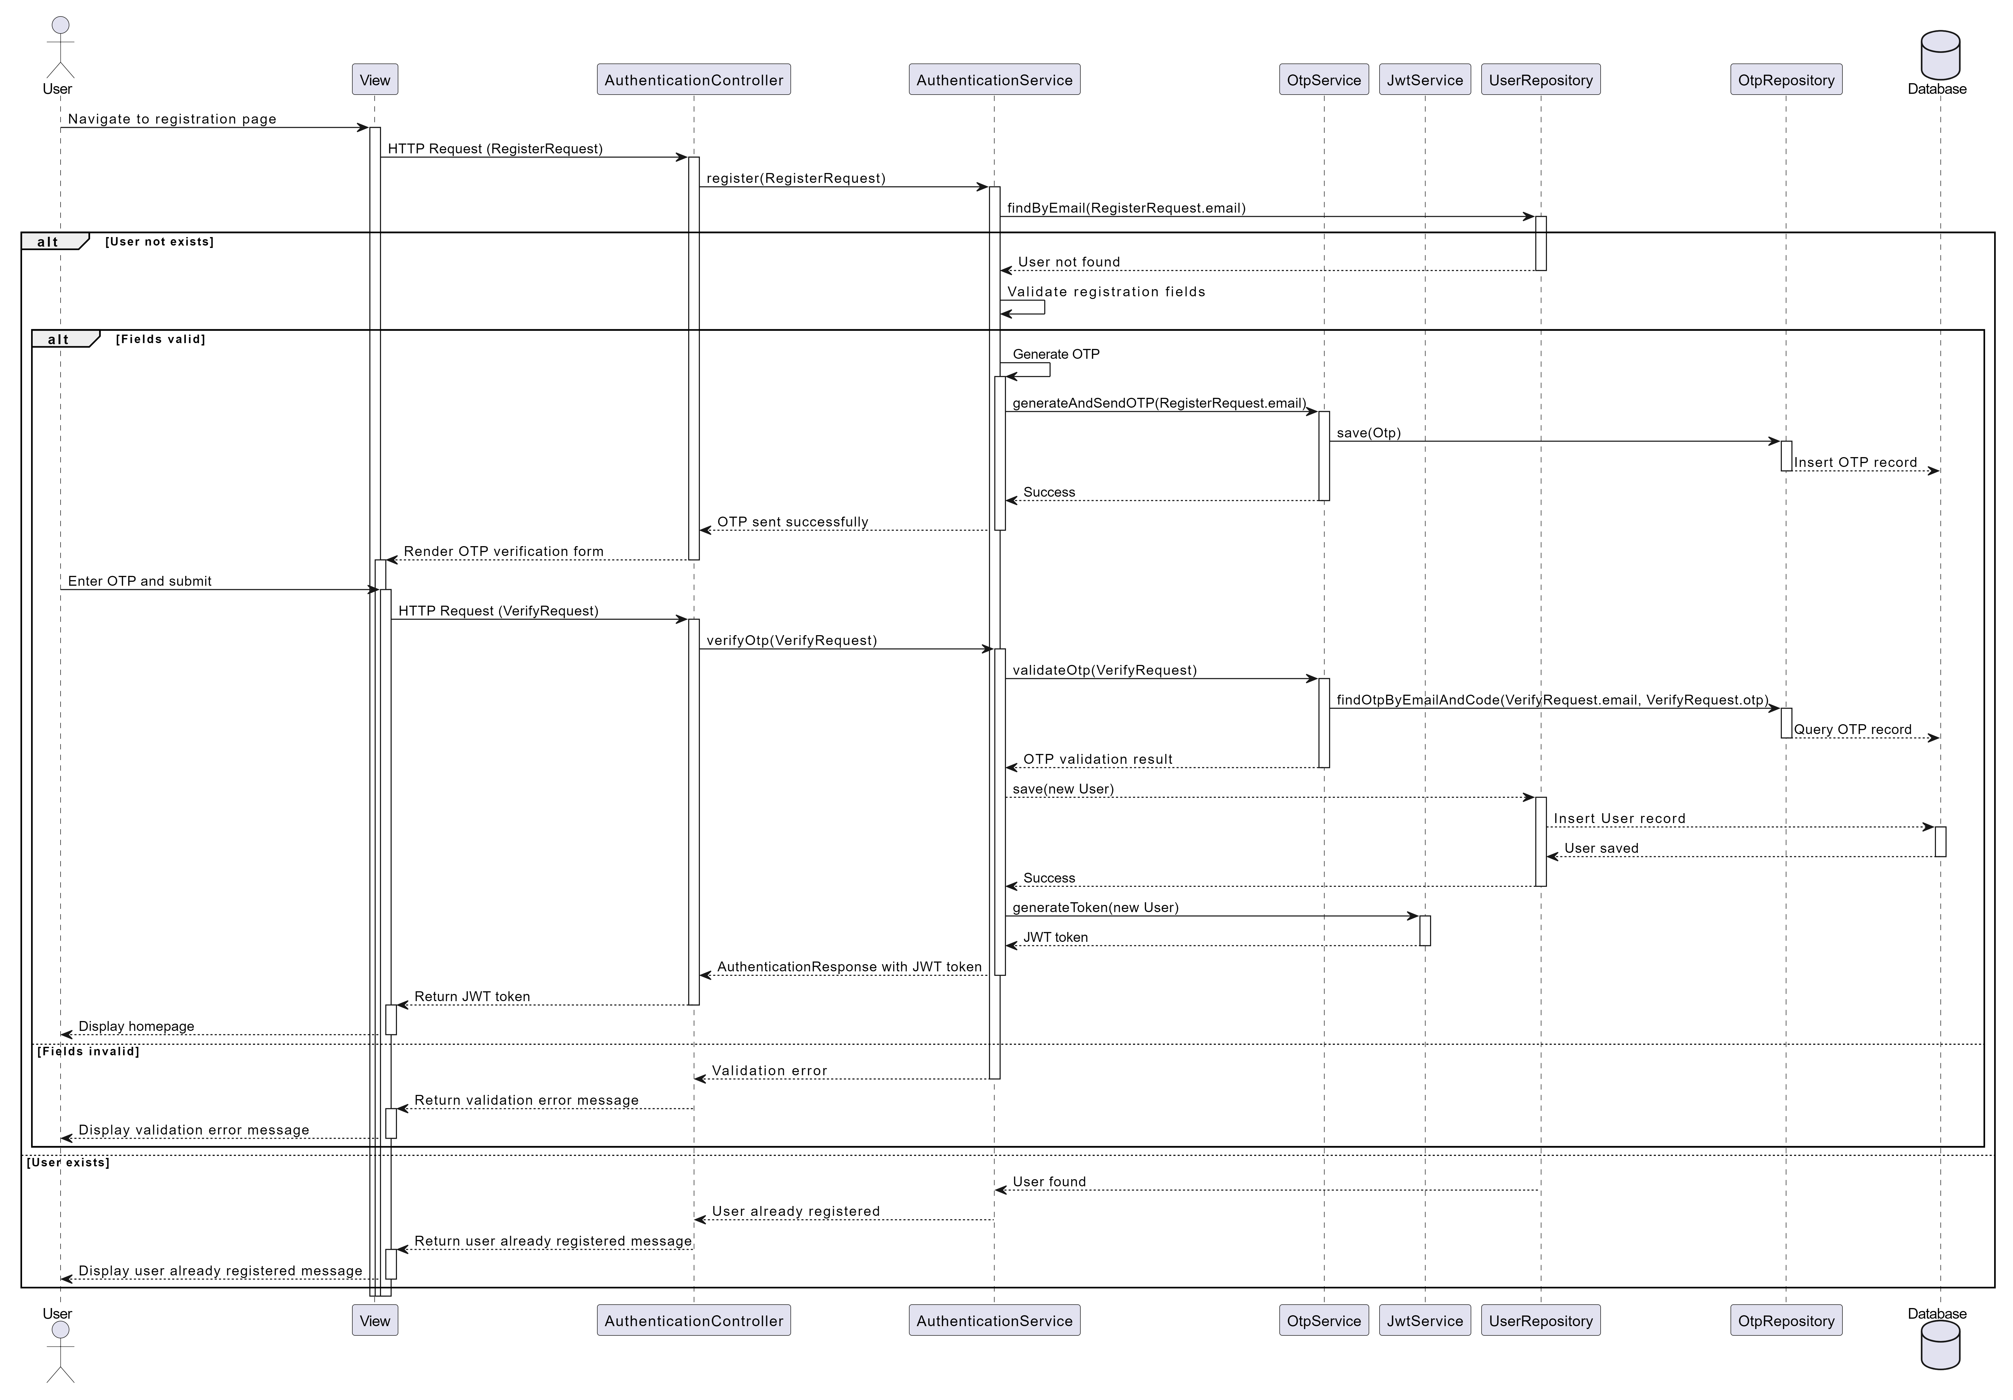

### 2.3 Database queries

* Query to check if a user with the specified email already exists: SELECT * FROM users WHERE email = :email;
* Query to insert a new user into the users table: INSERT INTO users (full_name, email, password, role, status, verified) VALUES (:fullName, :email, :password, :role, :status, :verified);

## 3. Reset password

### 3.1 Class Diagram

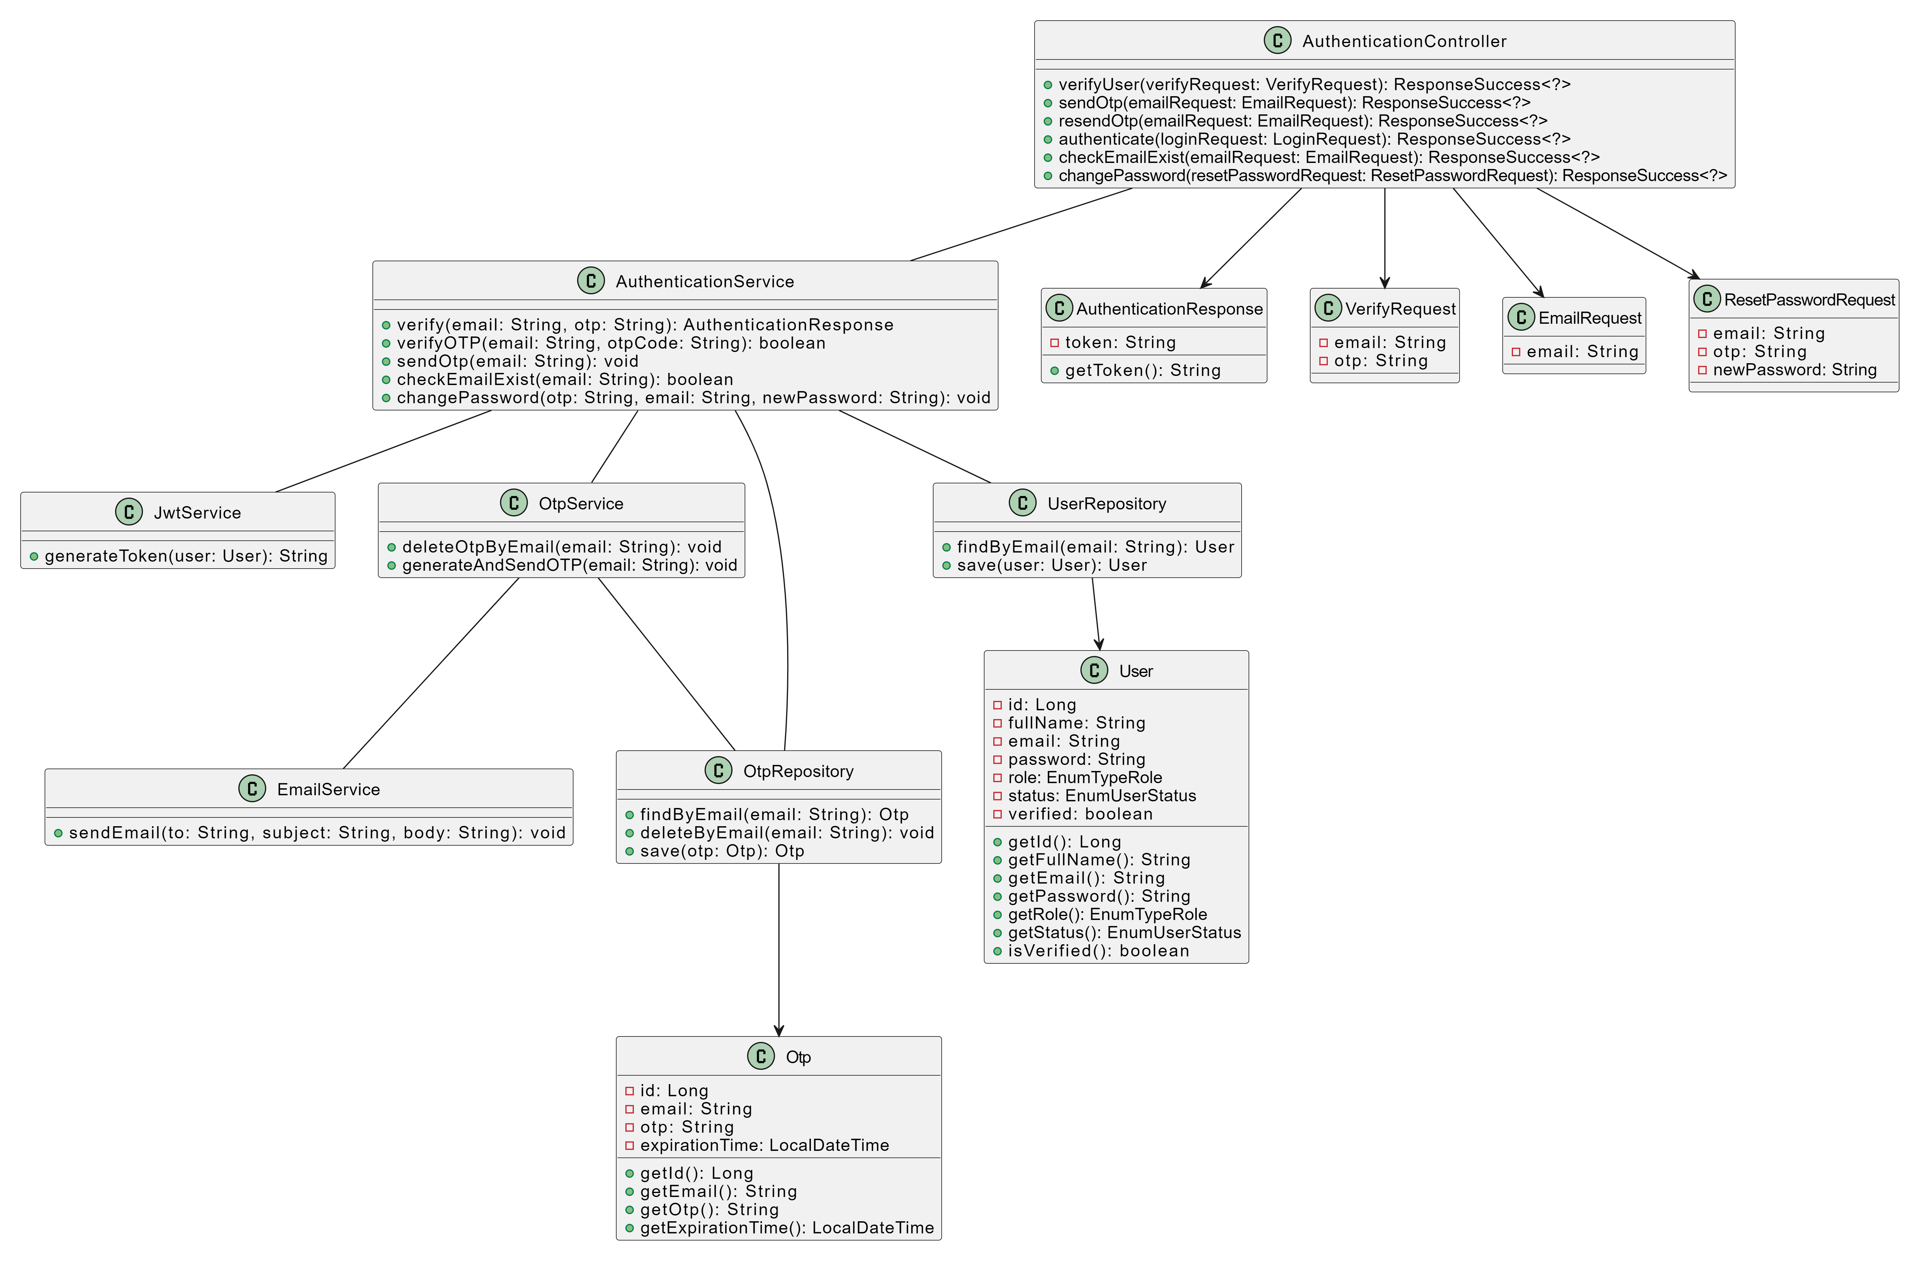

### 3.2 Sequence Diagram

### 

### 3.3 Database queries

* Check if the email exists in the user table: SELECT * FROM User WHERE email = ?;
* Update the user's password: UPDATE User SET password = ? WHERE email = ?;

## 4. Add Author

### 4.1 Class Diagram

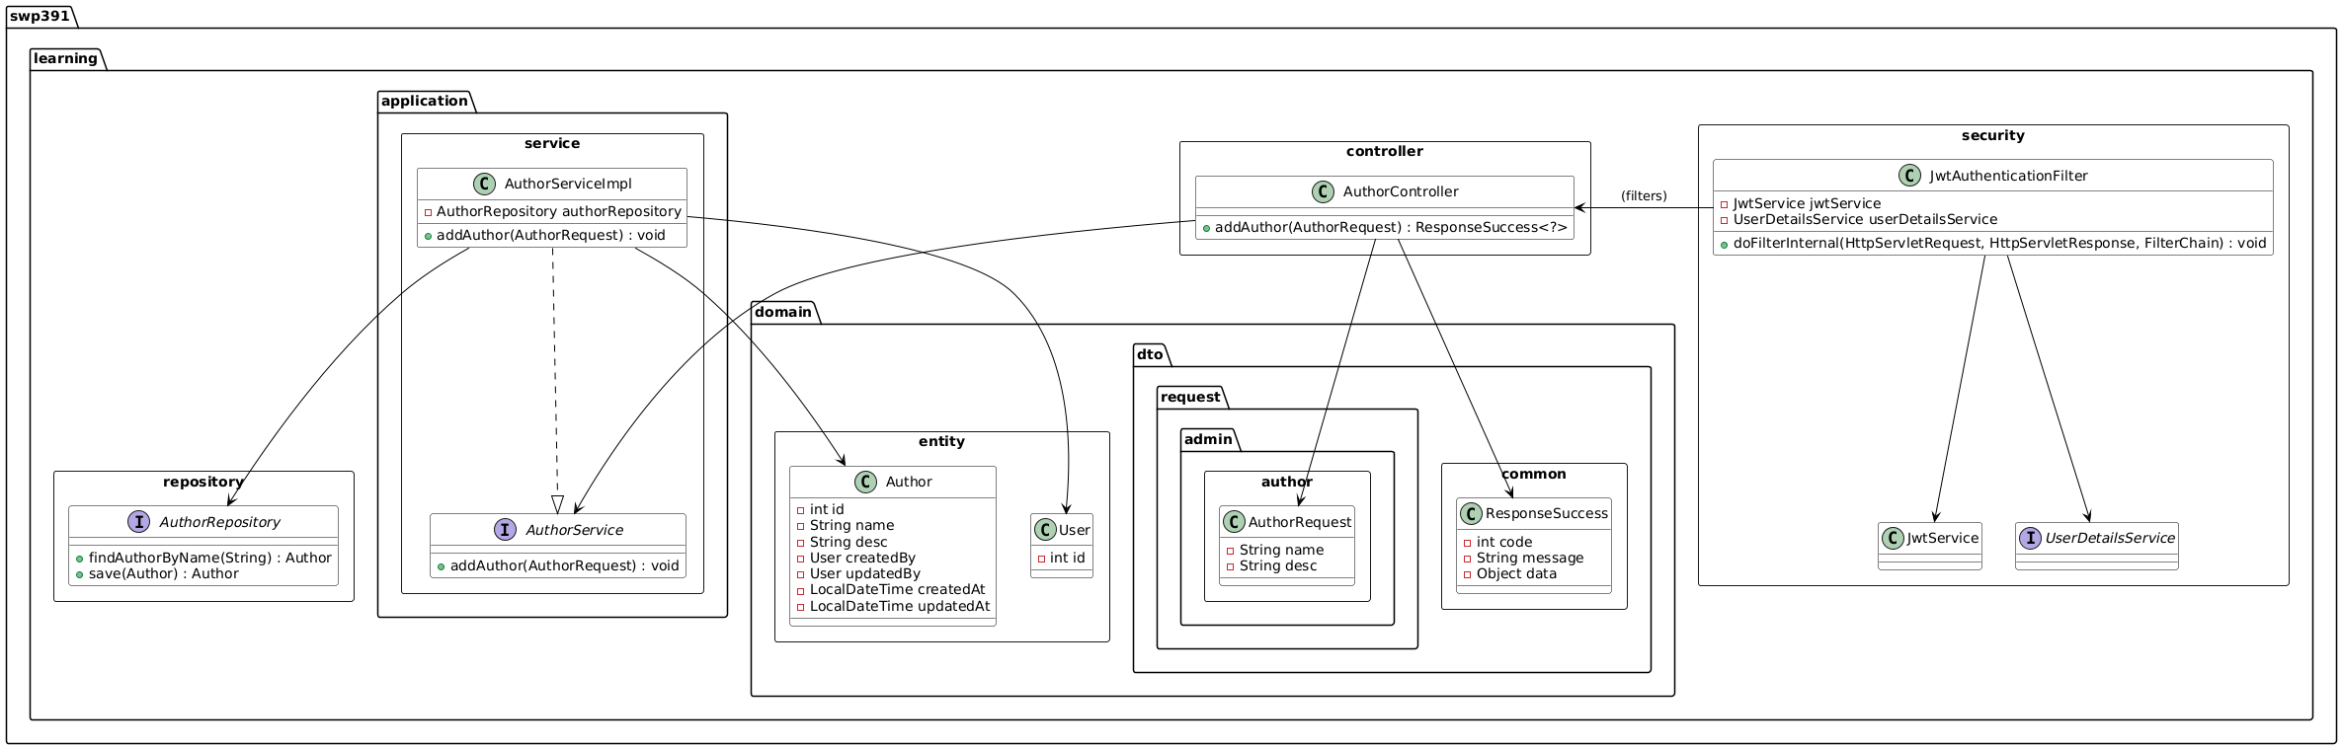

### 4.2 Sequence Diagram(s)

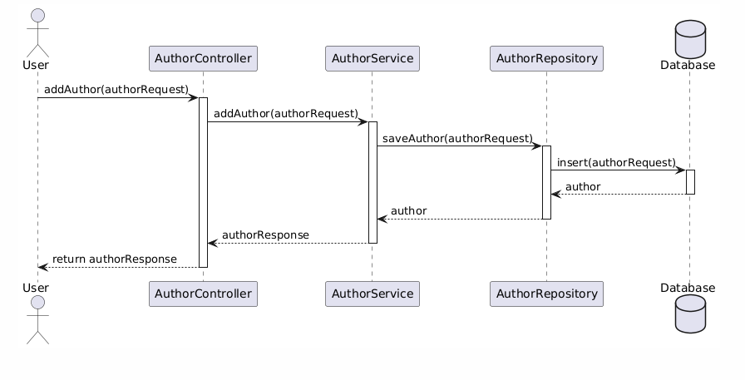

## 5. Update Author

### 5.1 Class Diagram

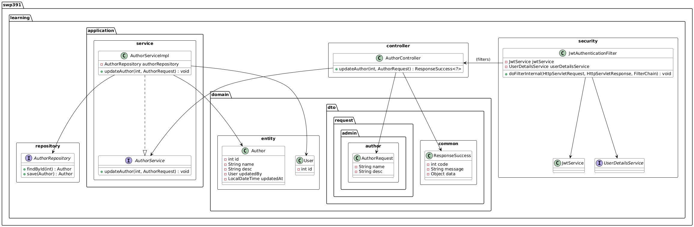

### 5.2 Sequence Diagram(s)

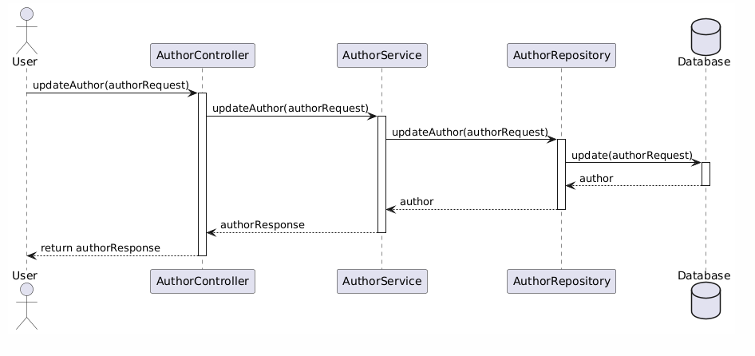

## 6. Delete Author

### 6.1 Class Diagram

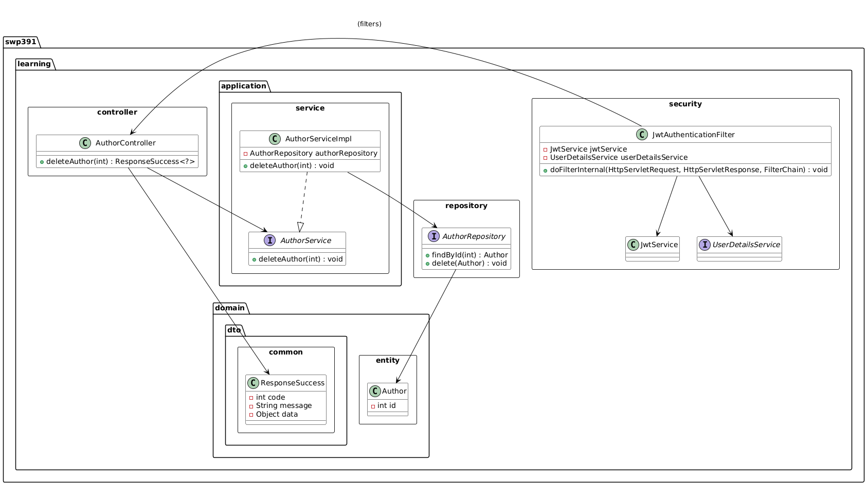

### 6.2 Sequence Diagram(s)

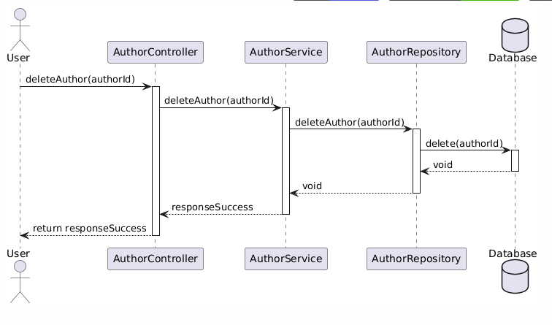

## 7. Get list Author

### 7.1 Class Diagram

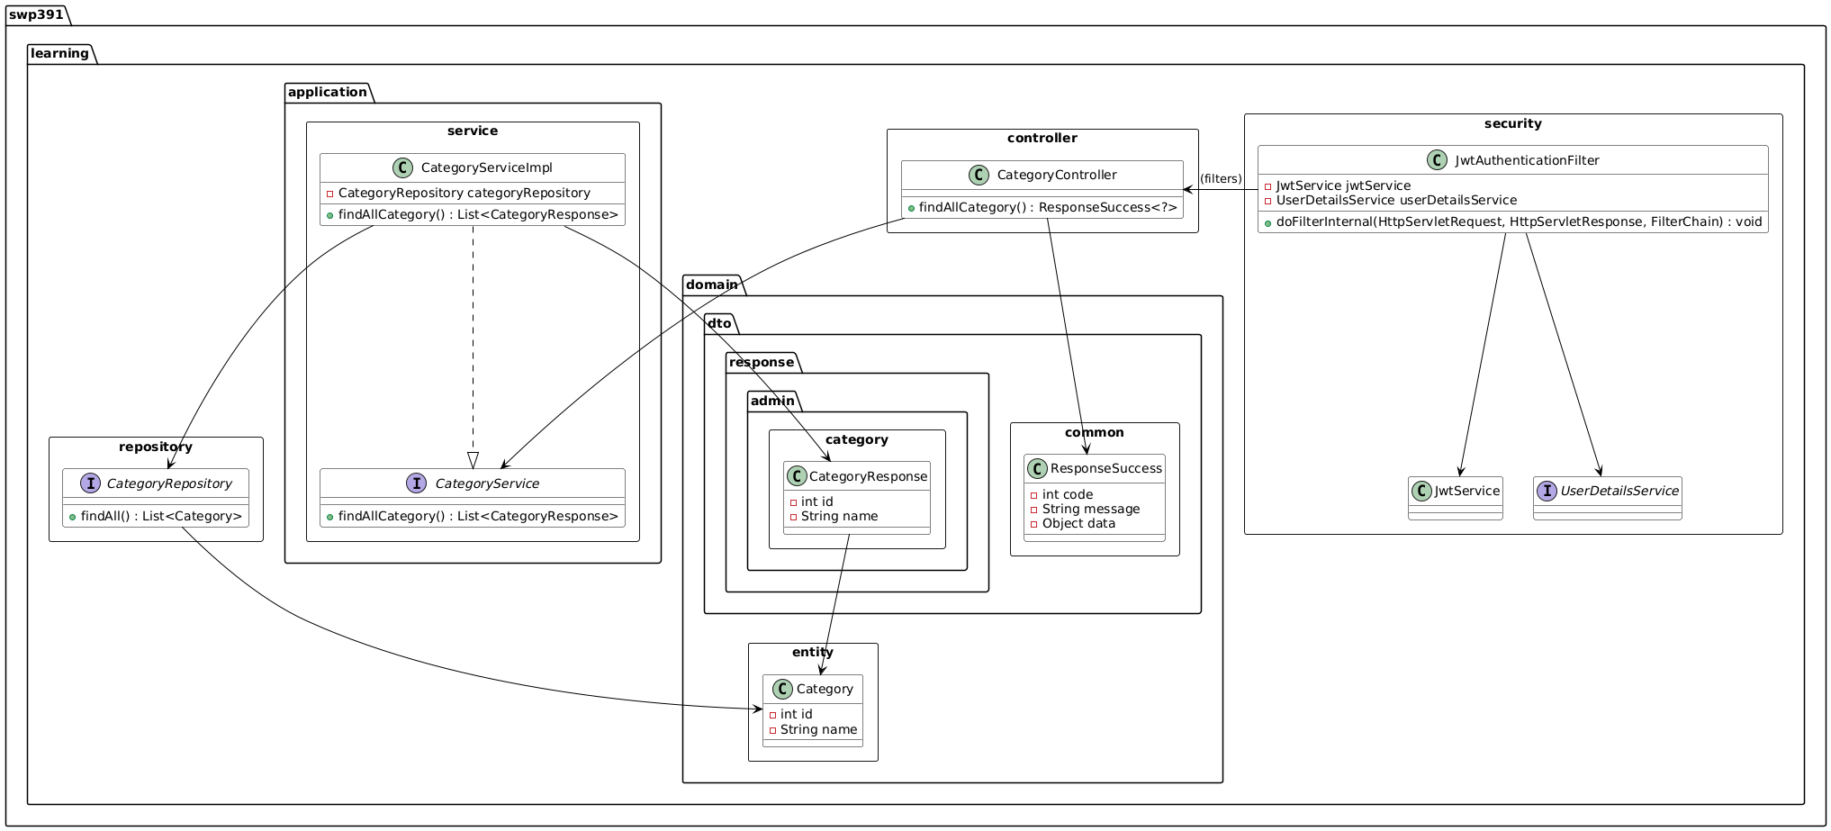

### 7.2 Sequence Diagram(s)

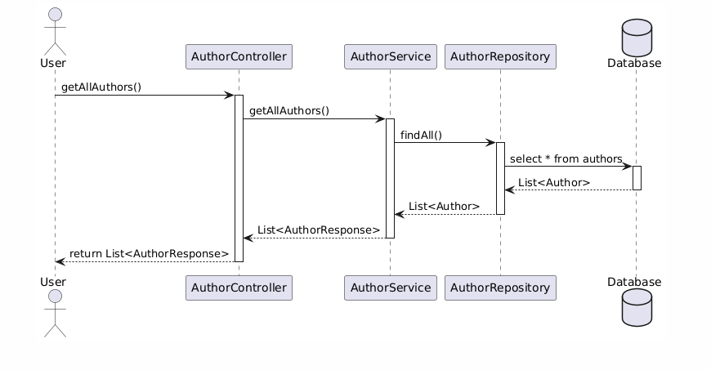

## 8 Get Author By ID

### 8.1 Class Diagram

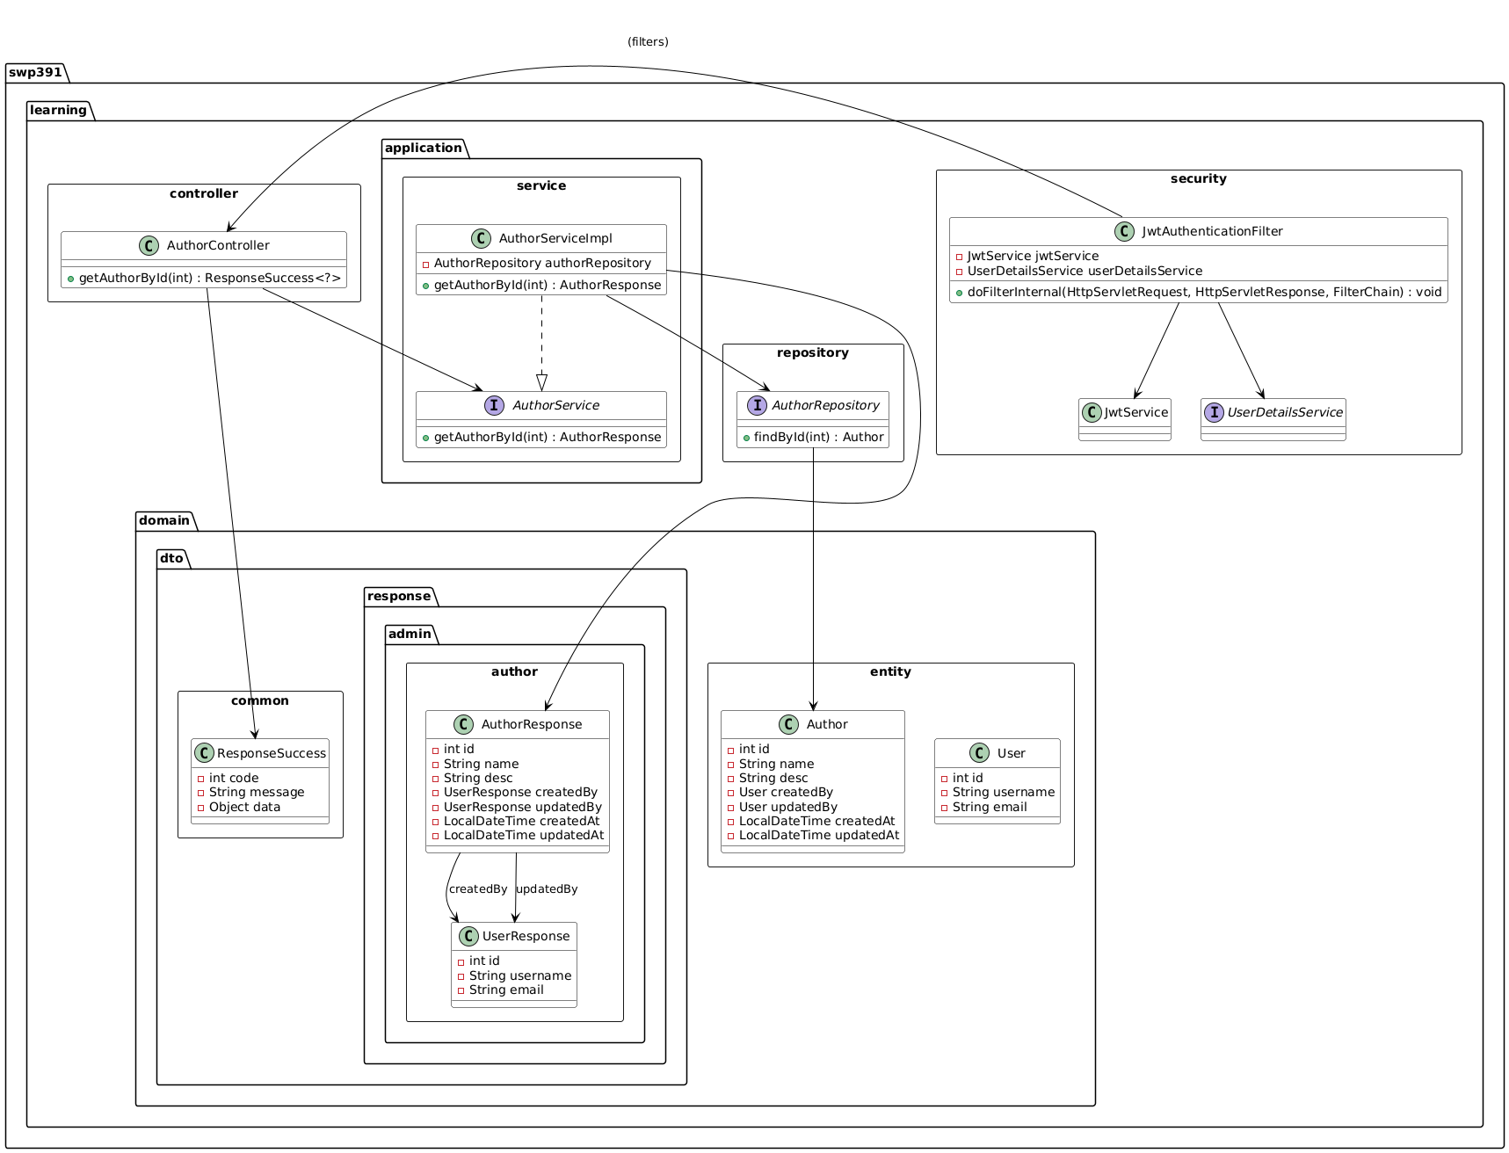

### 8.2 Sequence Diagram(s)

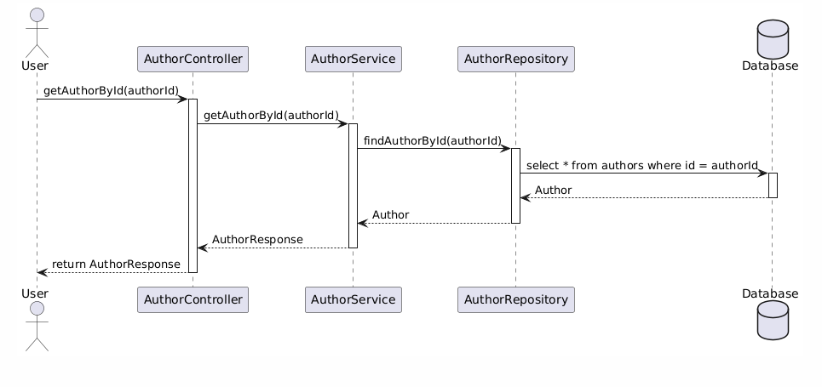

## 9. Add Category

### 9.1 Class Diagram

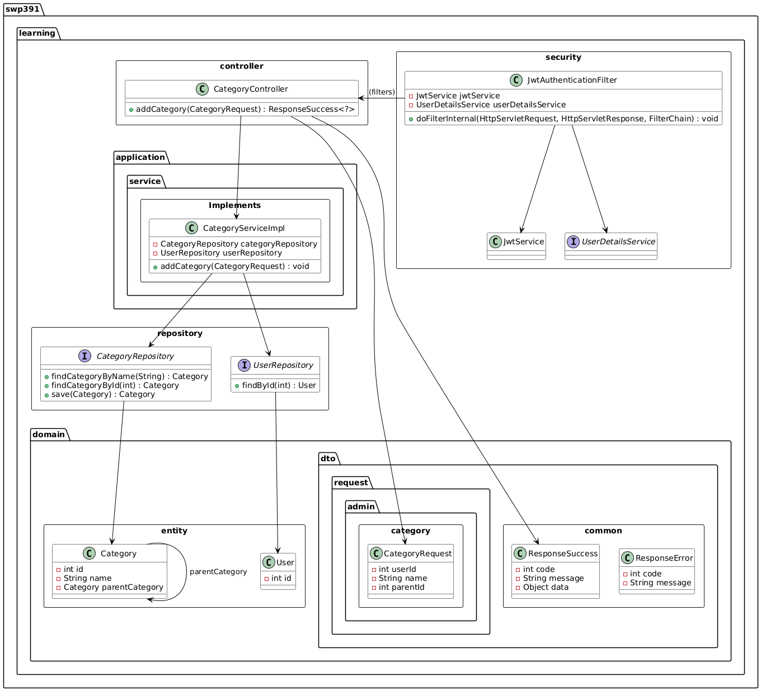

### 9.2 Sequence Diagram(s)

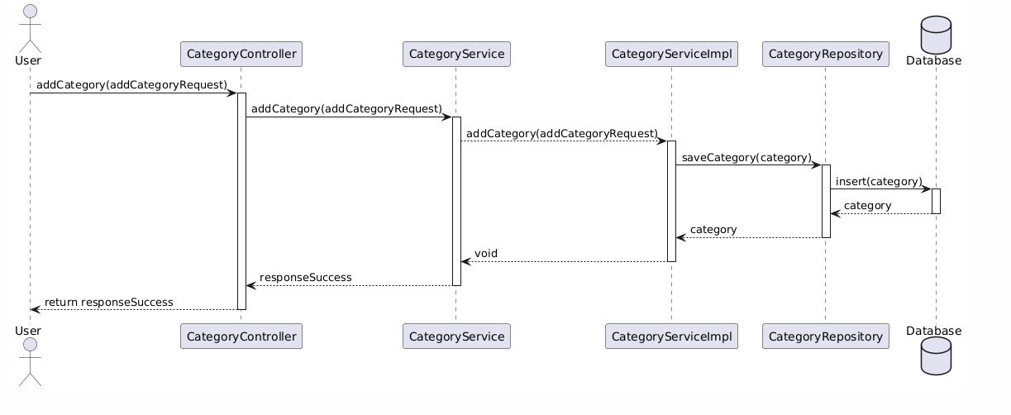

## 10. Update Category

### 10.1 Class Diagram

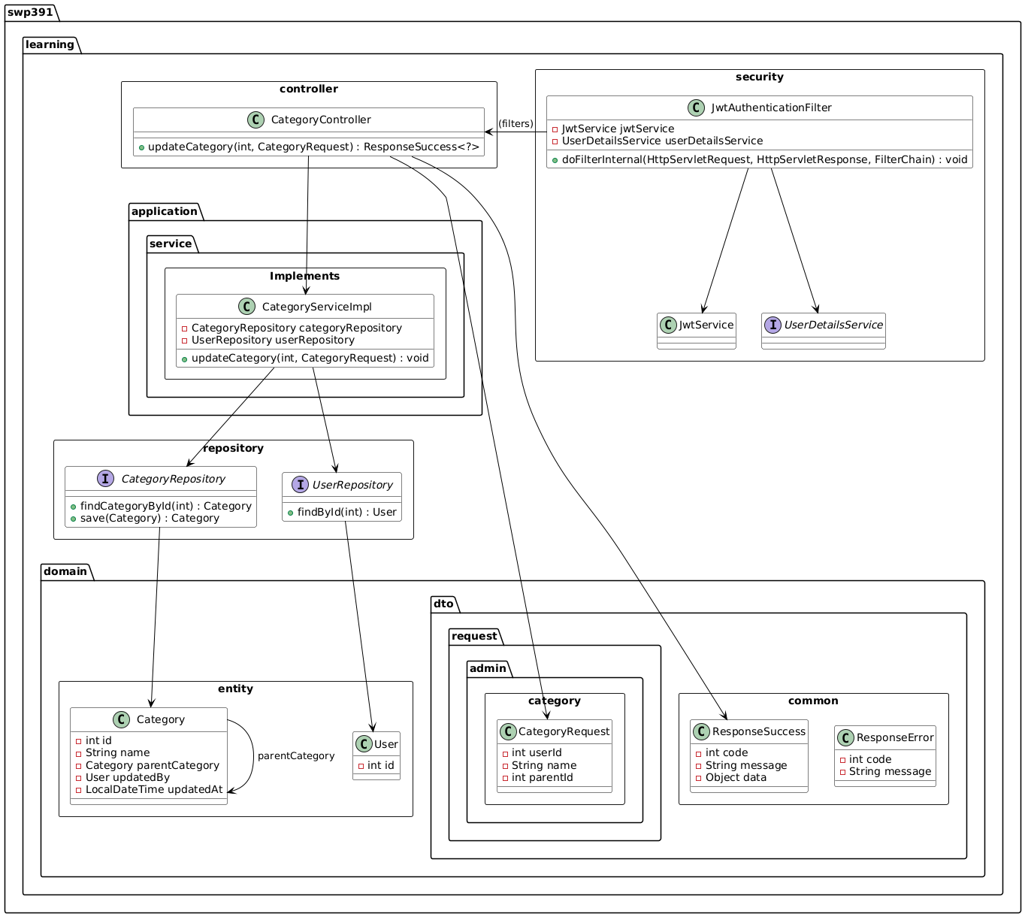

### 10.2 Sequence Diagram(s)

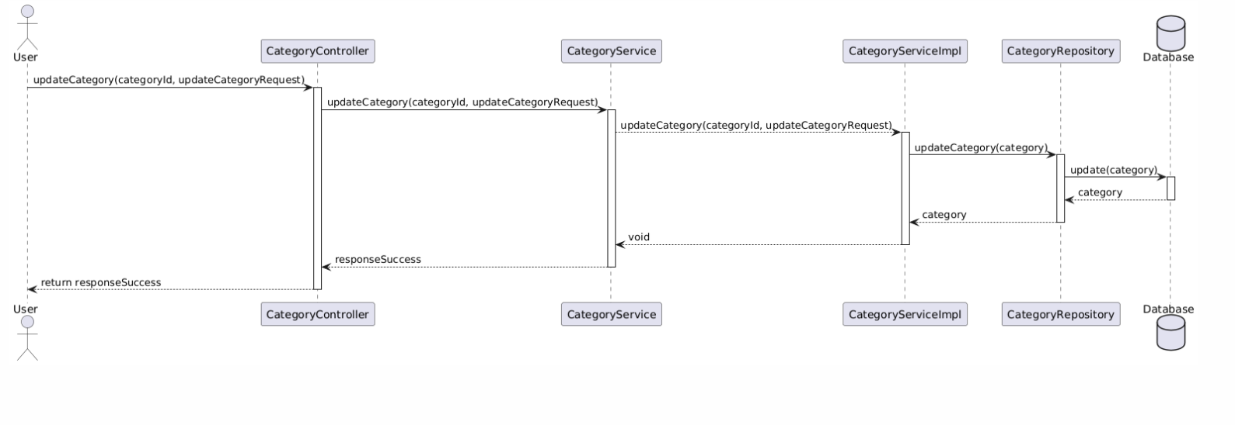

## 11. Delete Category

### 11.1 Class Diagram

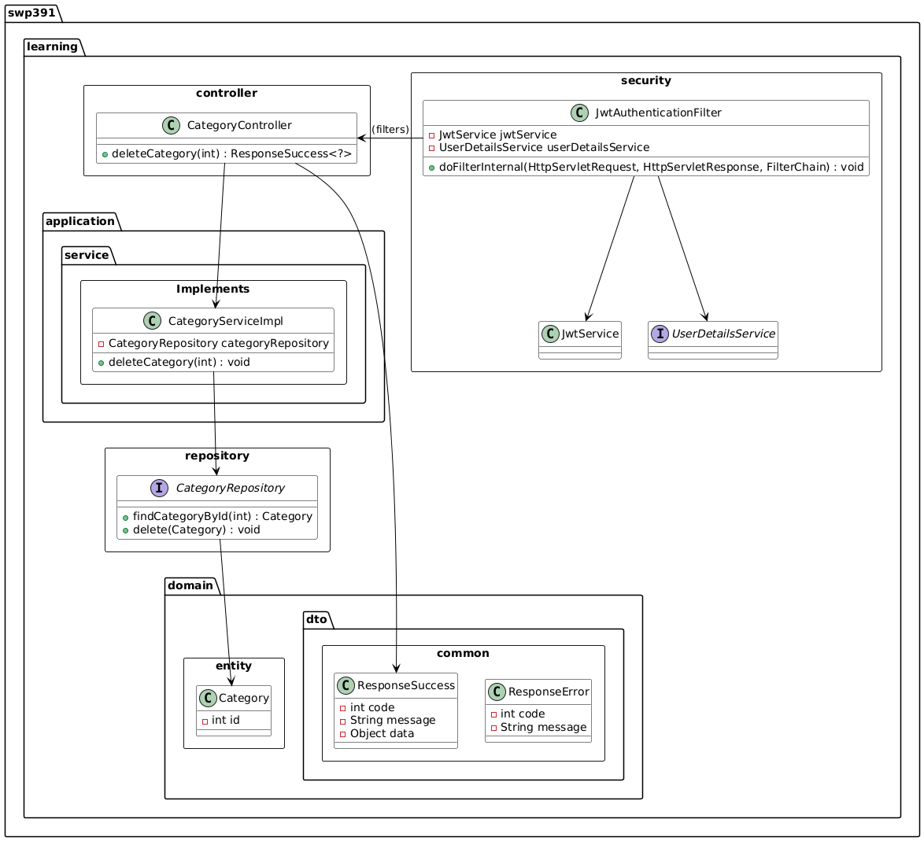

### 11.2 Sequence Diagram(s)

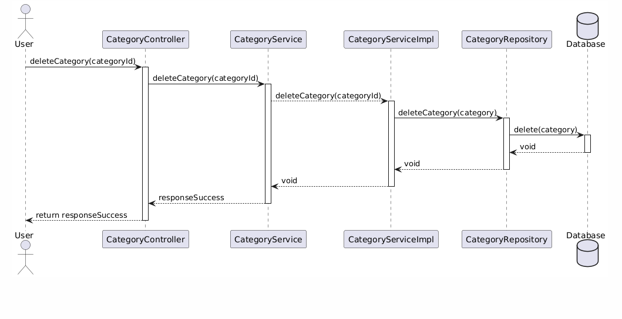

## 12. Get list Category

### 12.1 Class Diagram

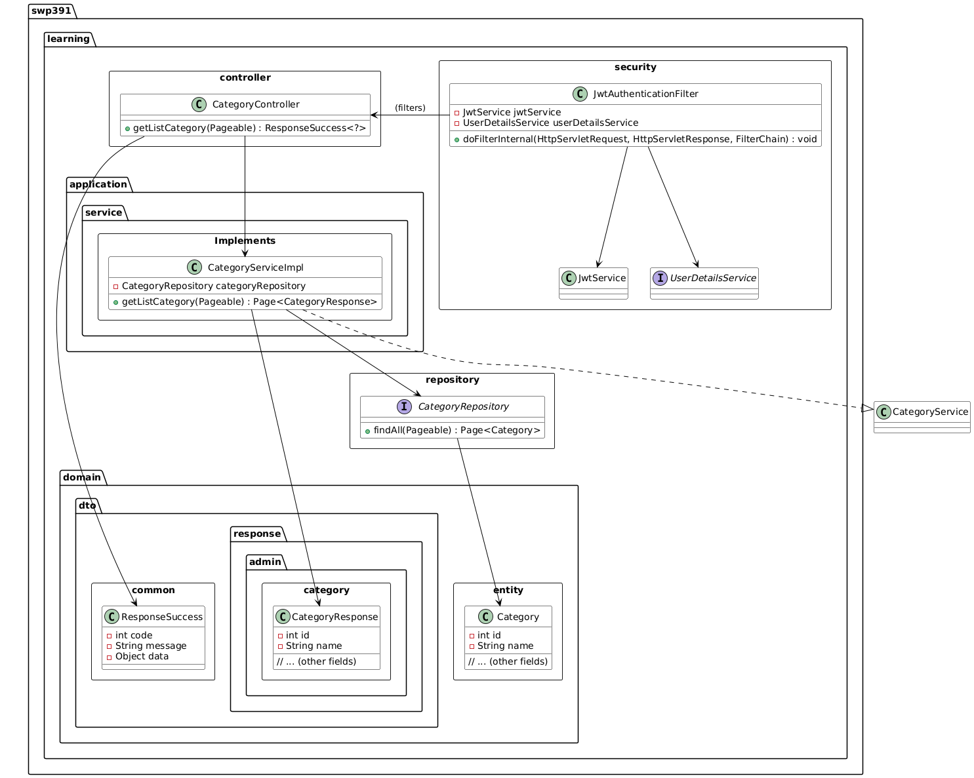

### 12.2 Sequence Diagram(s)

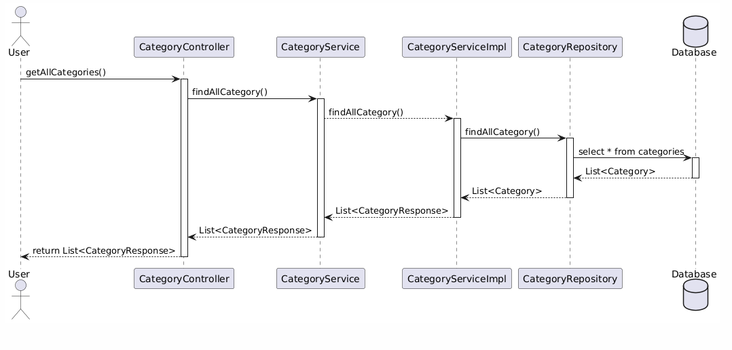

## 13. Add Review

### 13.1 Class Diagram

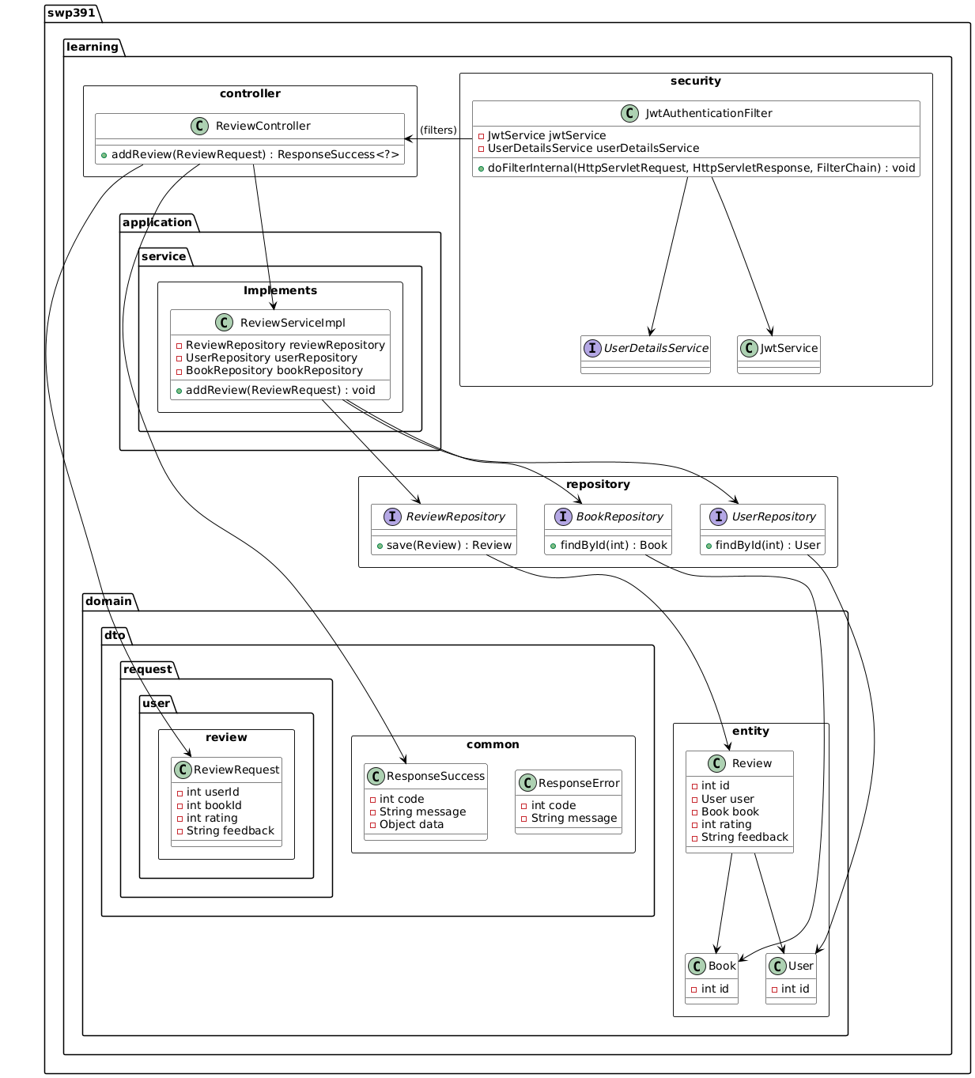

### 13.2 Sequence Diagram(s)

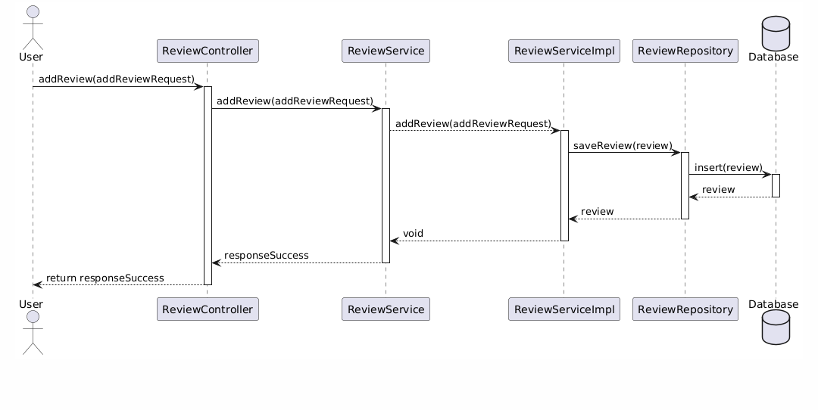

## 14. Update Review

### 14.1 Class Diagram

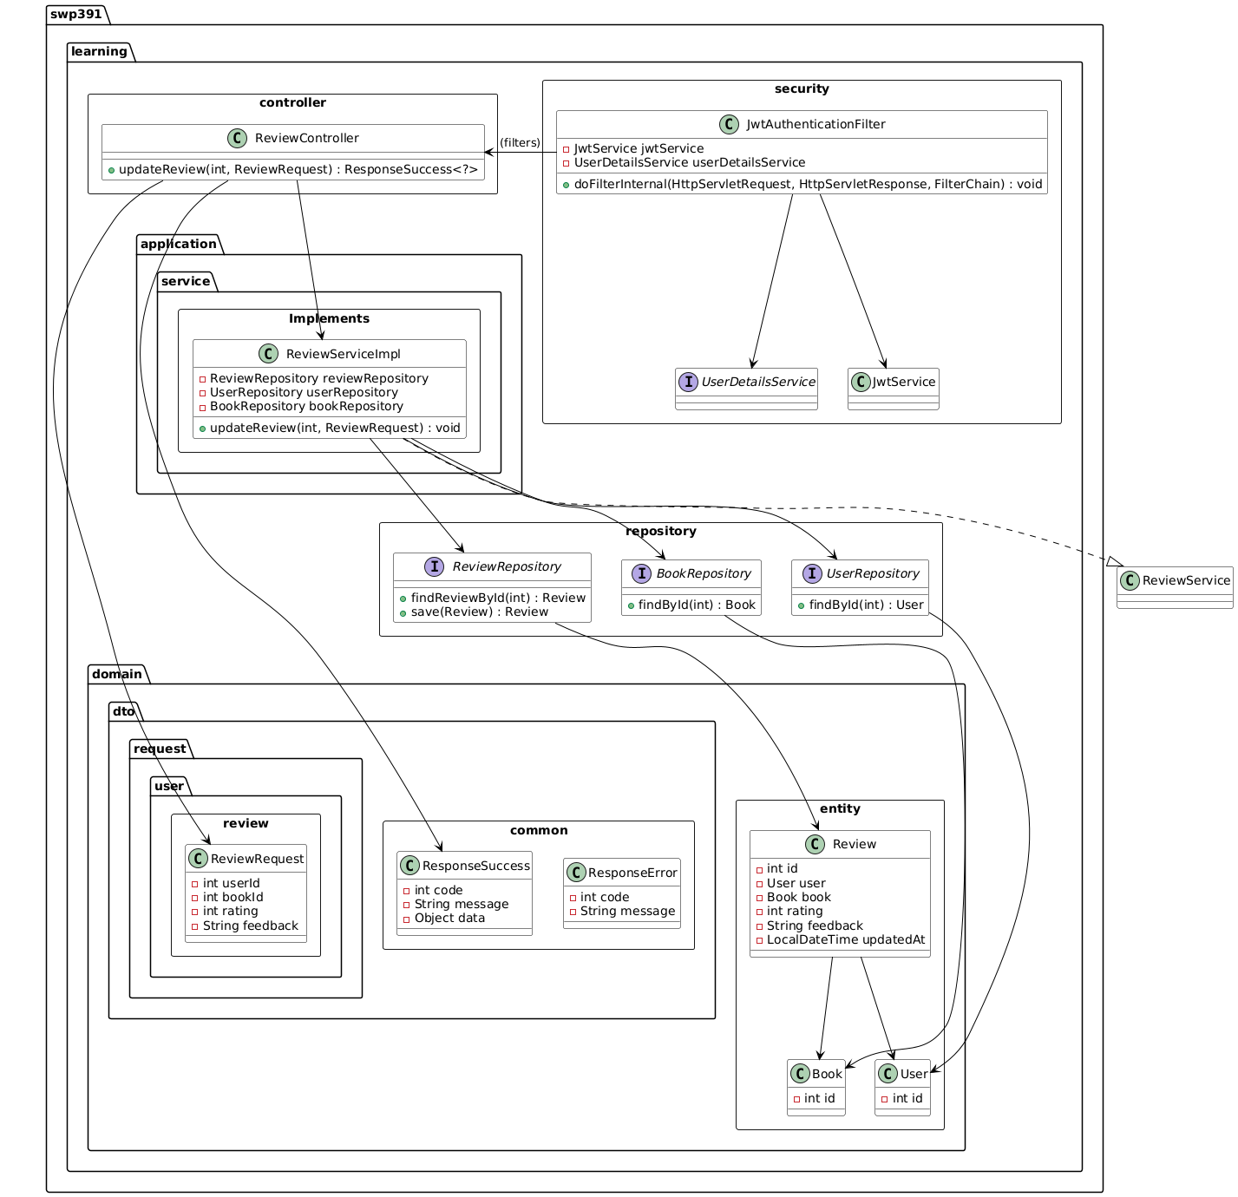

### 14.2 Sequence Diagram(s)

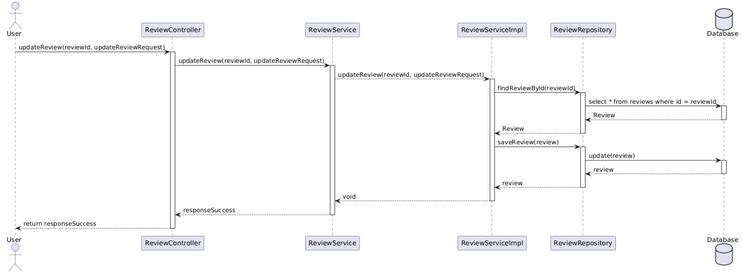

## 15. Delete Review

### 15.1 Class Diagram

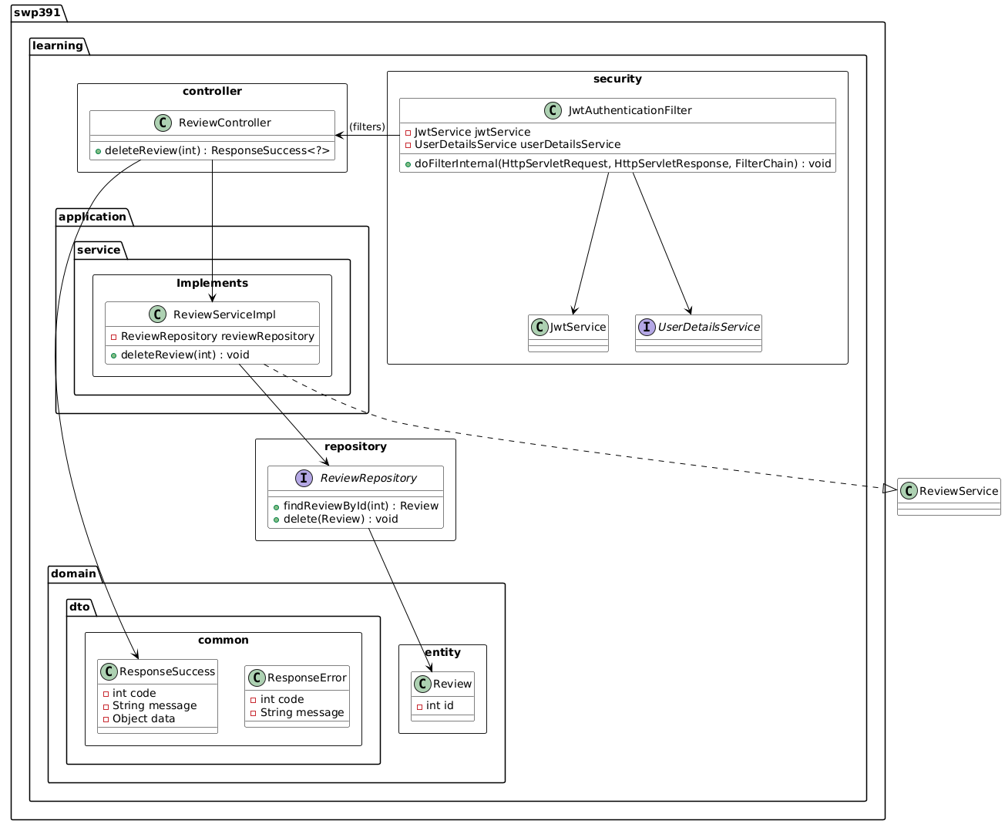

### 15.2 Sequence Diagram(s)

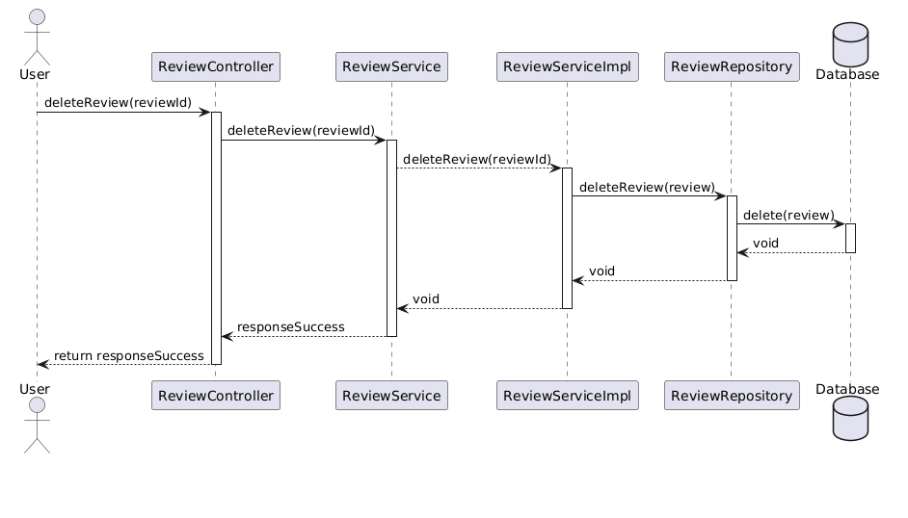

## 16. Get list Review

### 16.1 Class Diagram

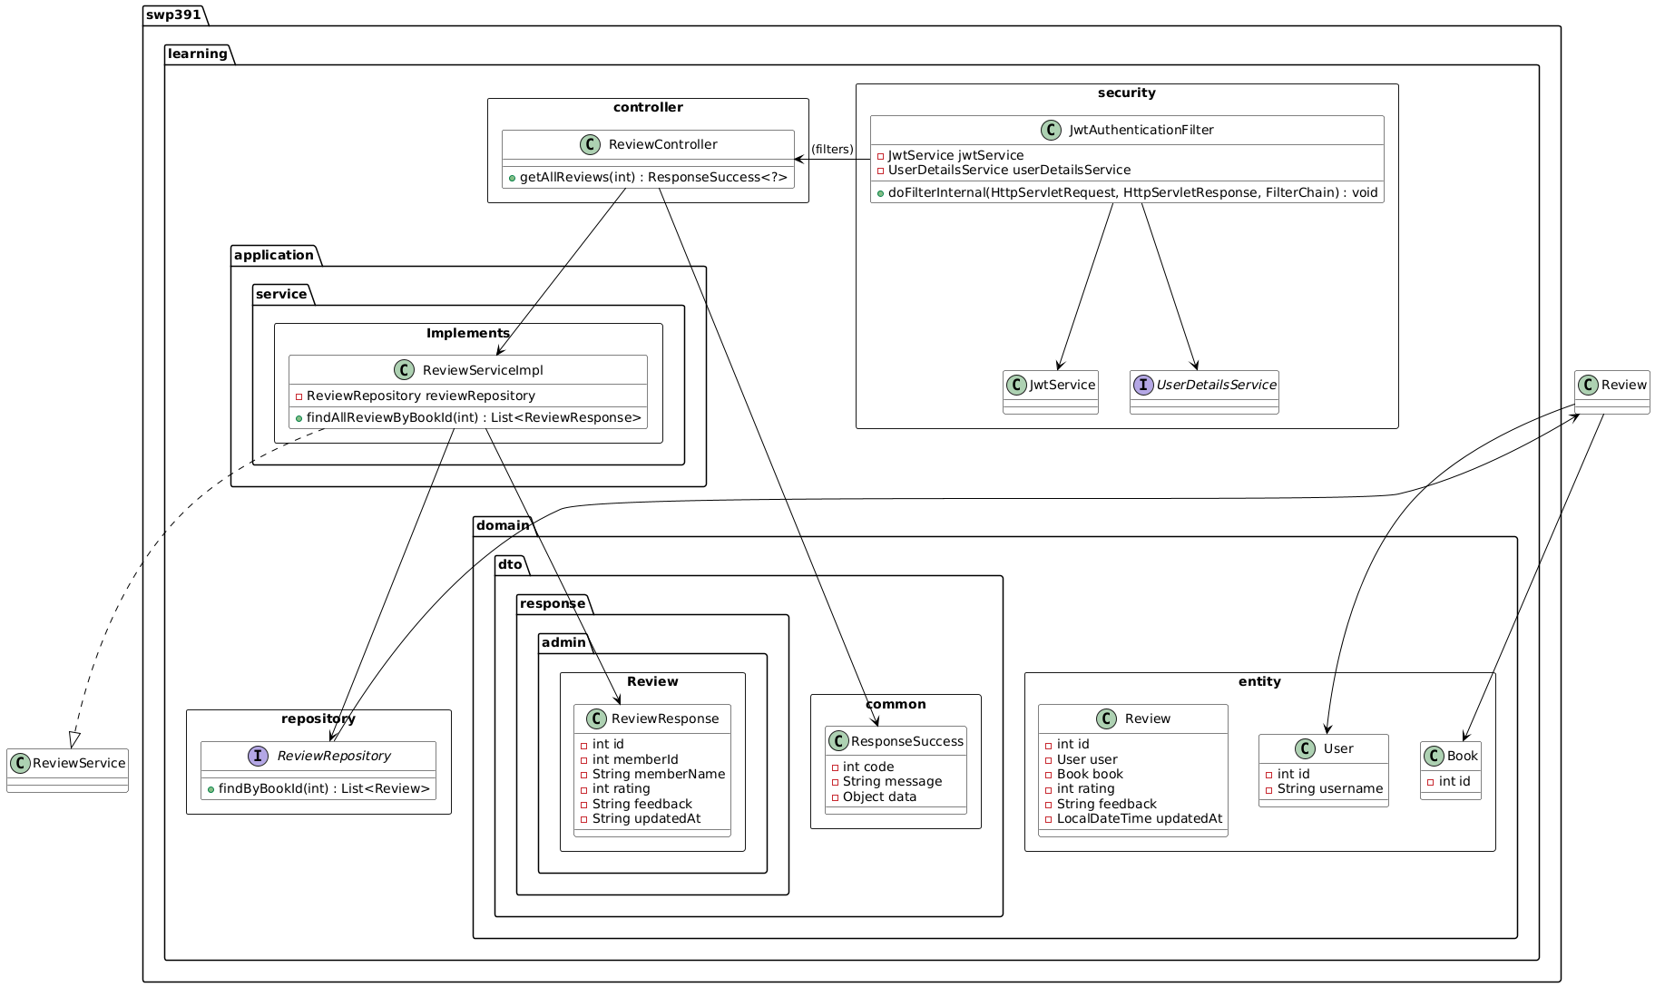

### 16.2 Sequence Diagram(s)

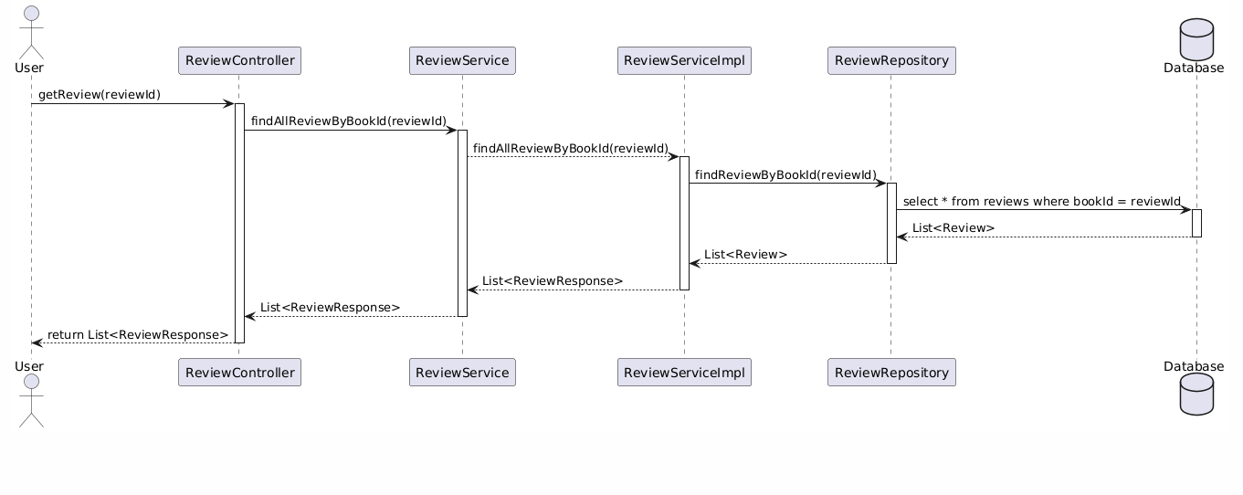

## 17. Add Book

### 17.1 Class Diagram

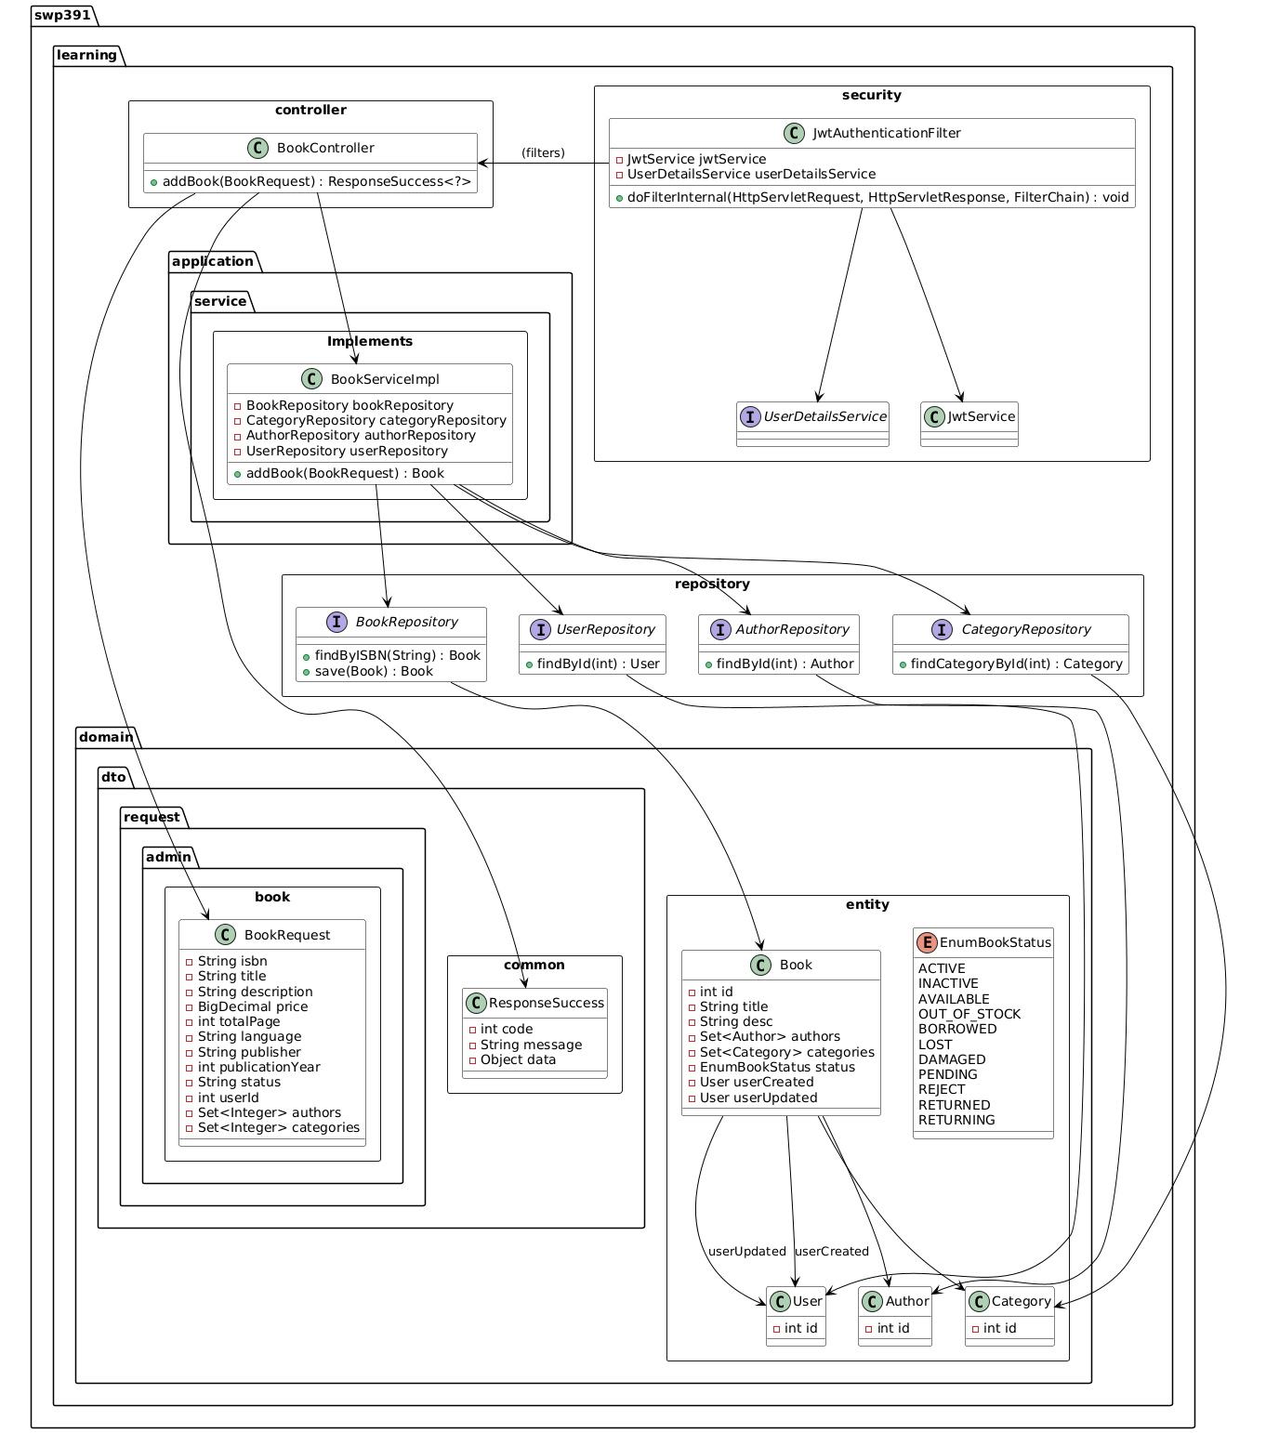

### 17.2 Sequence Diagram(s)

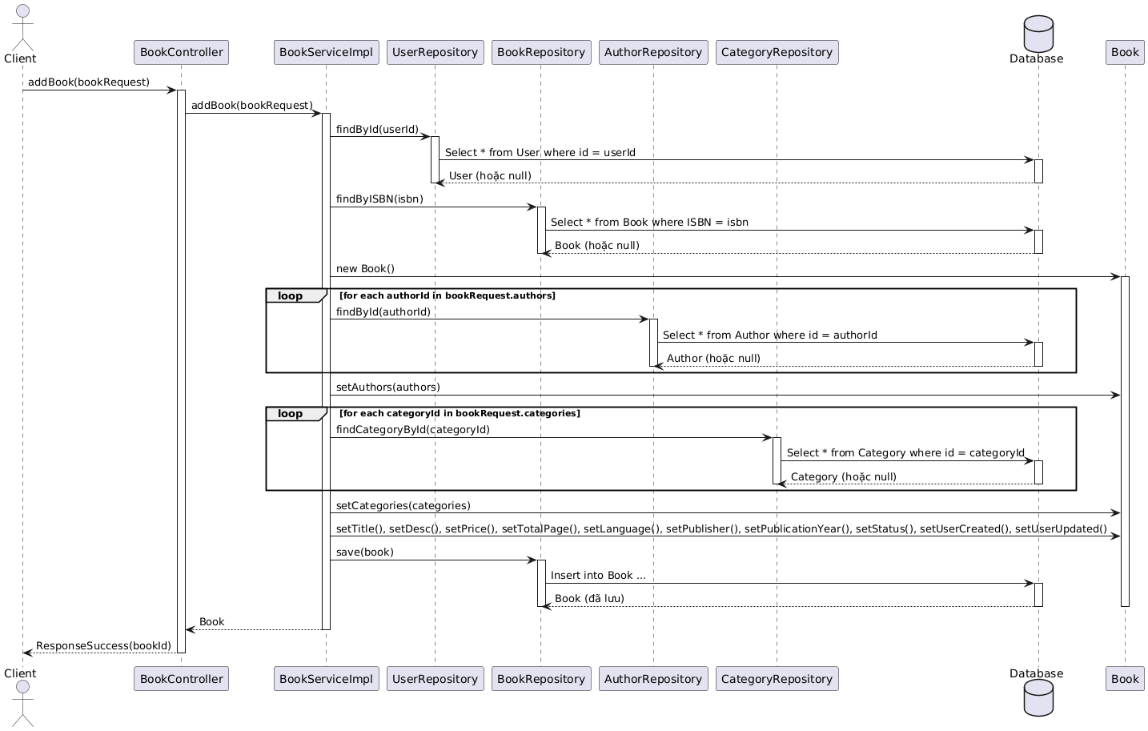

## 18. Update Book

### 18.1 Class Diagram

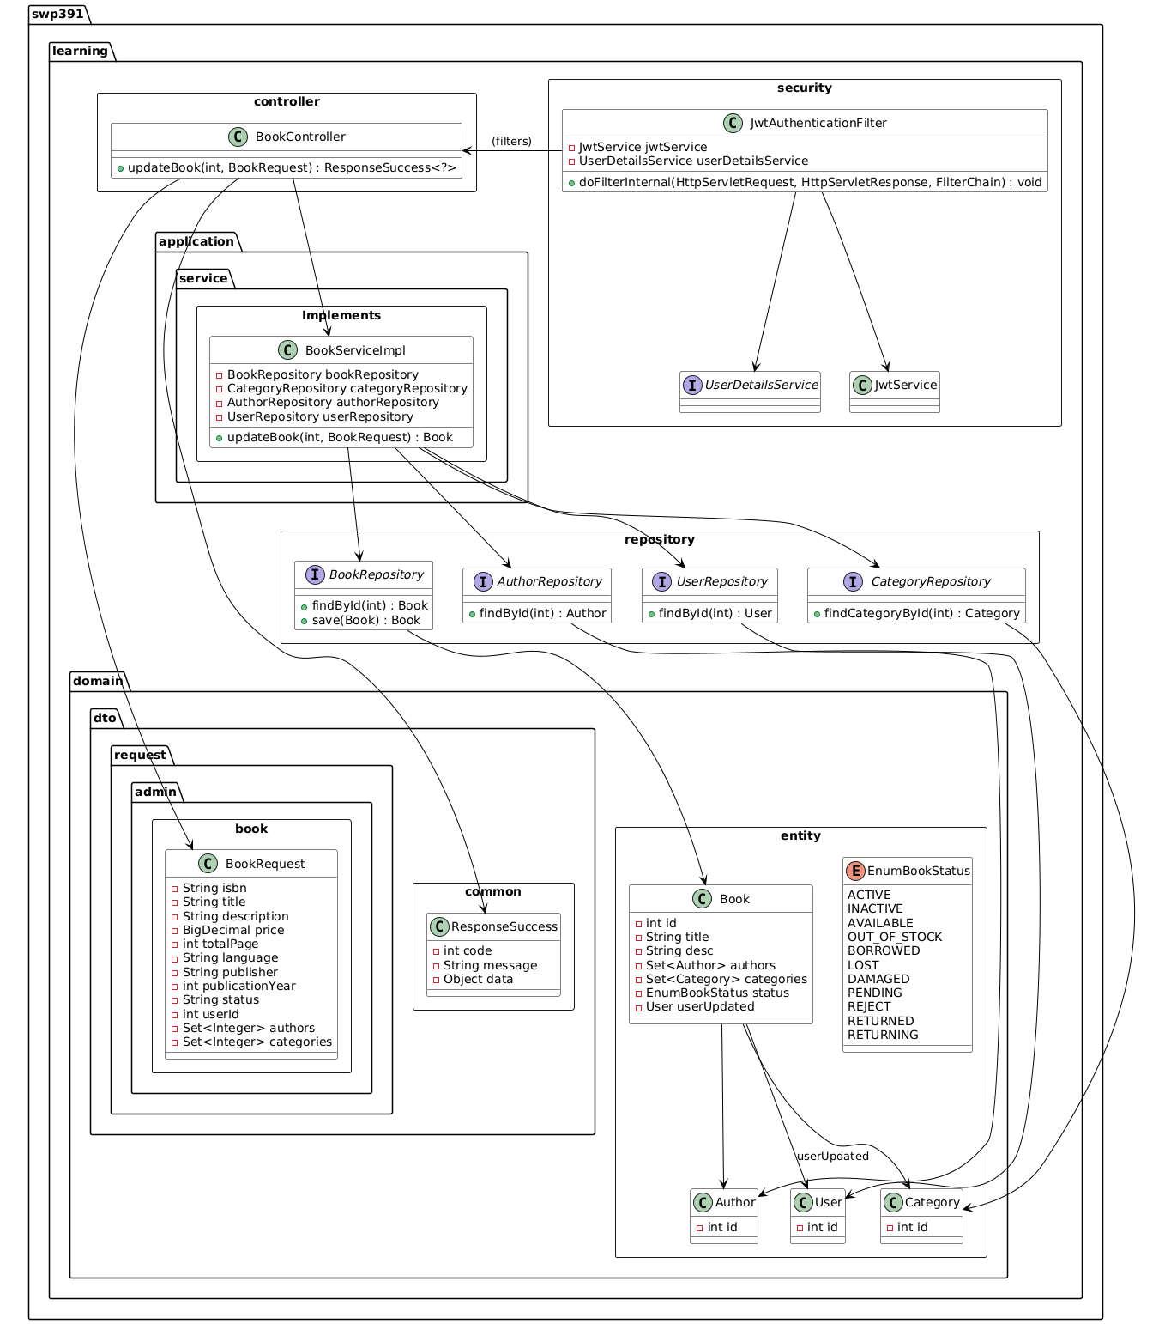

### 18.2 Sequence Diagram(s)

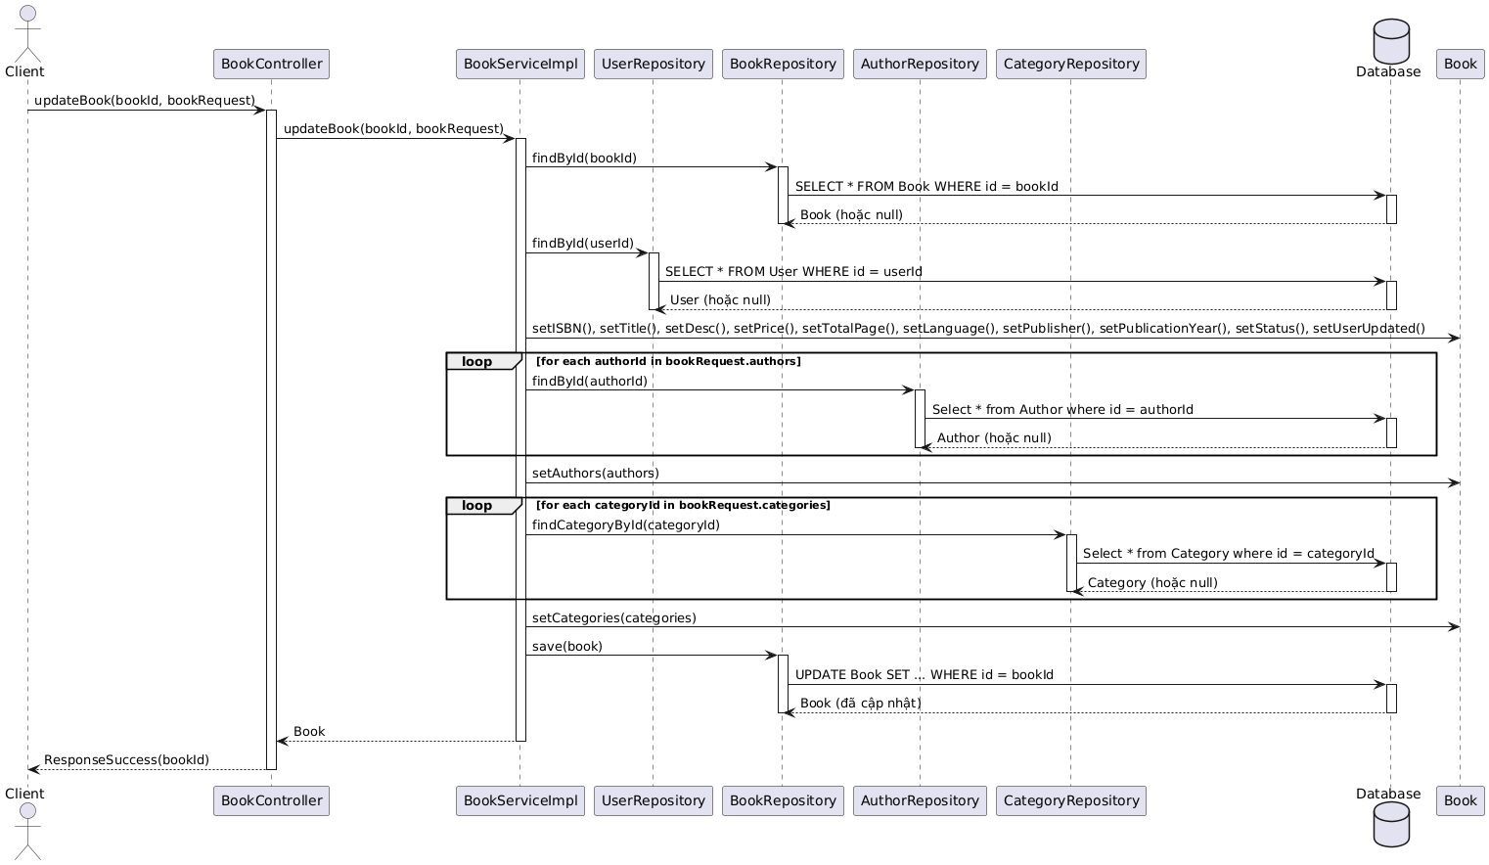

## 19. Delete Book

### 19.1 Class Diagram

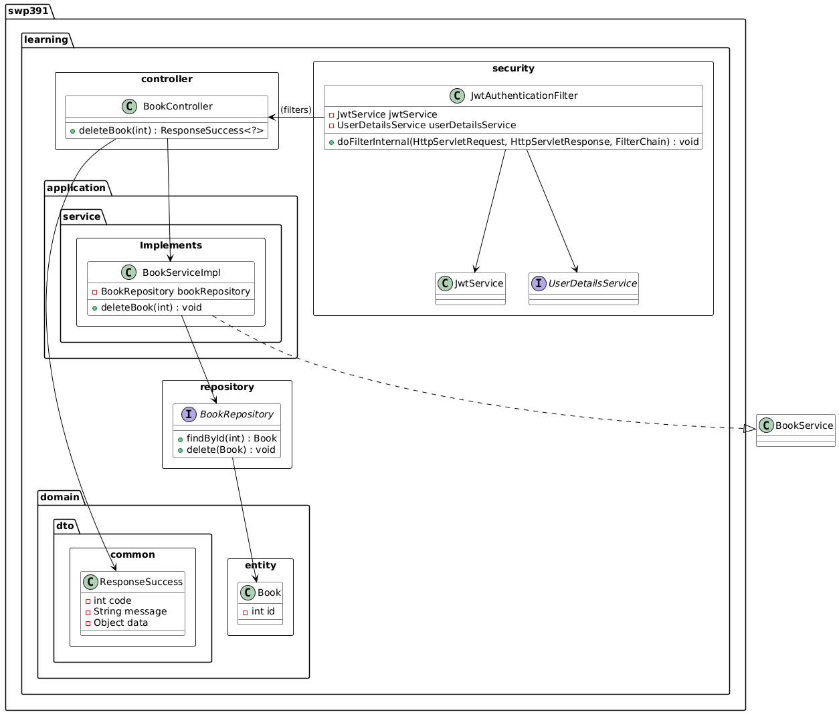

### 19.2 Sequence Diagram(s)

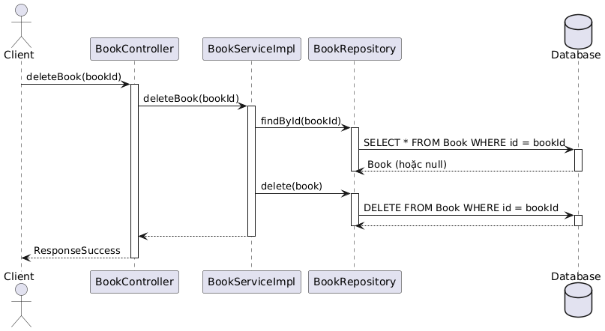

## 20. Get list Book

### 20.1 Class Diagram

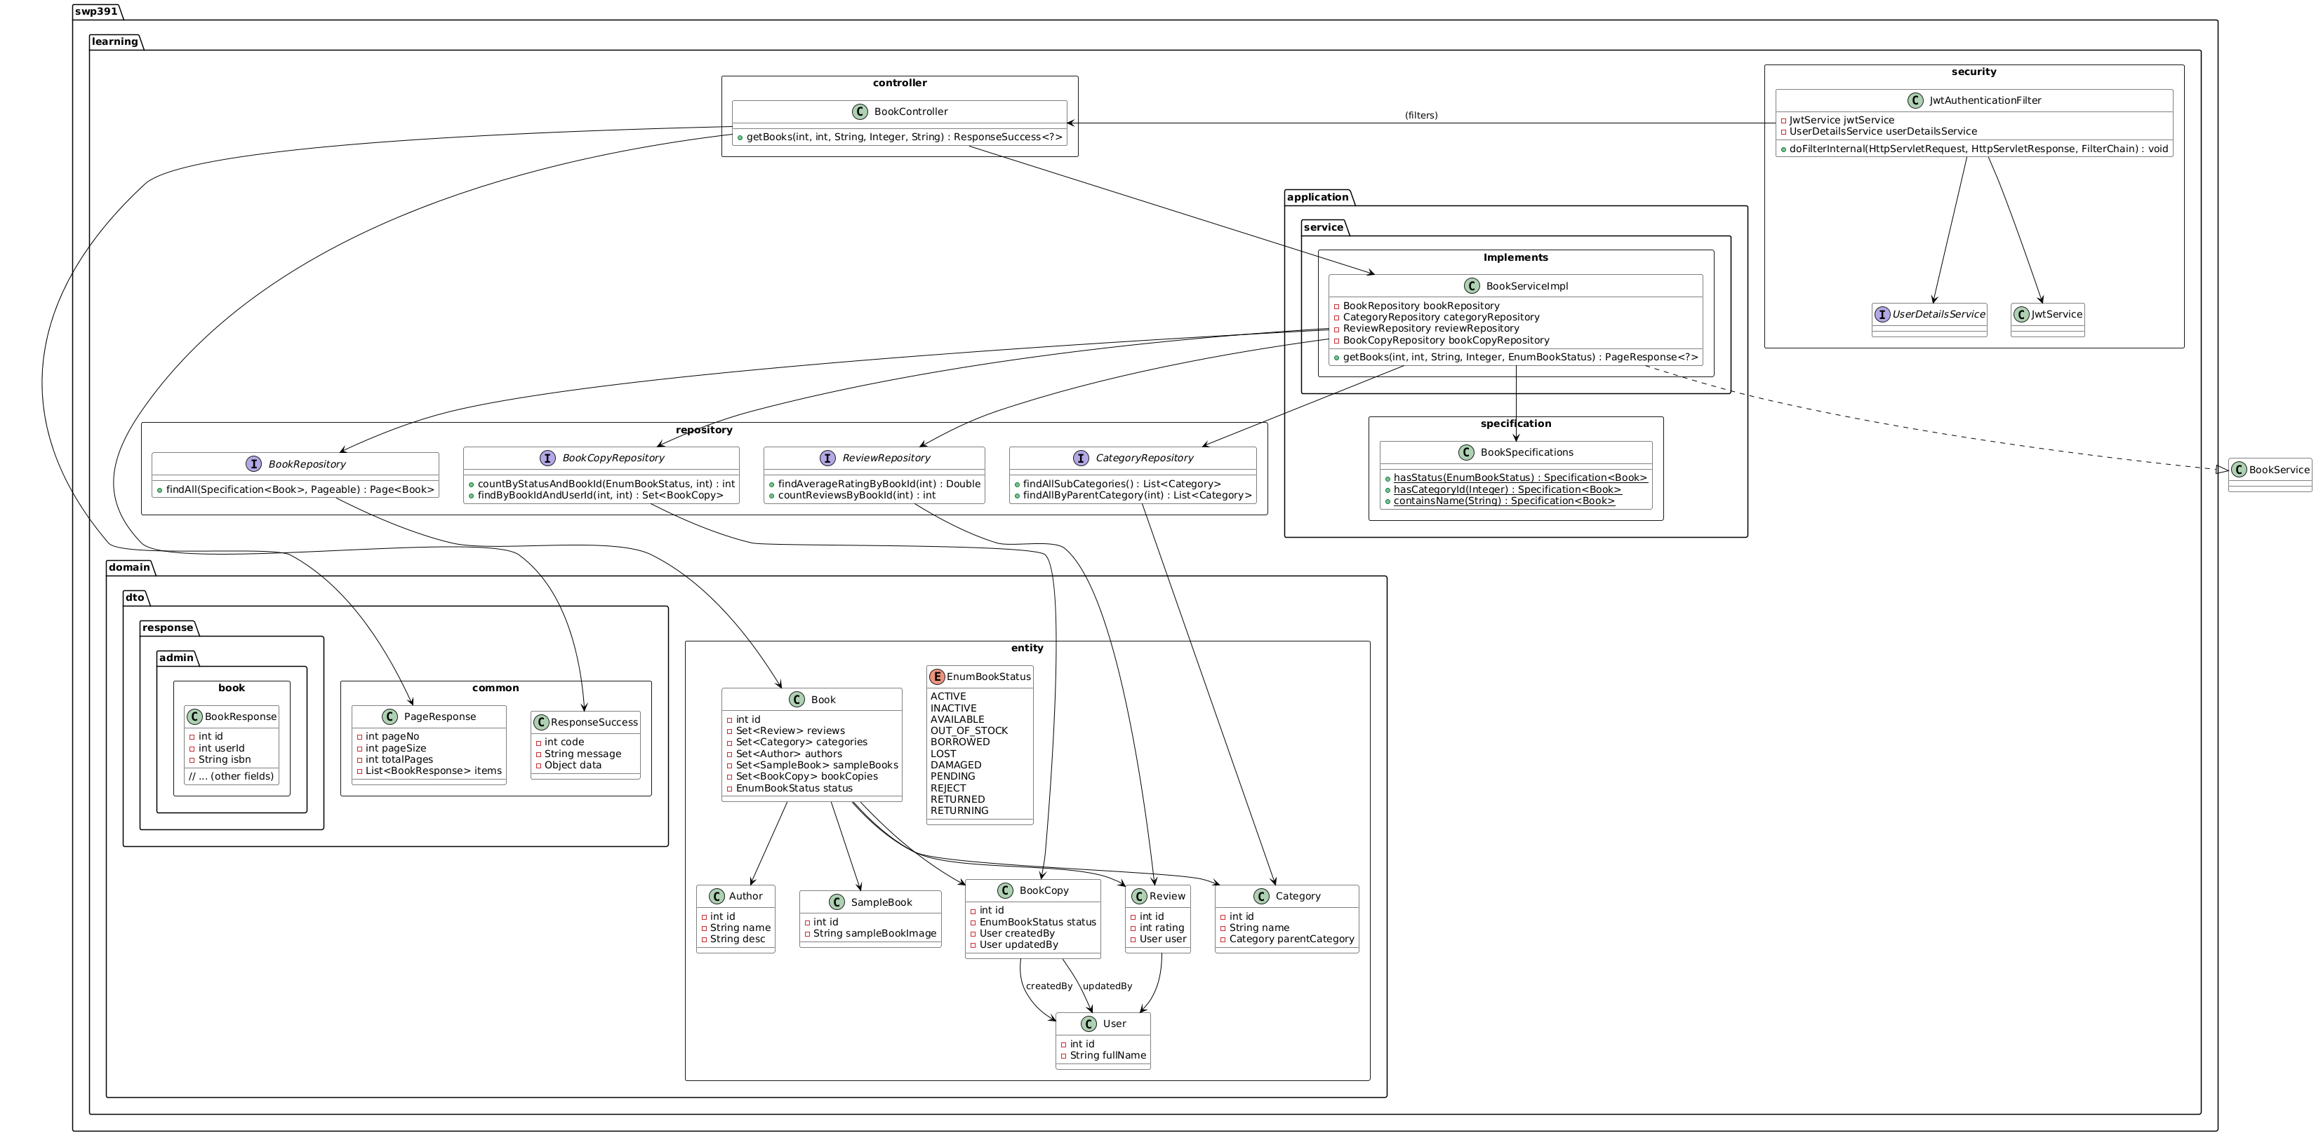

### 20.2 Sequence Diagram(s)

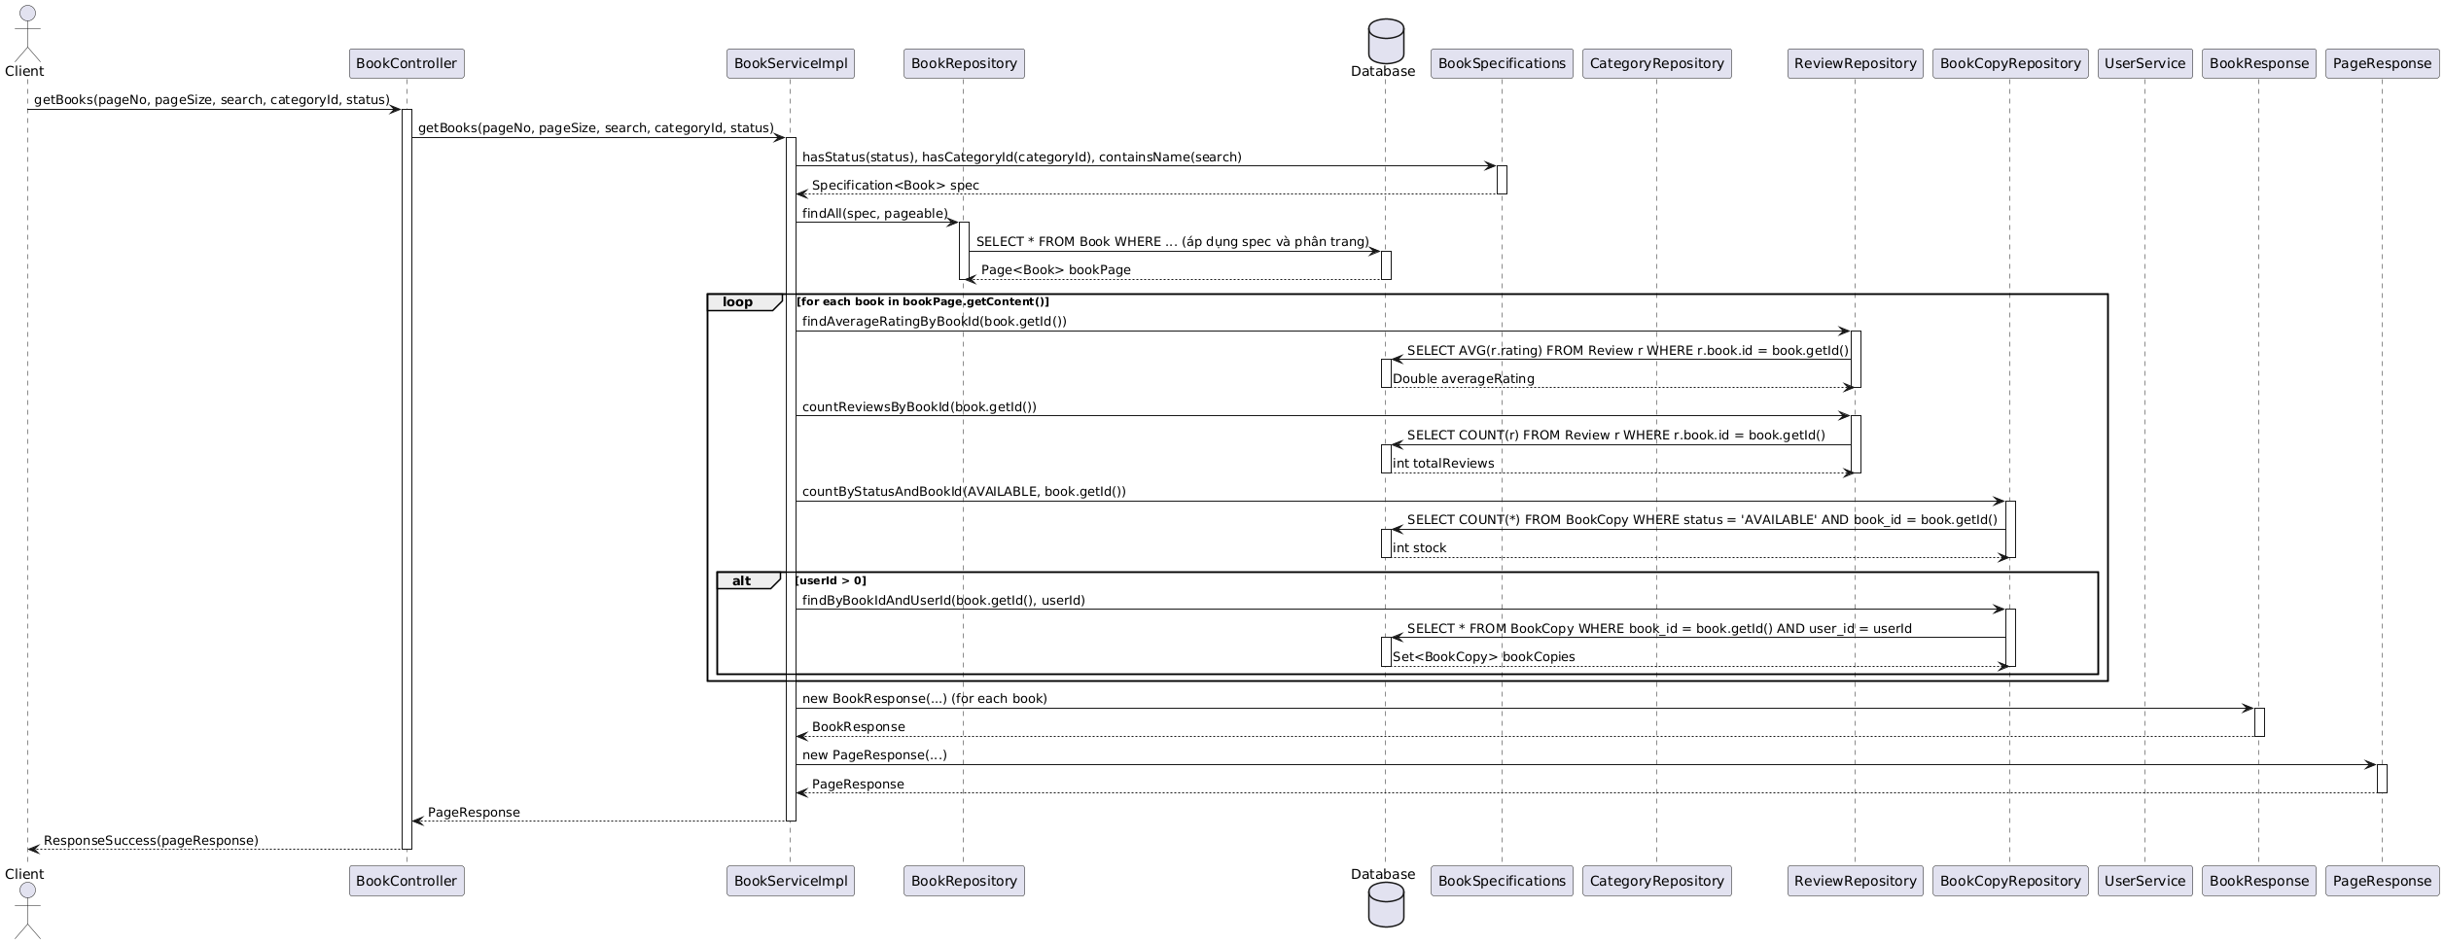

## 21. Get Book By ID

### 21.1 Class Diagram

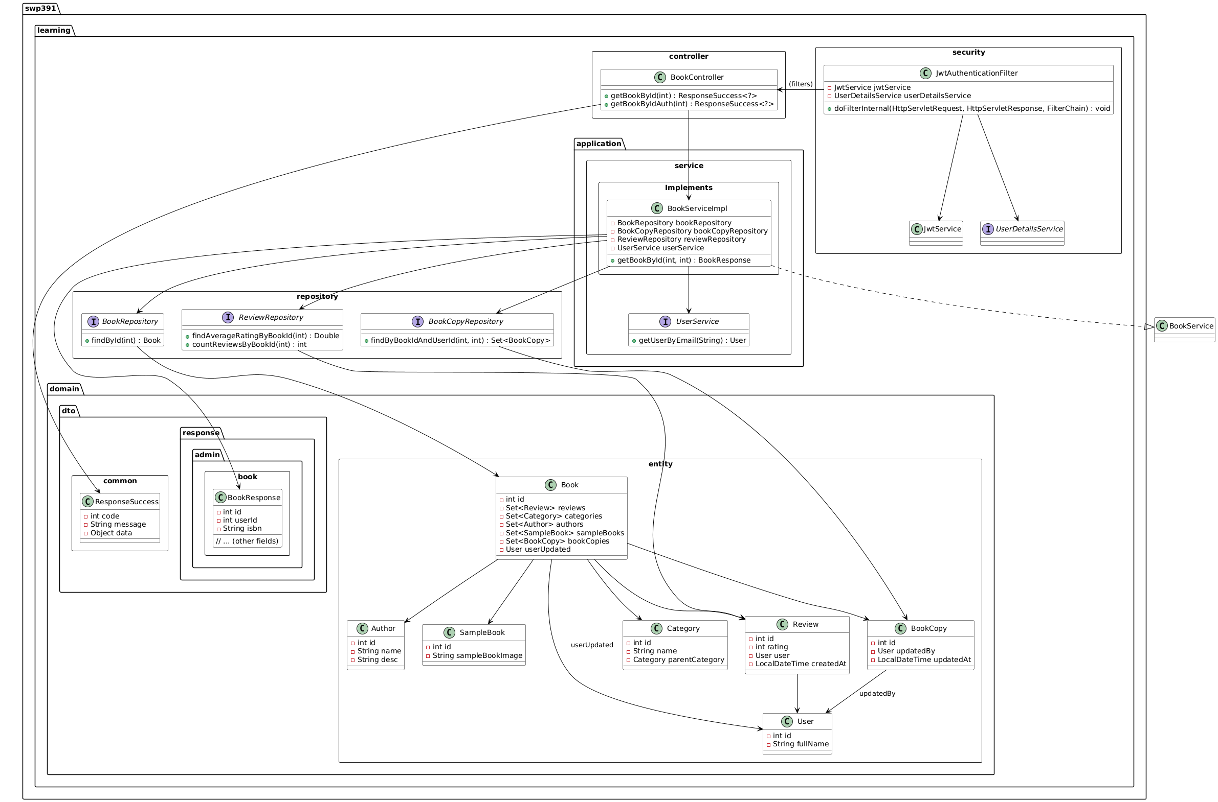

### 21.2 Sequence Diagram(s)

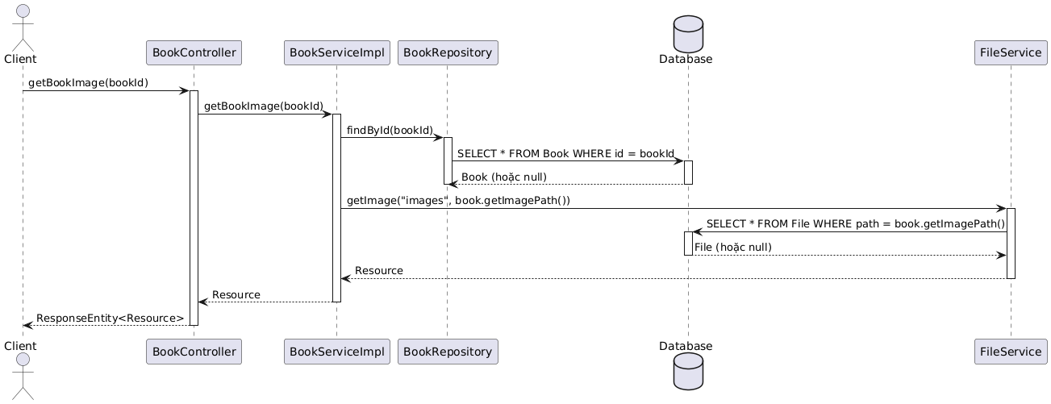

## 22. Add User

### 22.1 Class Diagram

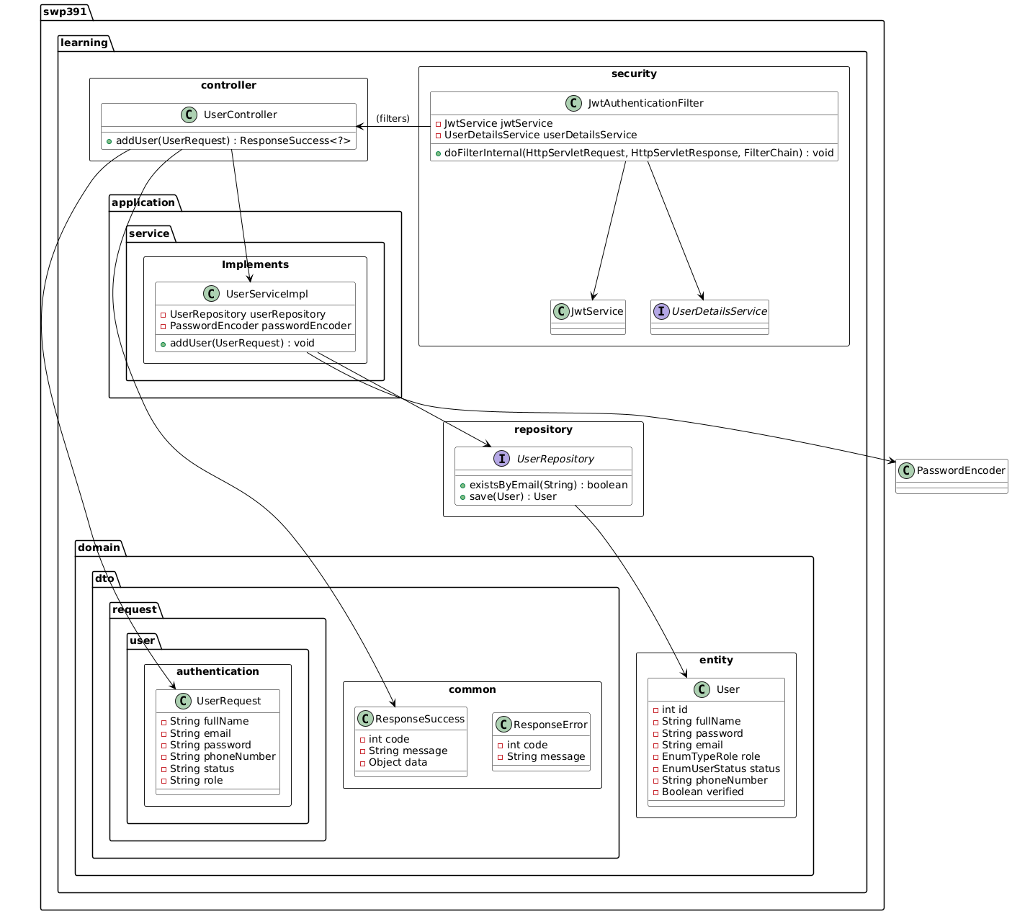

### 22.2 Sequence Diagram(s)

## 23. Update User

### 23.1 Class Diagram

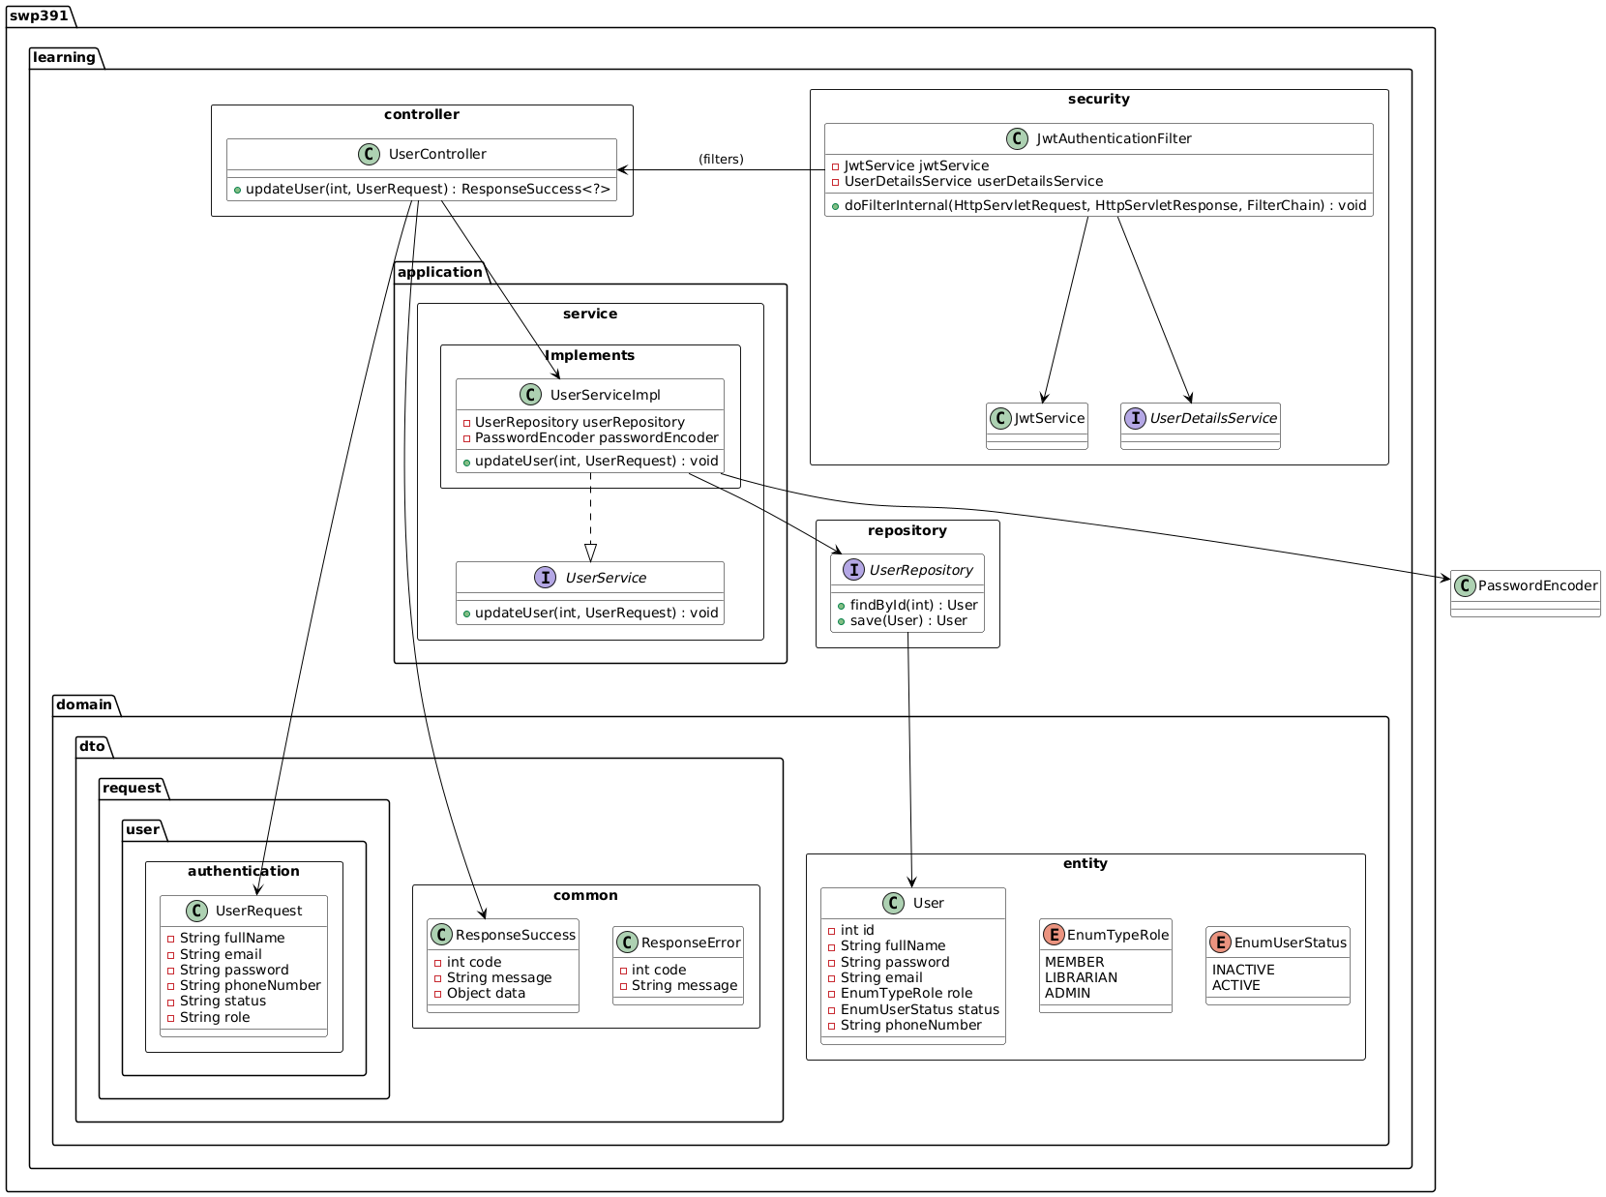

### 23.2 Sequence Diagram(s)

## 24. Delete User

### 24.1 Class Diagram

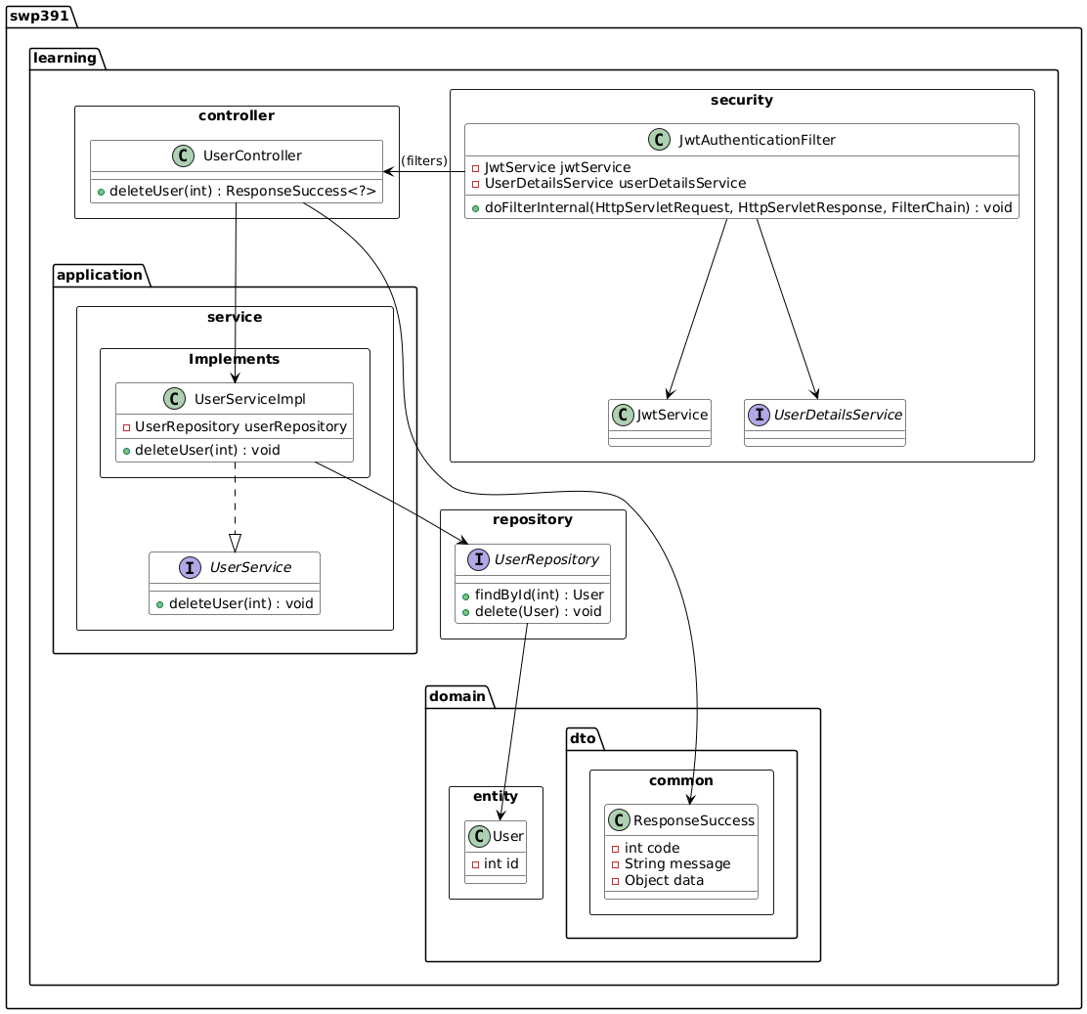

### 24.2 Sequence Diagram(s)

## 25. Get User By ID

### 25.1 Class Diagram

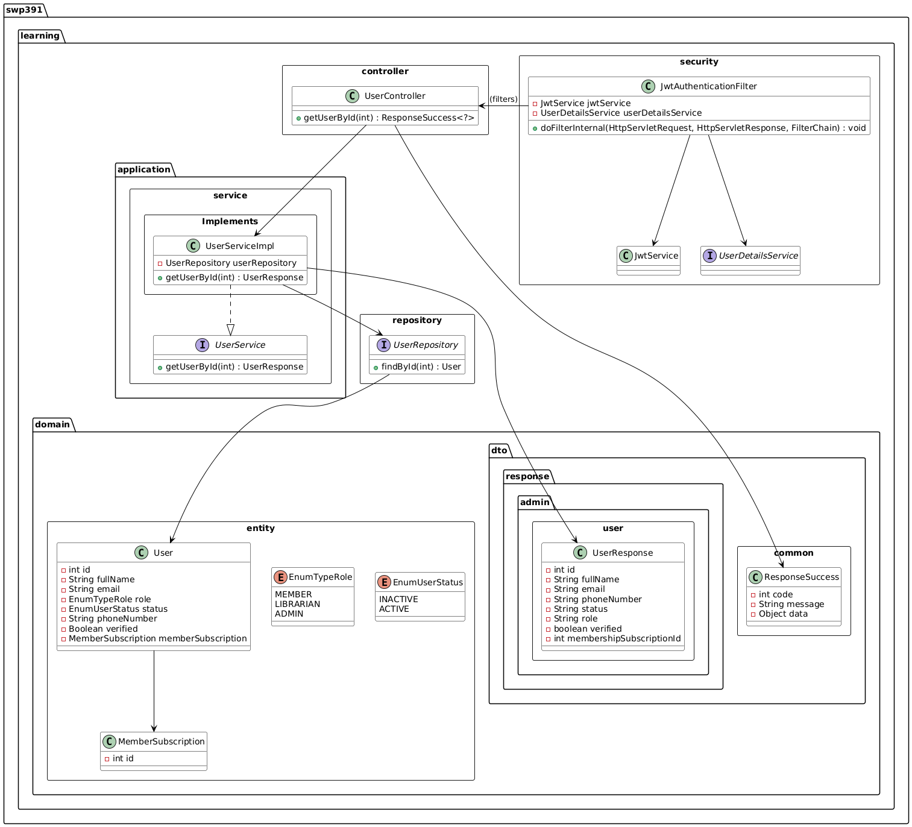

### 25.2 Sequence Diagram(s)

## 26. Get User By Role

### 26.1 Class Diagram

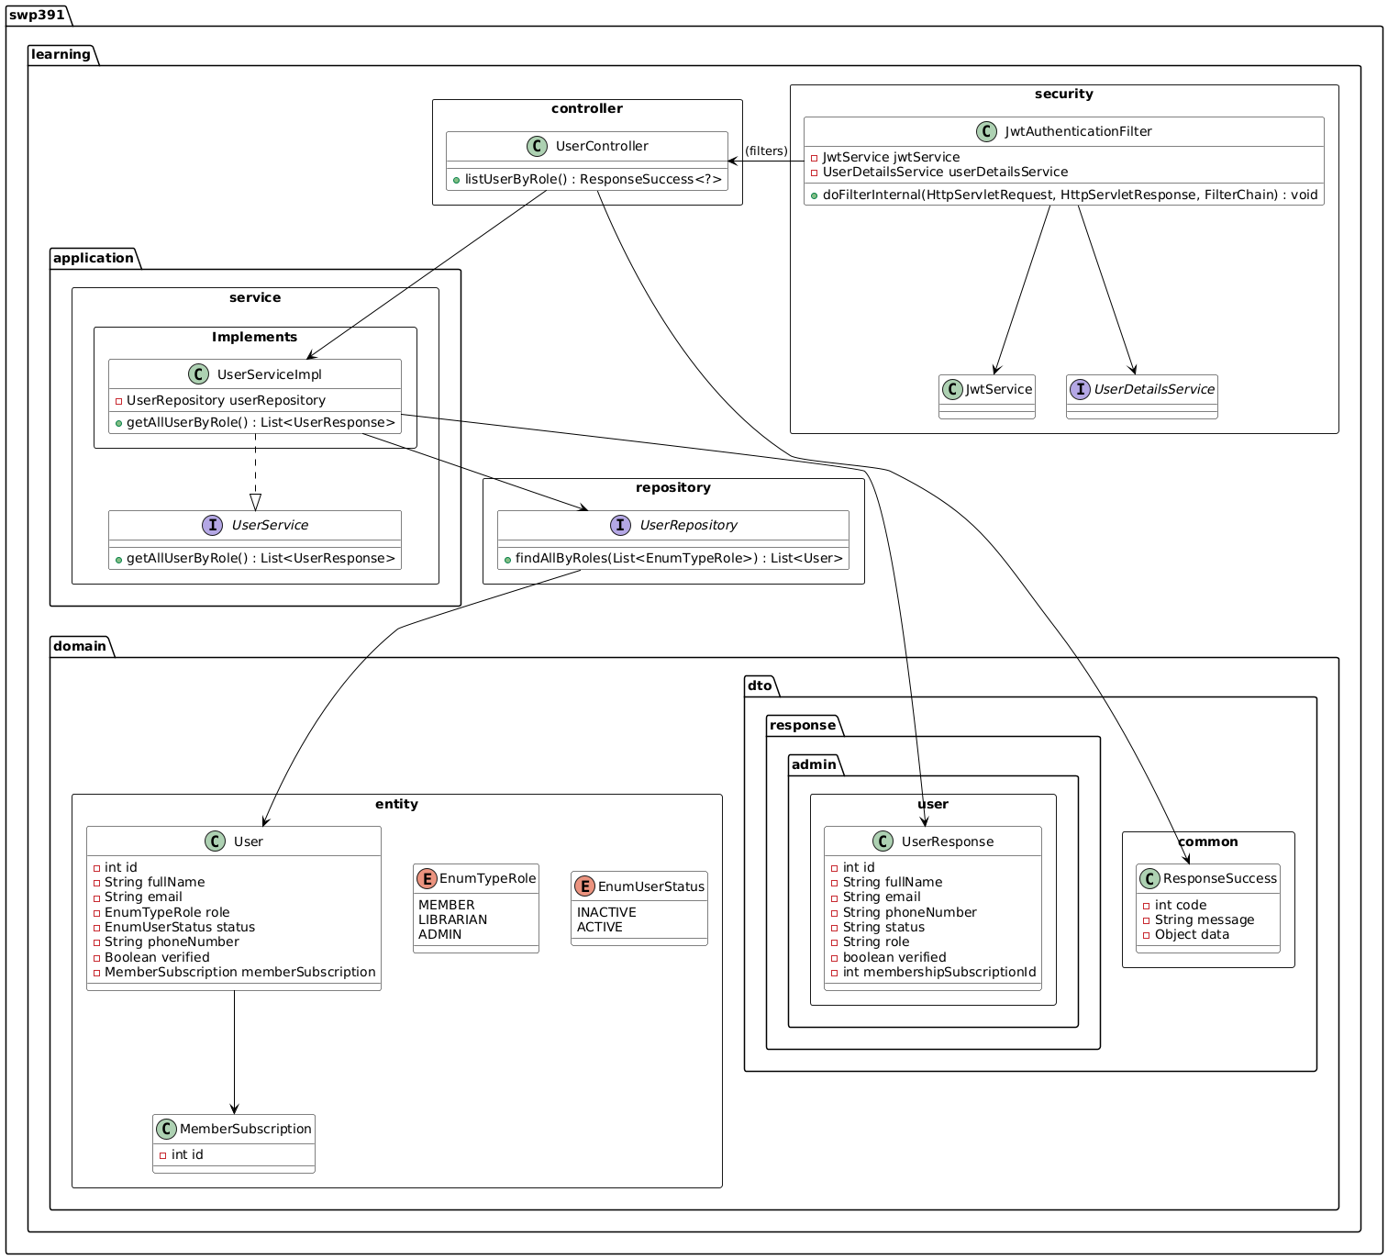

### 26.2 Sequence Diagram(s)

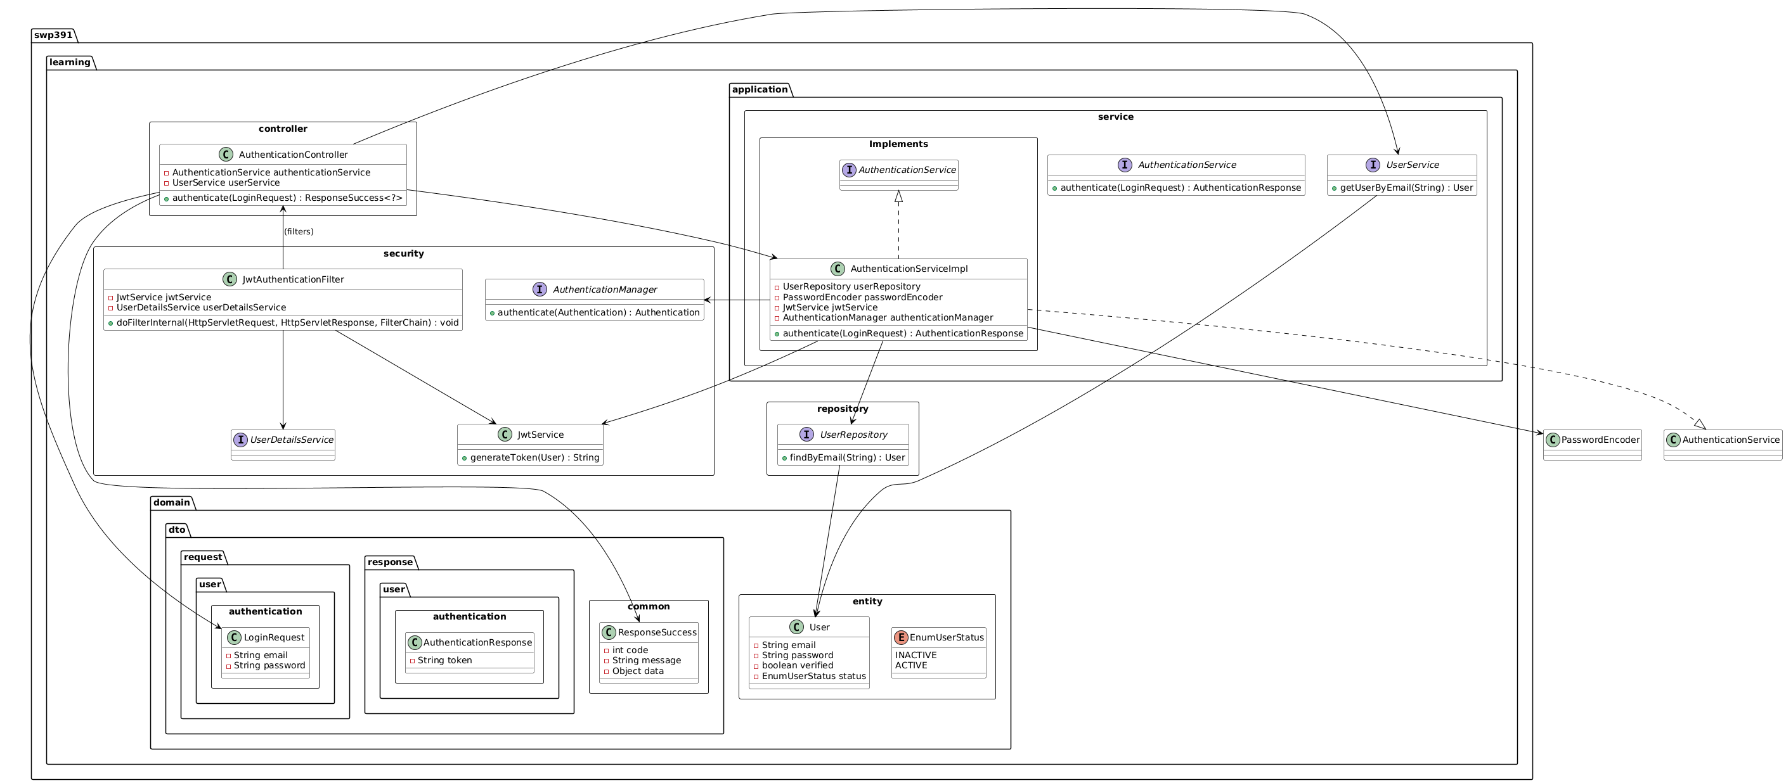

## 28. Get Benefit By ID

### 28.1 Class Diagram

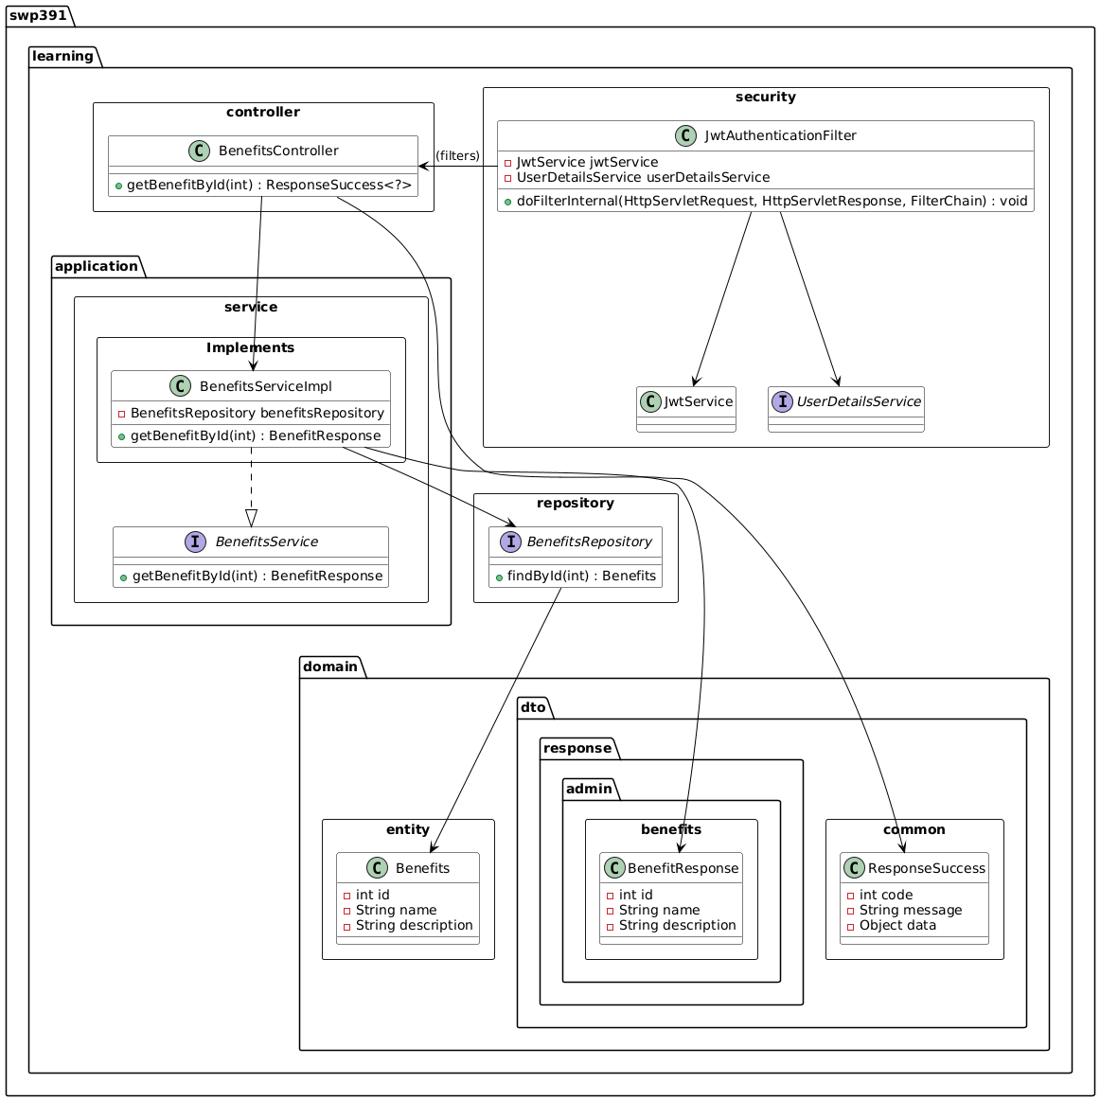

### 28.2 Sequence Diagram(s)

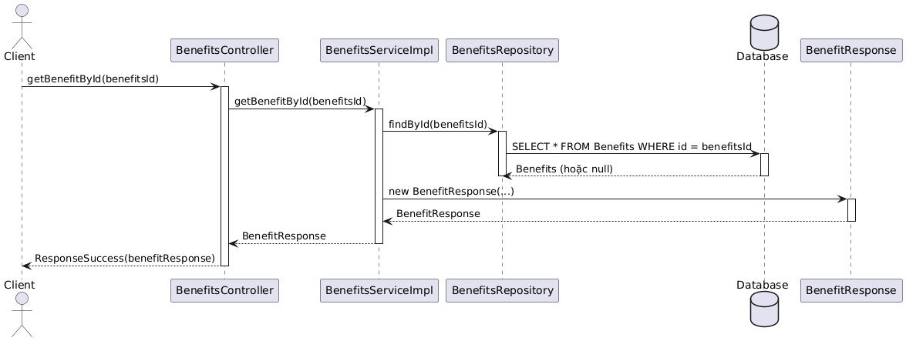

## 29. Get Benefits

### 29.1 Class Diagram

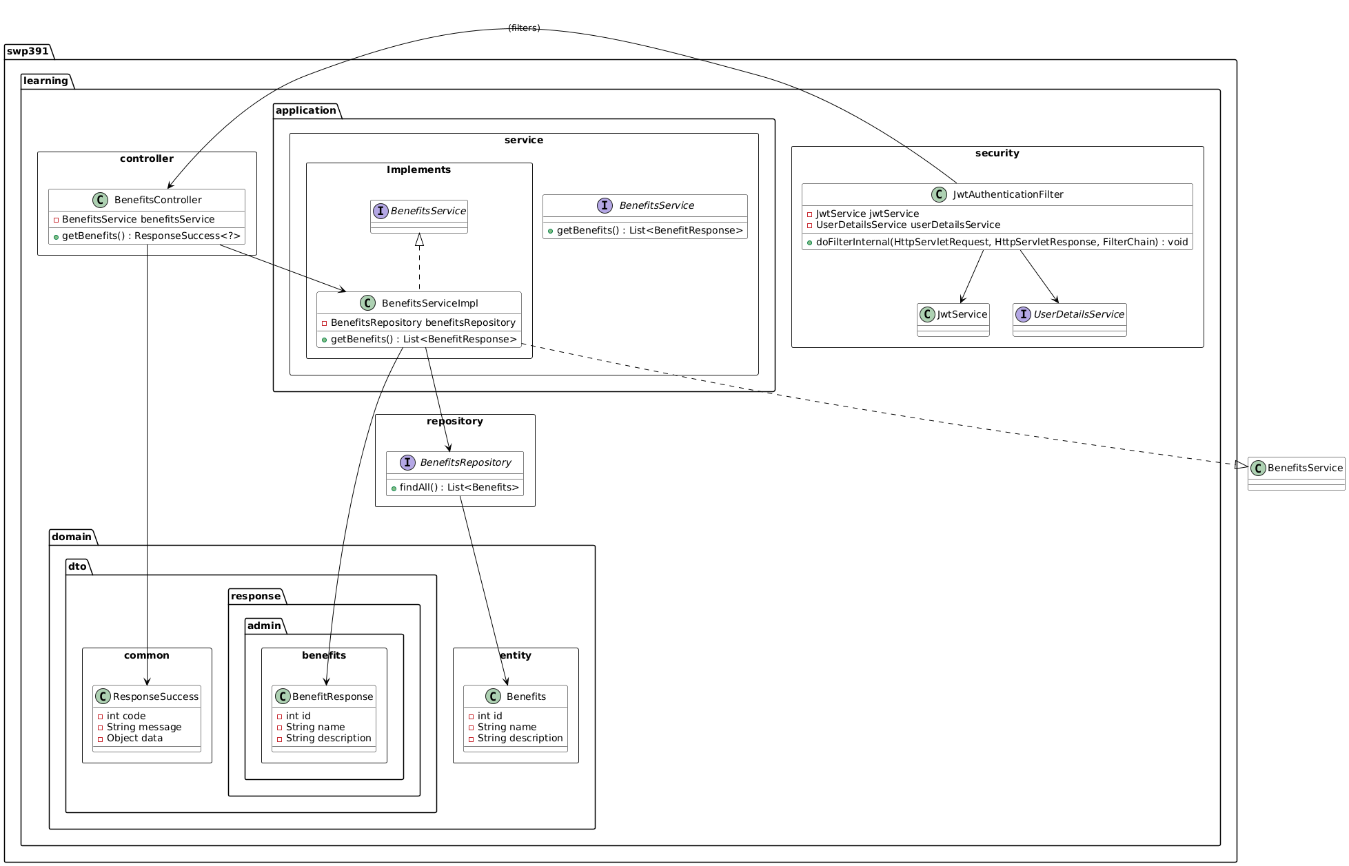

### 29.2 Sequence Diagram(s)

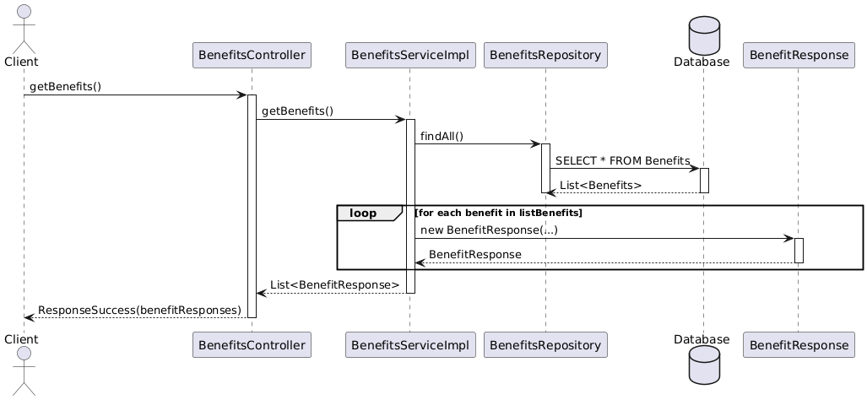

## 30. Add Payment

### 30.1 Class Diagram

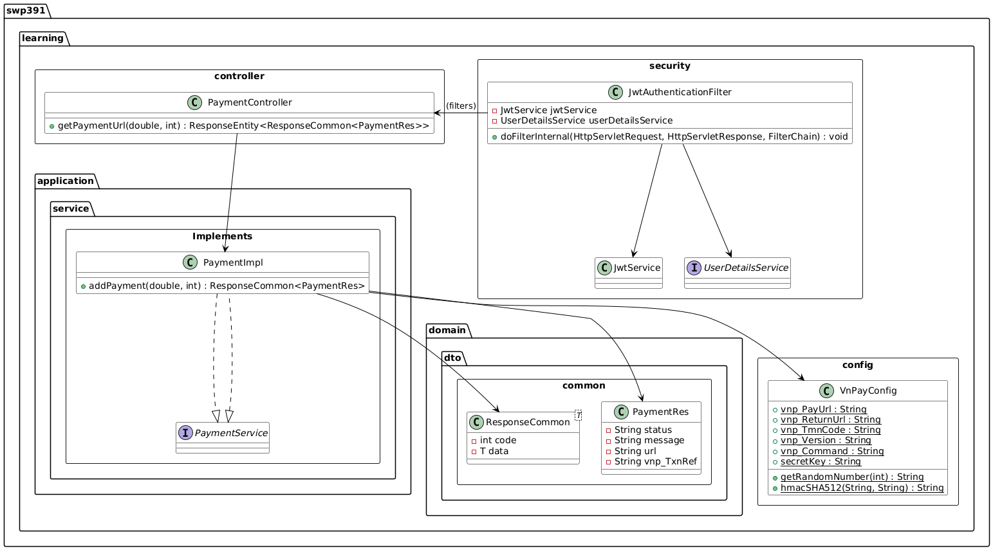

### 30.2 Sequence Diagram(s)

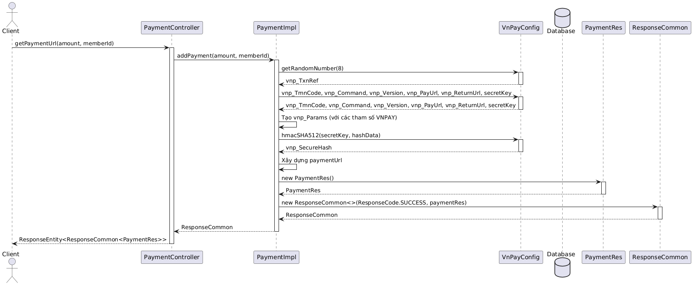

## 31. Get Payment By User

### 31.1 Class Diagram

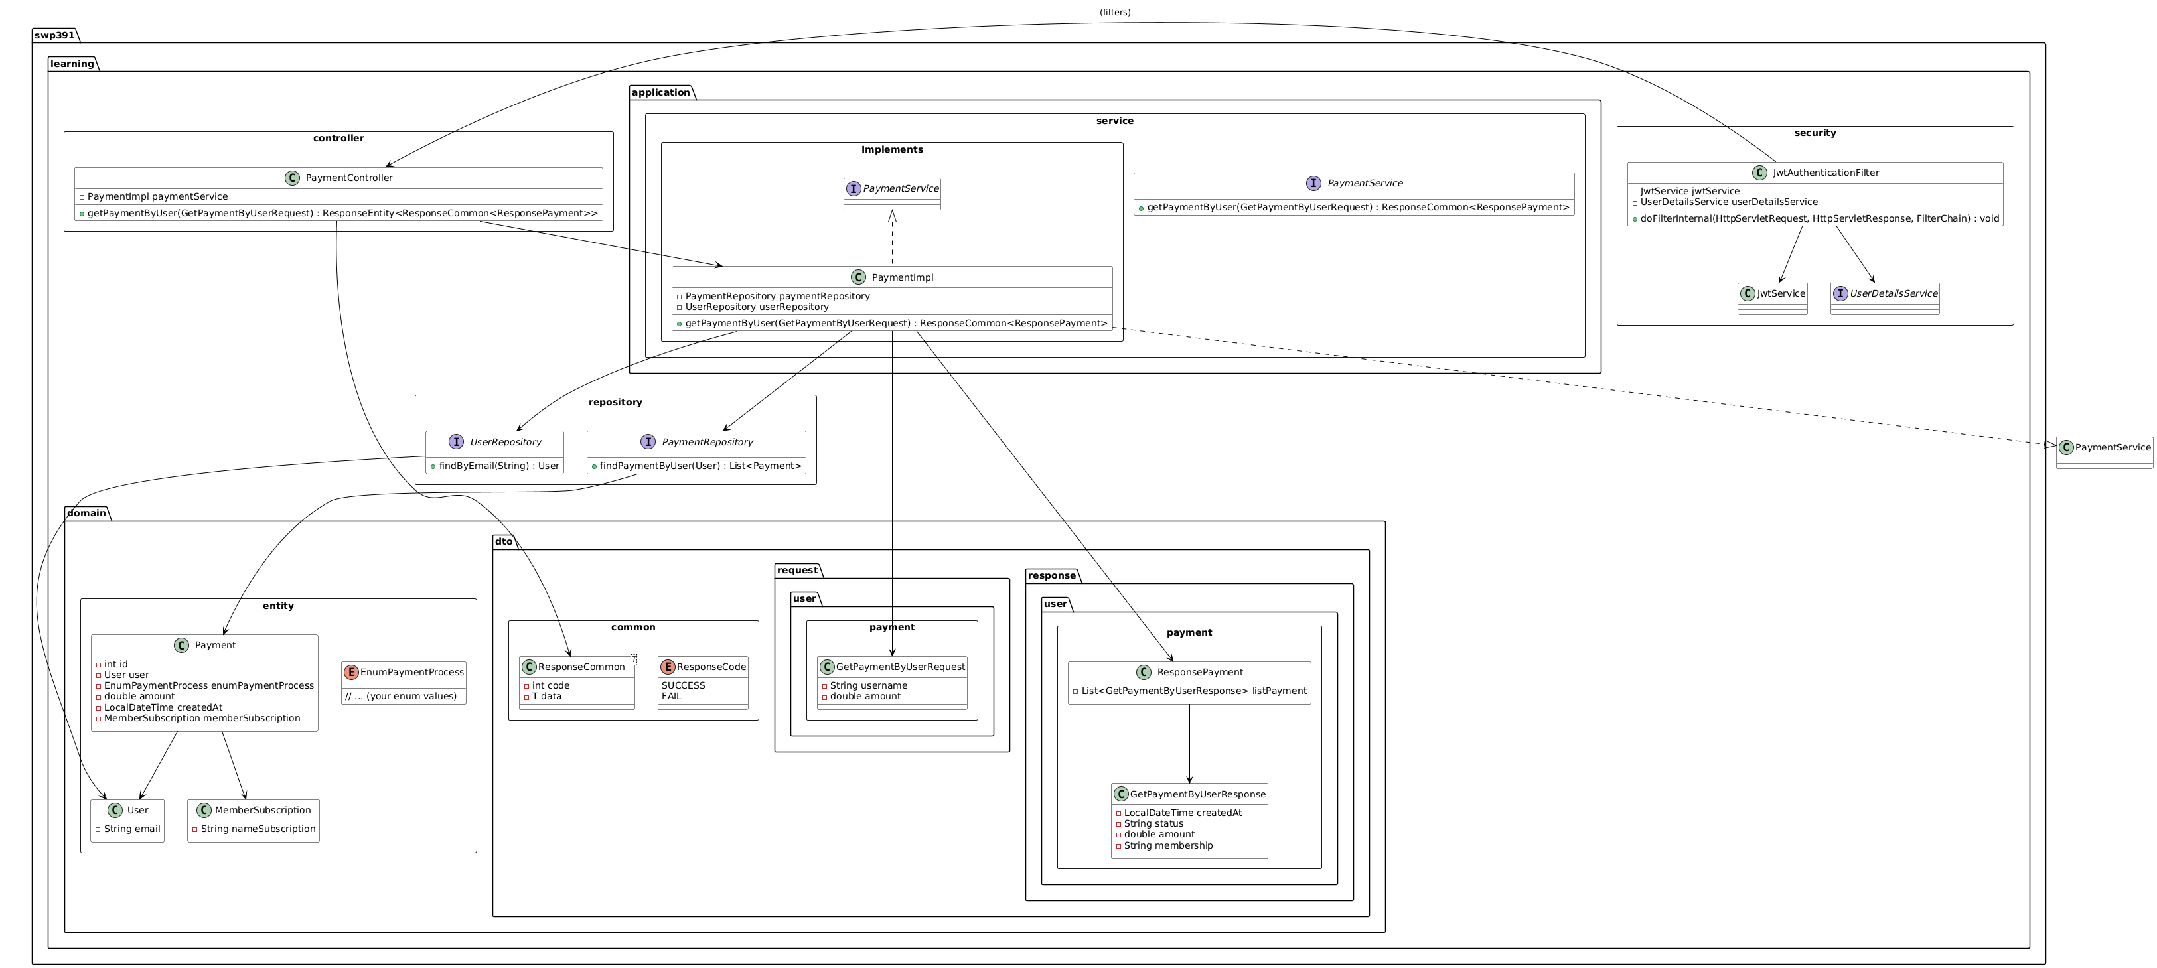

### 31 .2 Sequence Diagram(s)

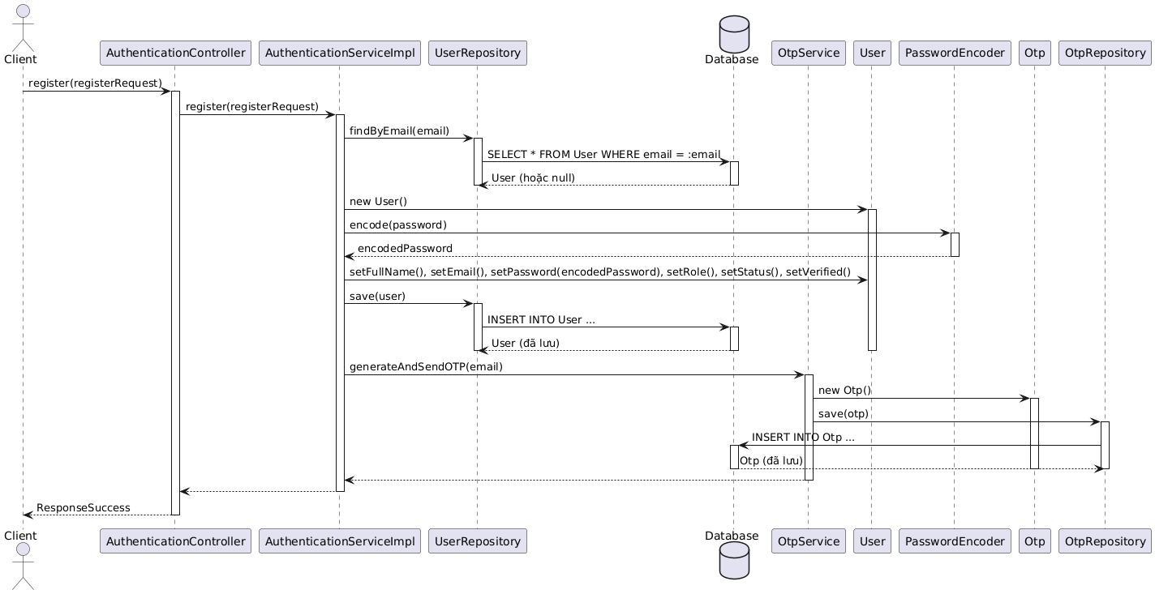

## 32. Add Membership Package

### 32.1 Class Diagram

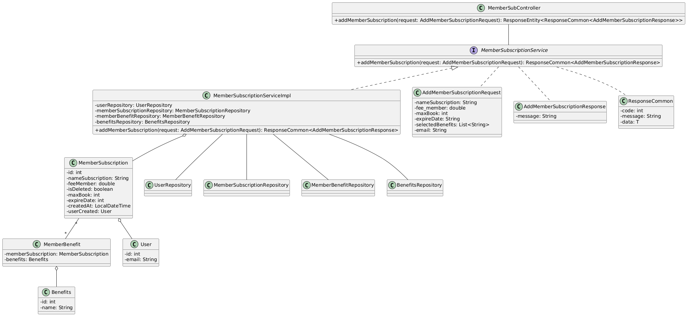

### 32 .2 Sequence Diagram(s)

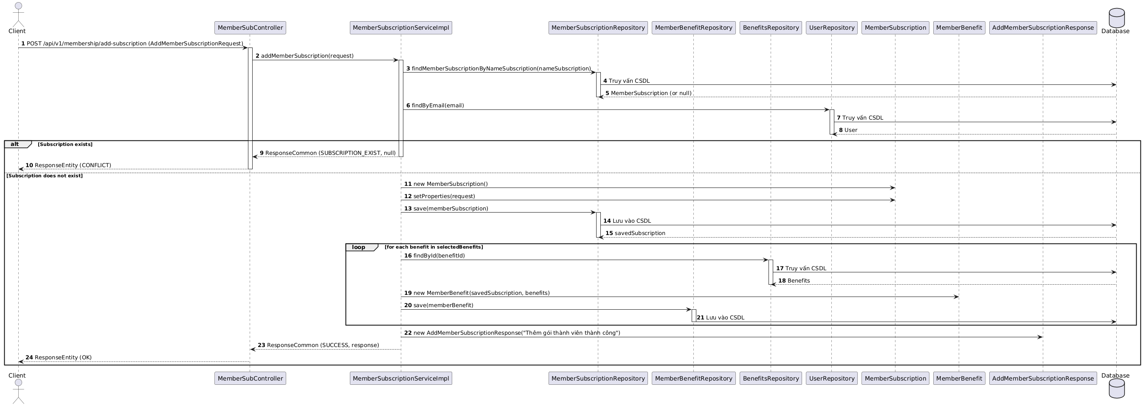

## 33. Update Membership Package

### 33.1 Class Diagram

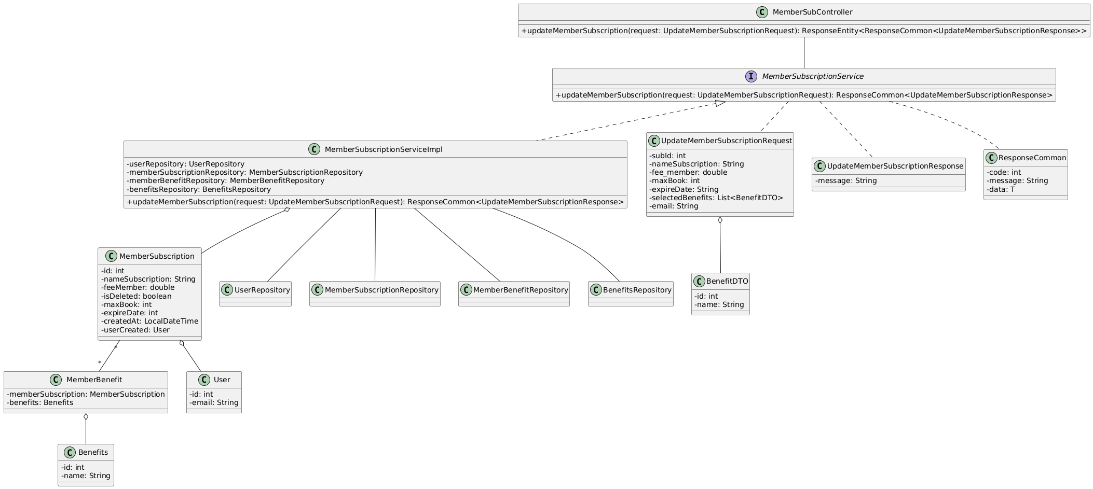

### 33 .2 Sequence Diagram(s)

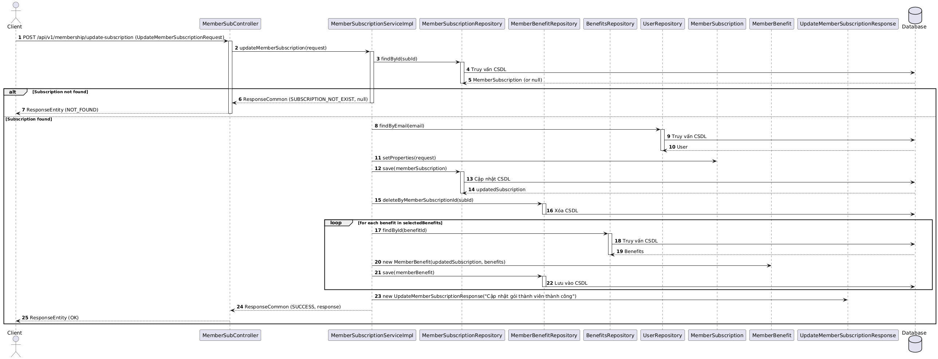

## 34. Delete Membership Package

### 34.1 Class Diagram

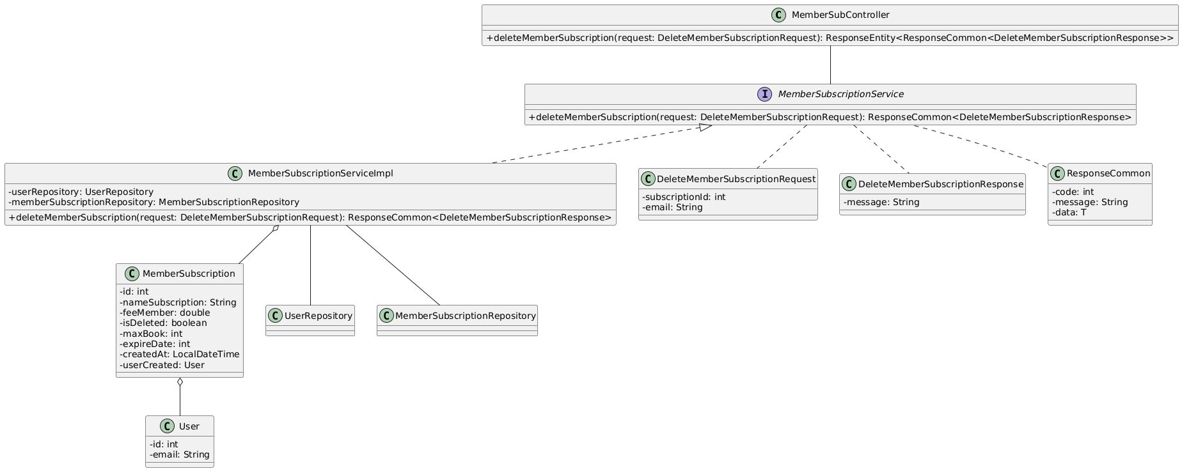

### 34.2 Sequence Diagram(s)

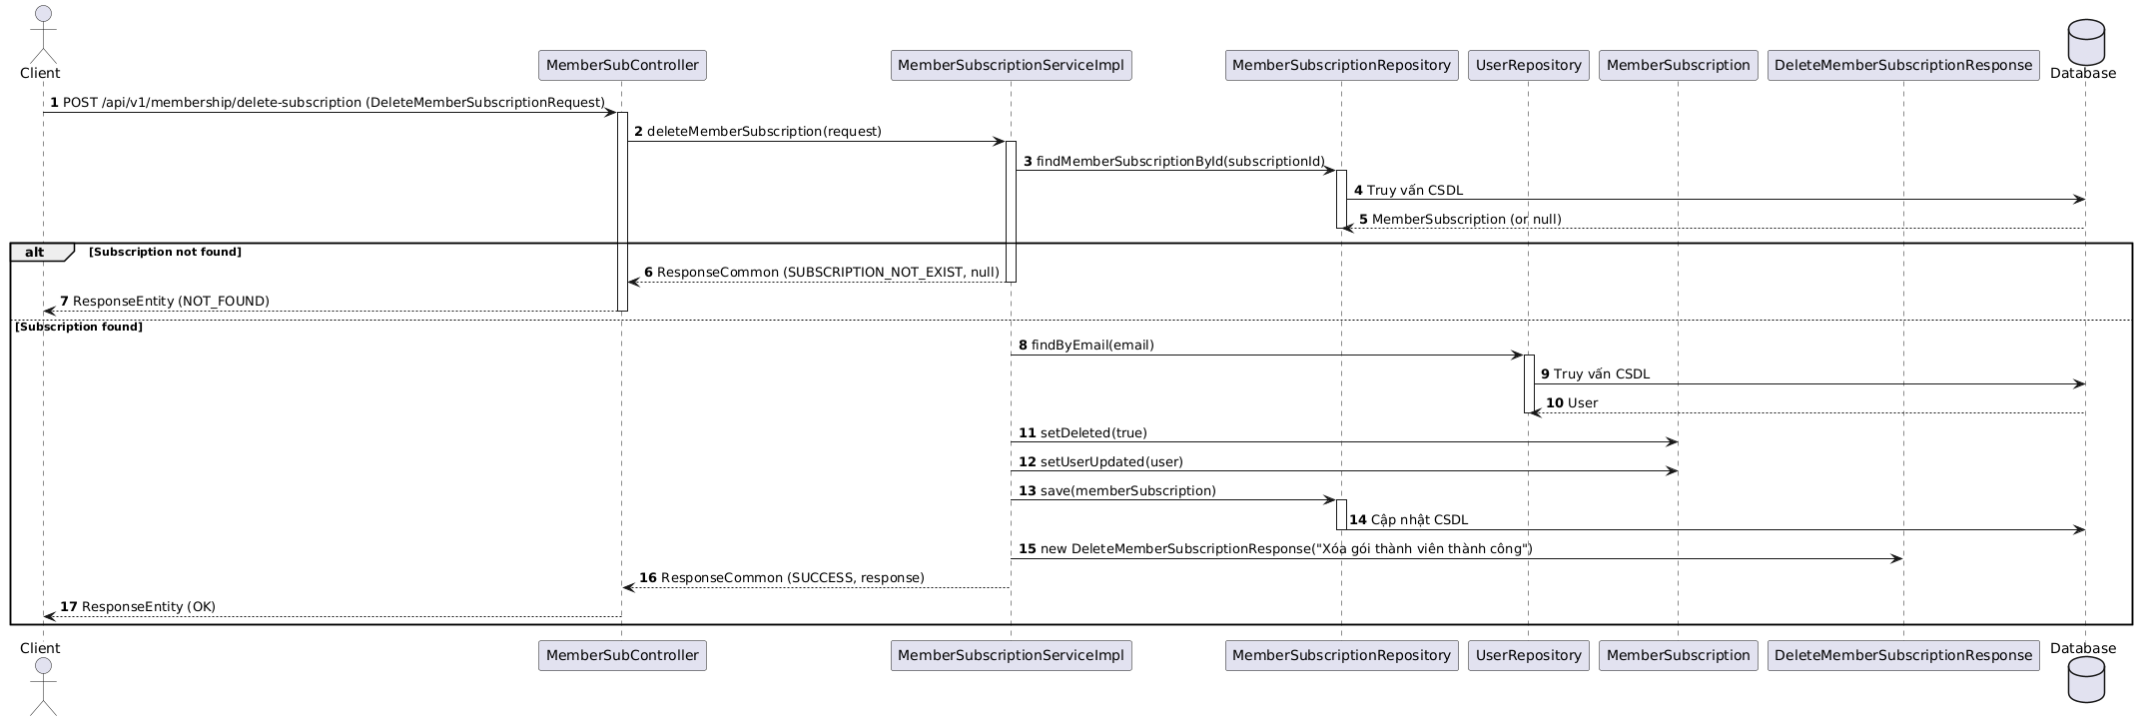

## 35. Get All Membership Subscription

### 35.1 Class Diagram

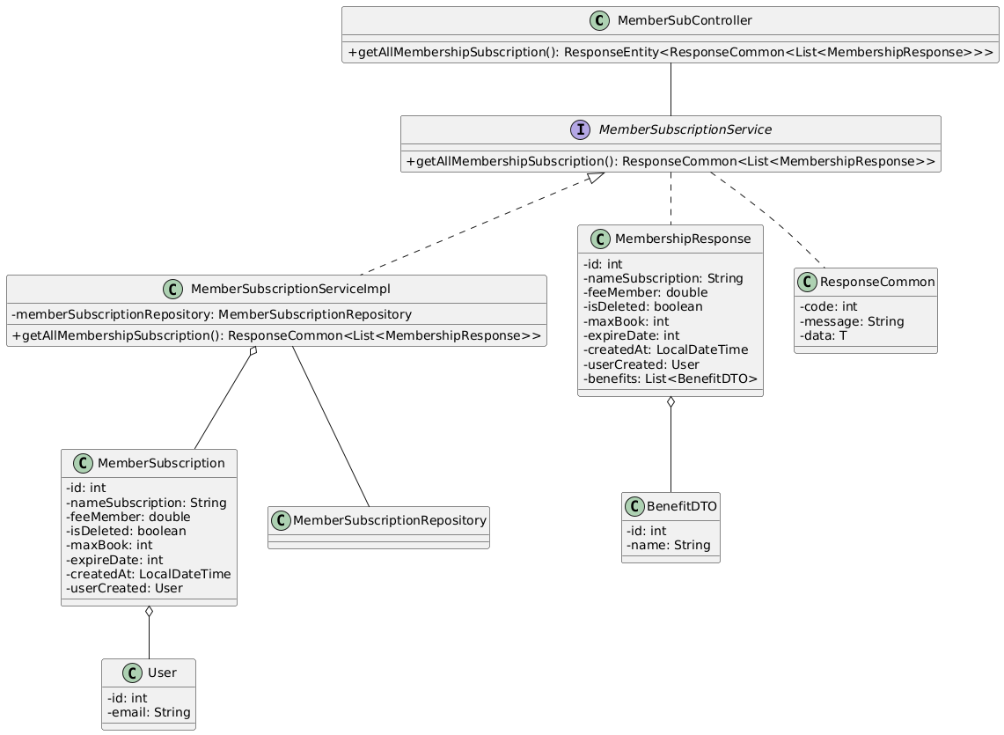

### 35.2 Sequence Diagram(s)

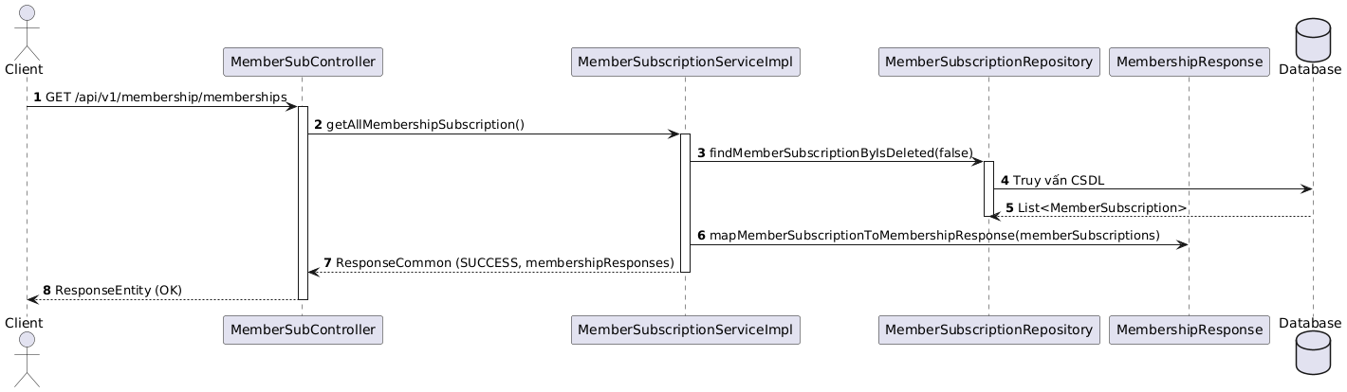

## 36. Add Loan

### 36.1 Class Diagram

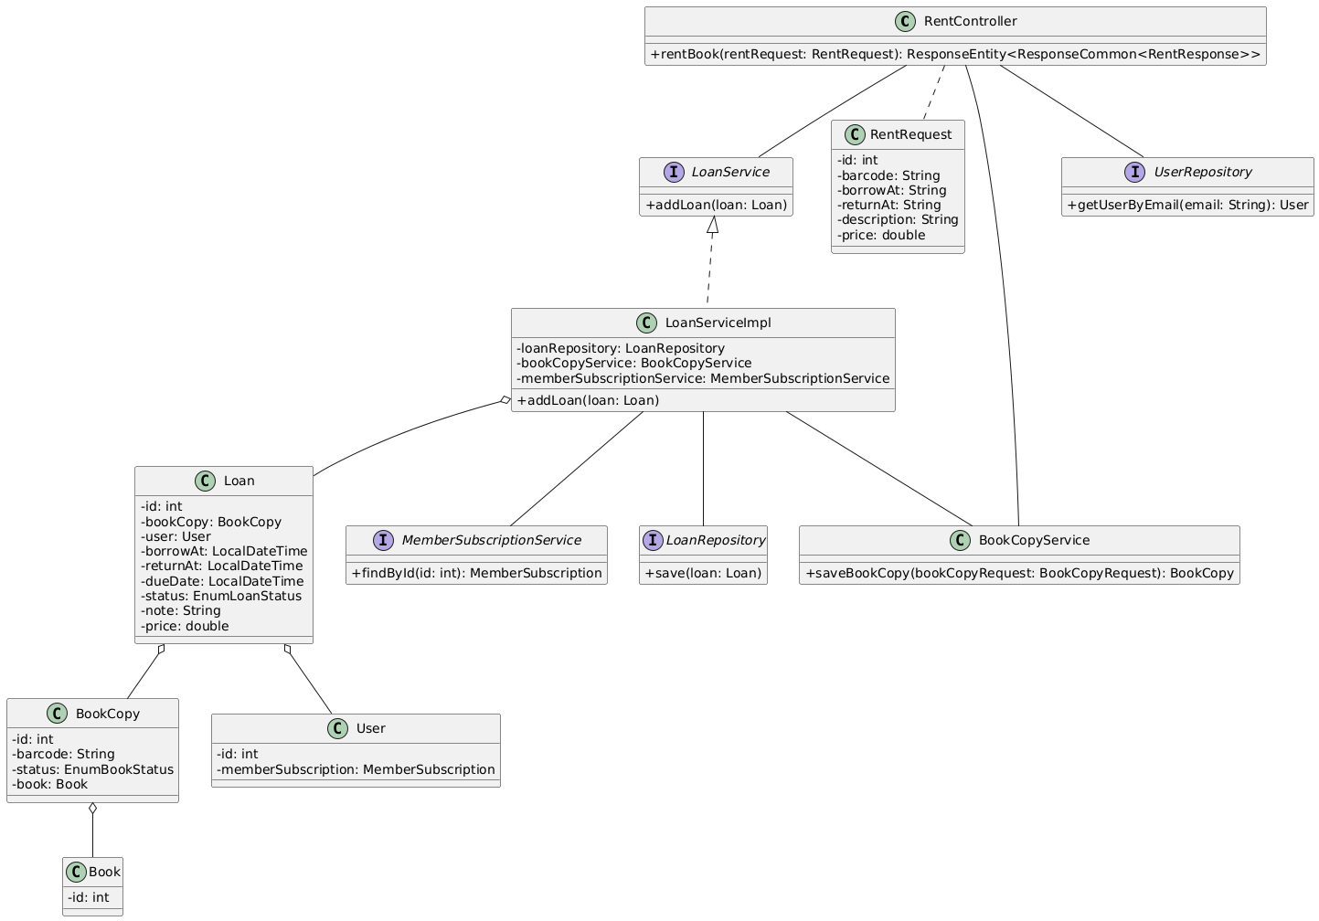

### 36.2 Sequence Diagram(s)

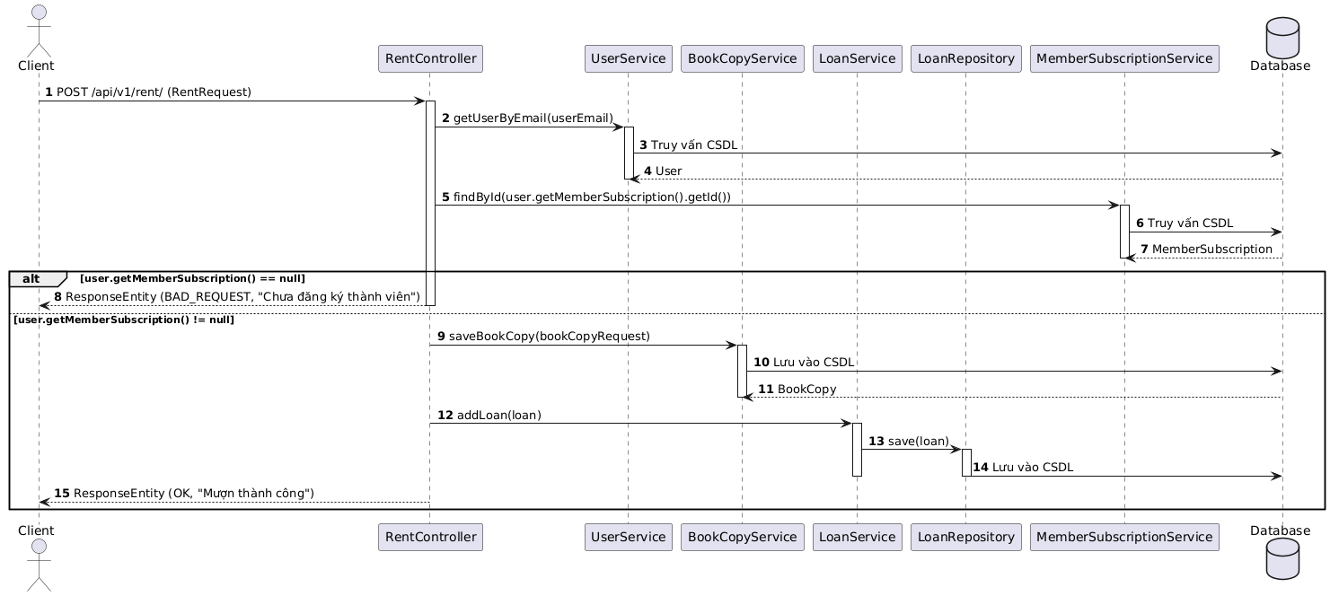

## 37. Get Loan By User ID and Active

### 37.1 Class Diagram

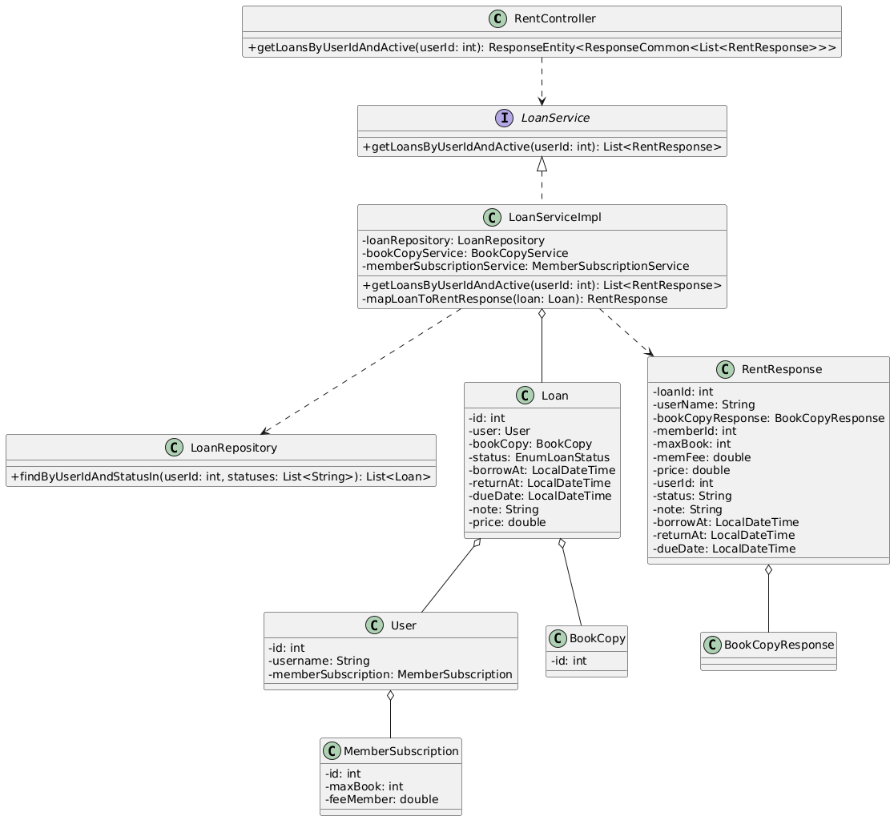

### 37.2 Sequence Diagram(s)

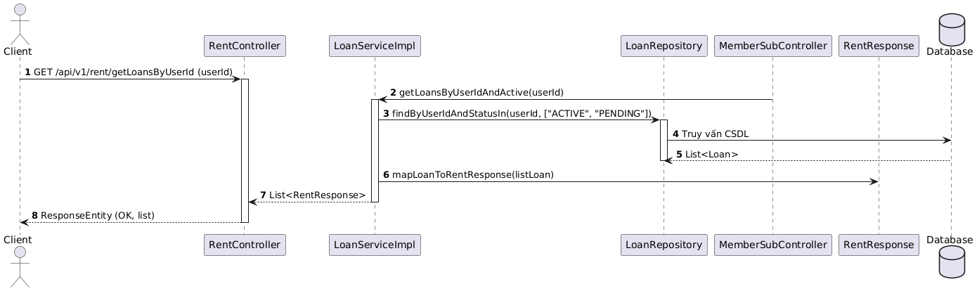

## 38. Get Loan With Pending State

### 38.1 Class Diagram

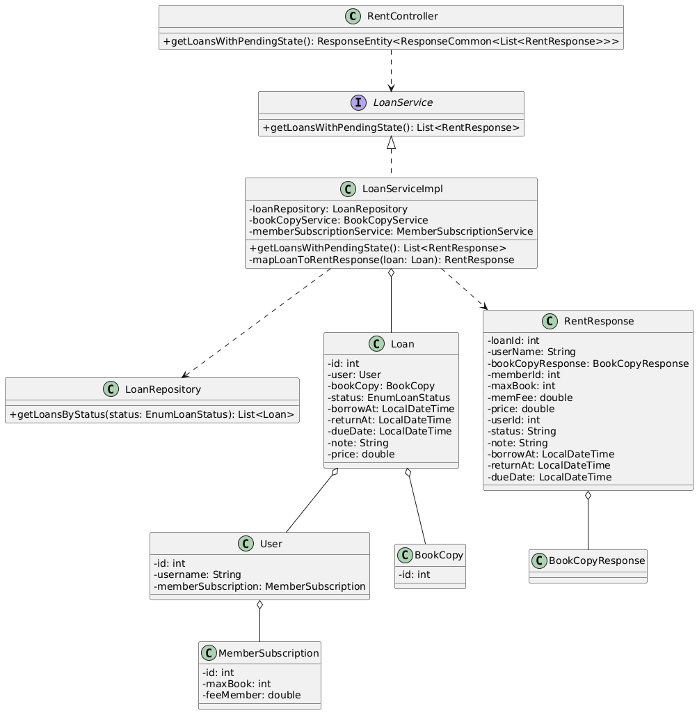

### 38.2 Sequence Diagram(s)

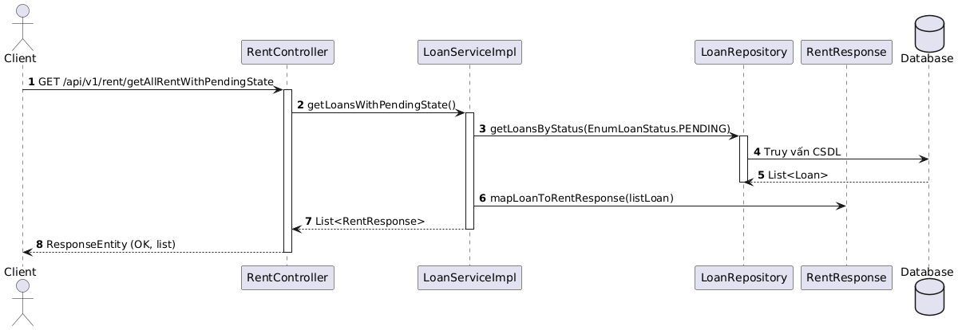

## 39. Get Loan With Reject State

### 39.1 Class Diagram

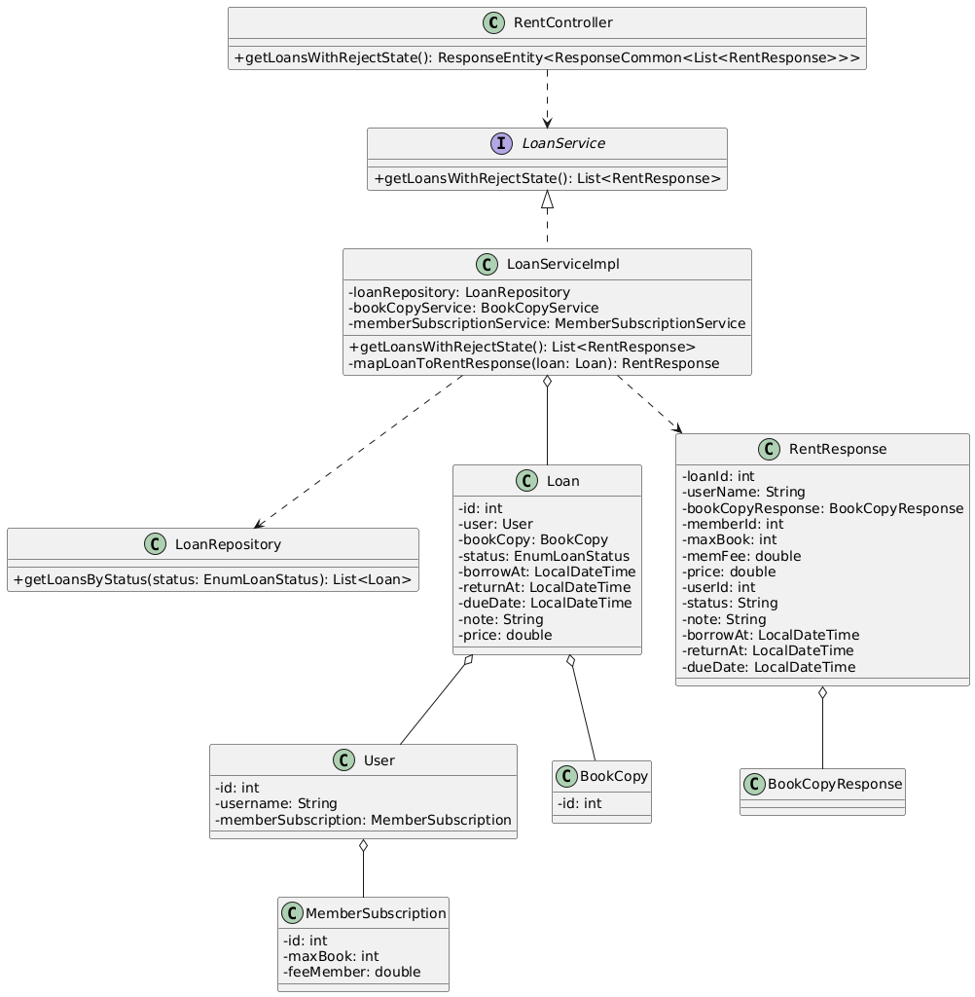

### 39.2 Sequence Diagram(s)

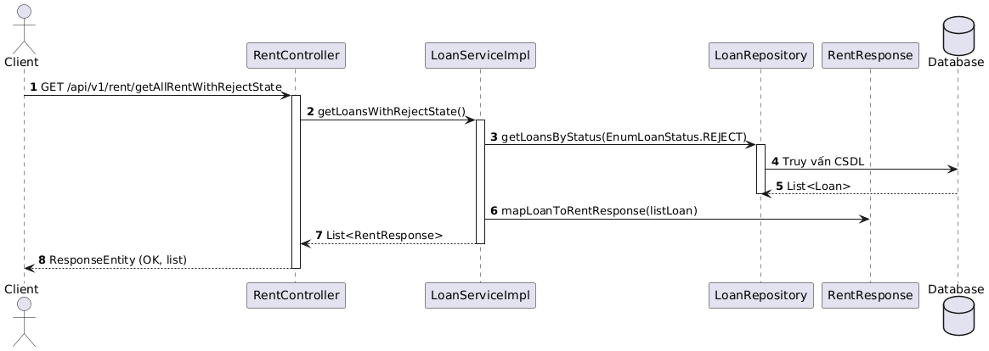

## 40. Get Loan With Return State

### 40.1 Class Diagram

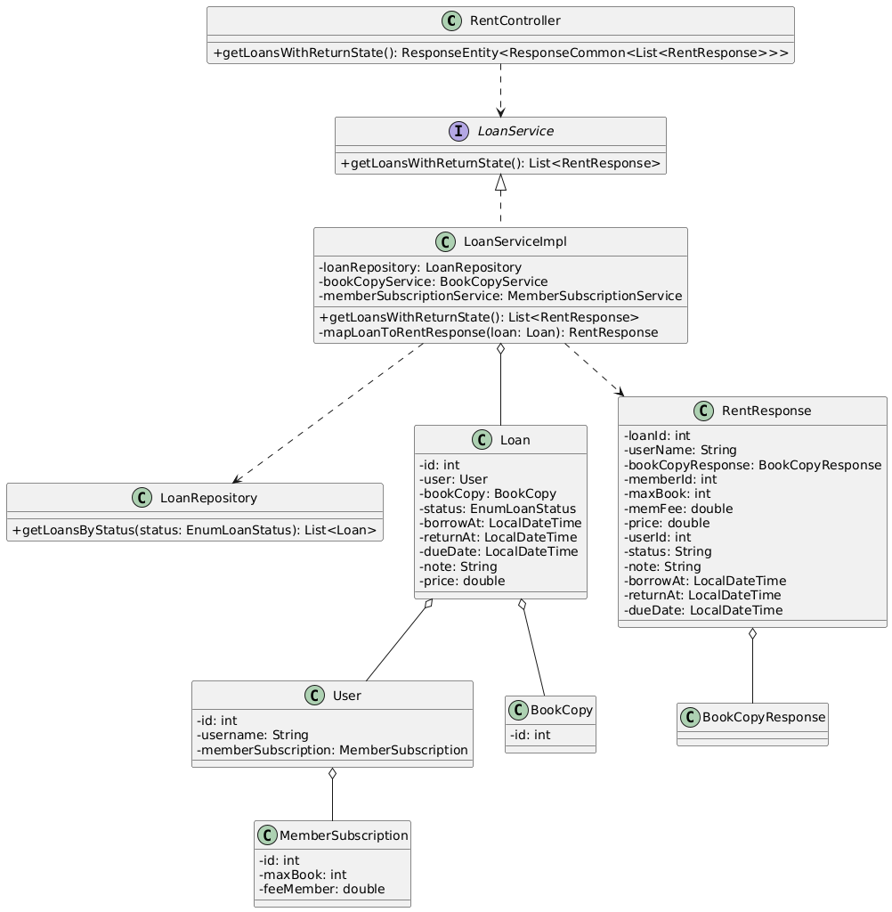

### 40.2 Sequence Diagram(s)

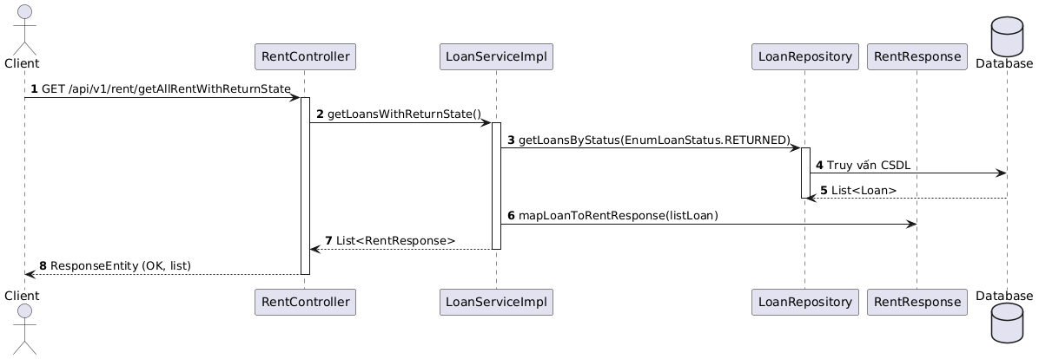

## 41. Approve Loan

### 41.1 Class Diagram

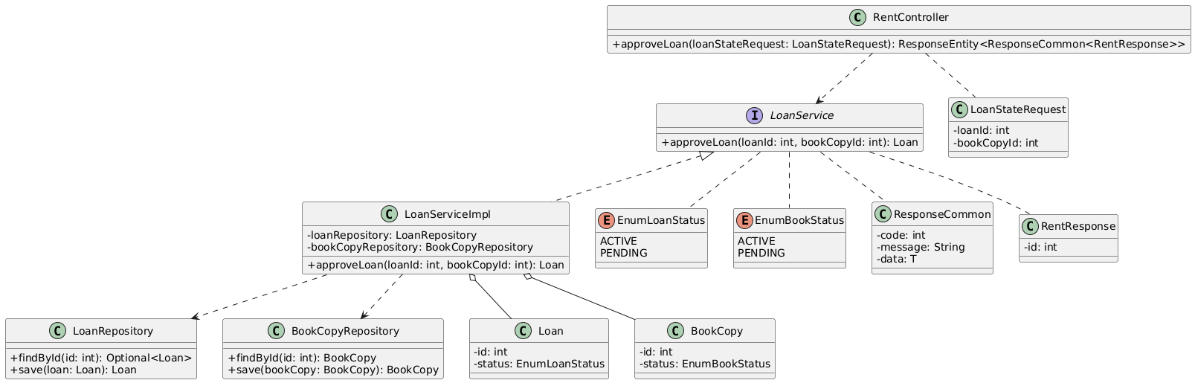

### 41.2 Sequence Diagram(s)

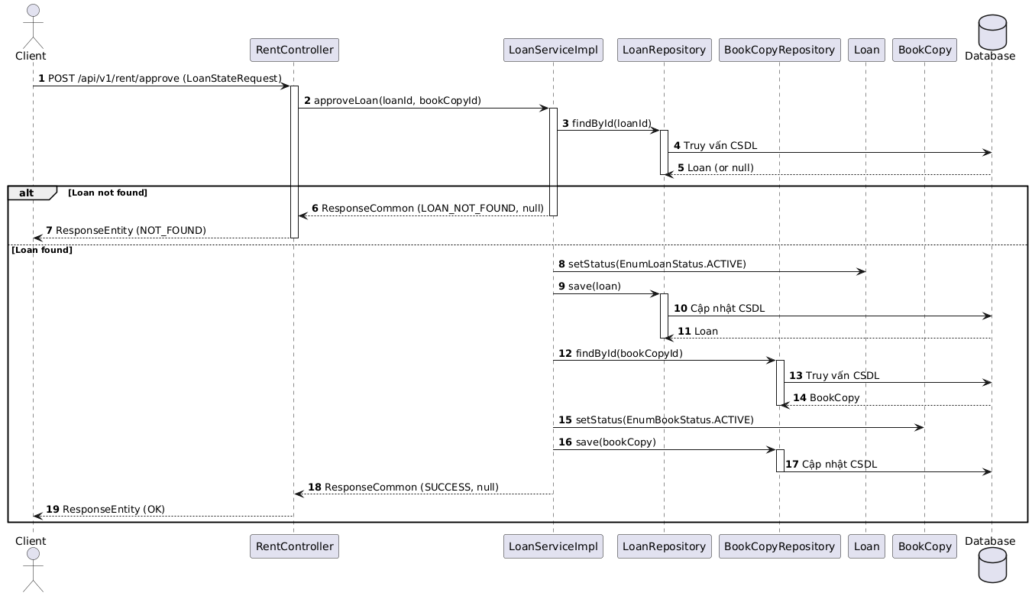

## 42. Reject Loan

### 42.1 Class Diagram

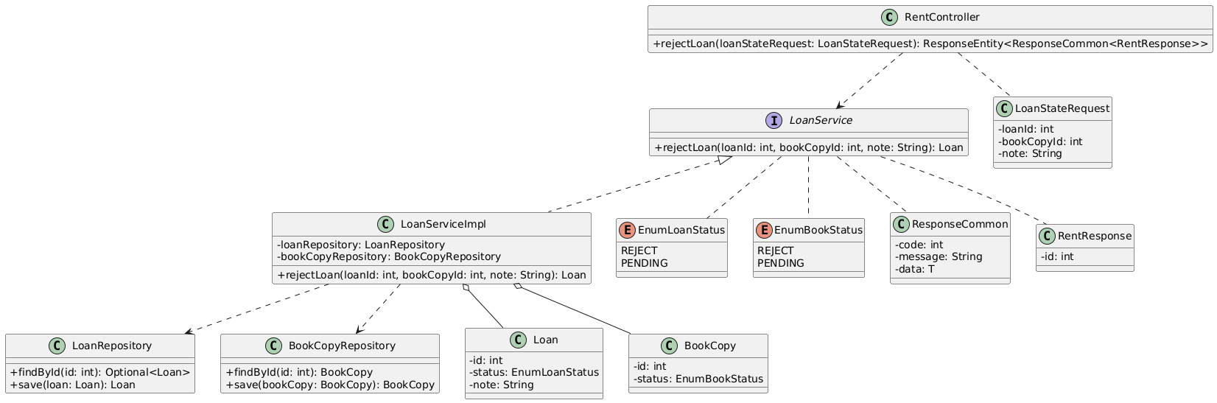

### 42.2 Sequence Diagram(s)

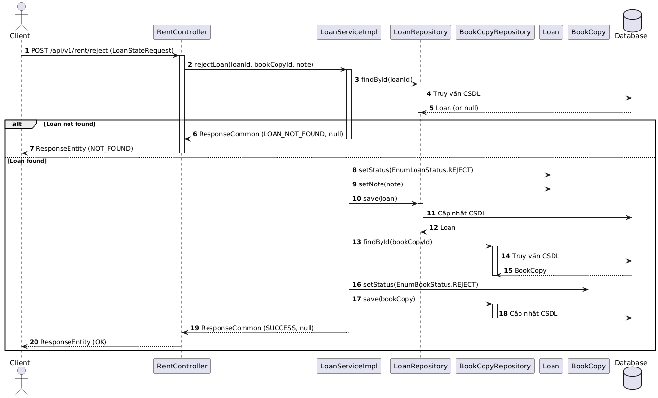

## 43. Returning Loan

### 43.1 Class Diagram

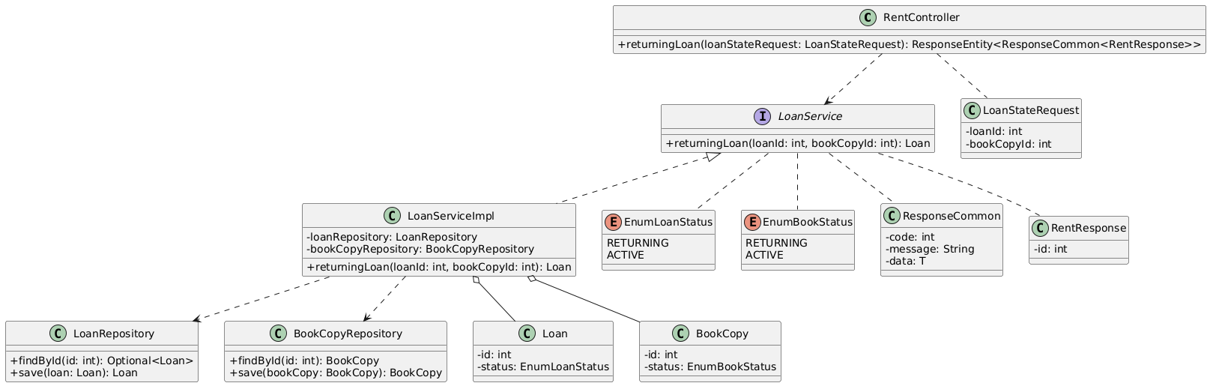

### 43.2 Sequence Diagram(s)

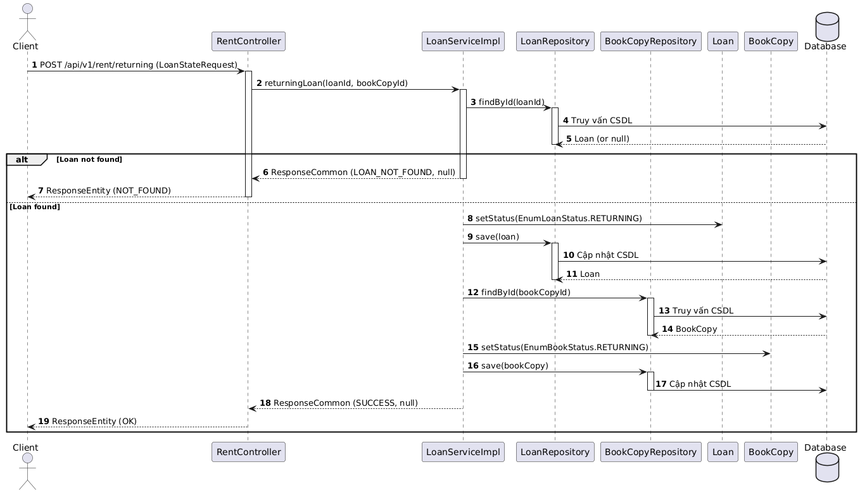

## 44. Return Loan

### 44.1 Class Diagram

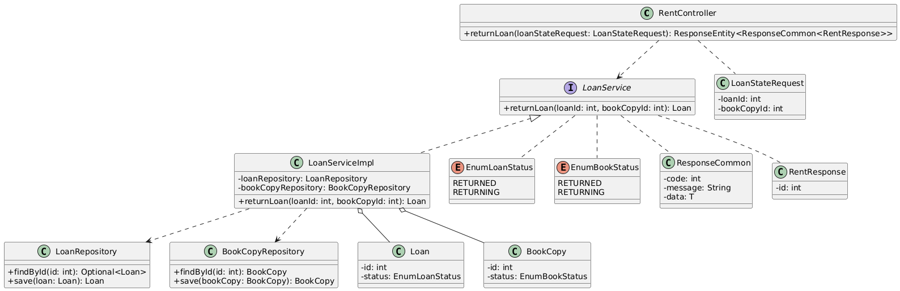

### 44.2 Sequence Diagram(s)

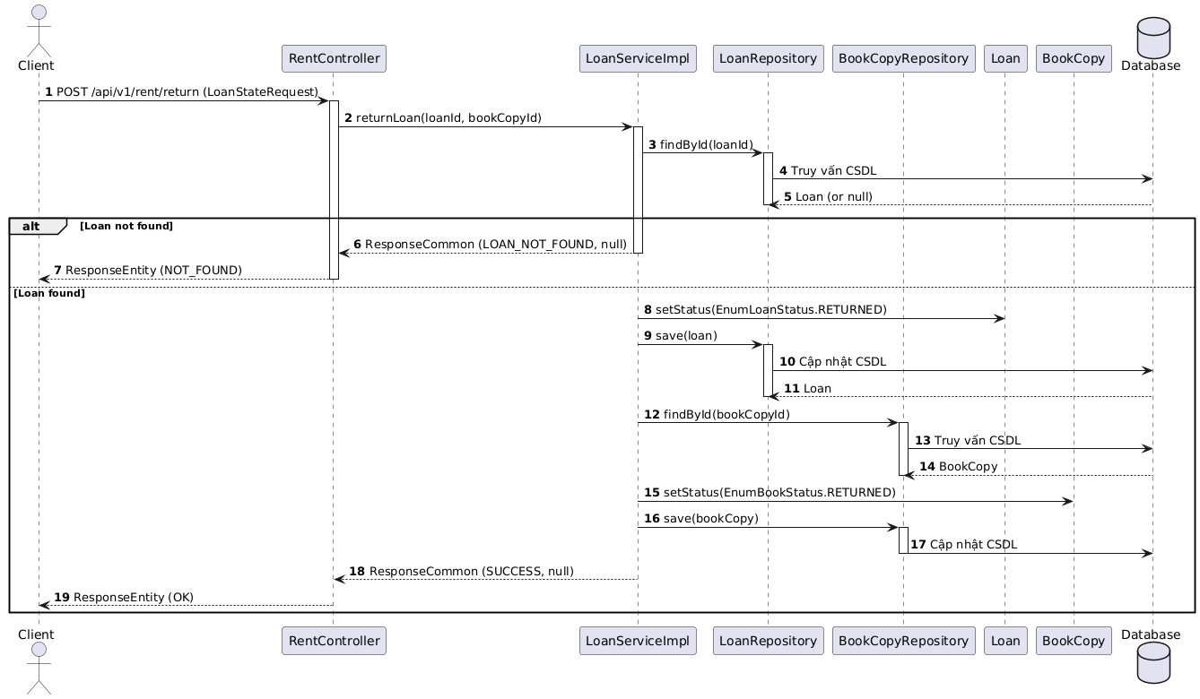

## 45. Get Loan With Returning State

### 45.1 Class Diagram

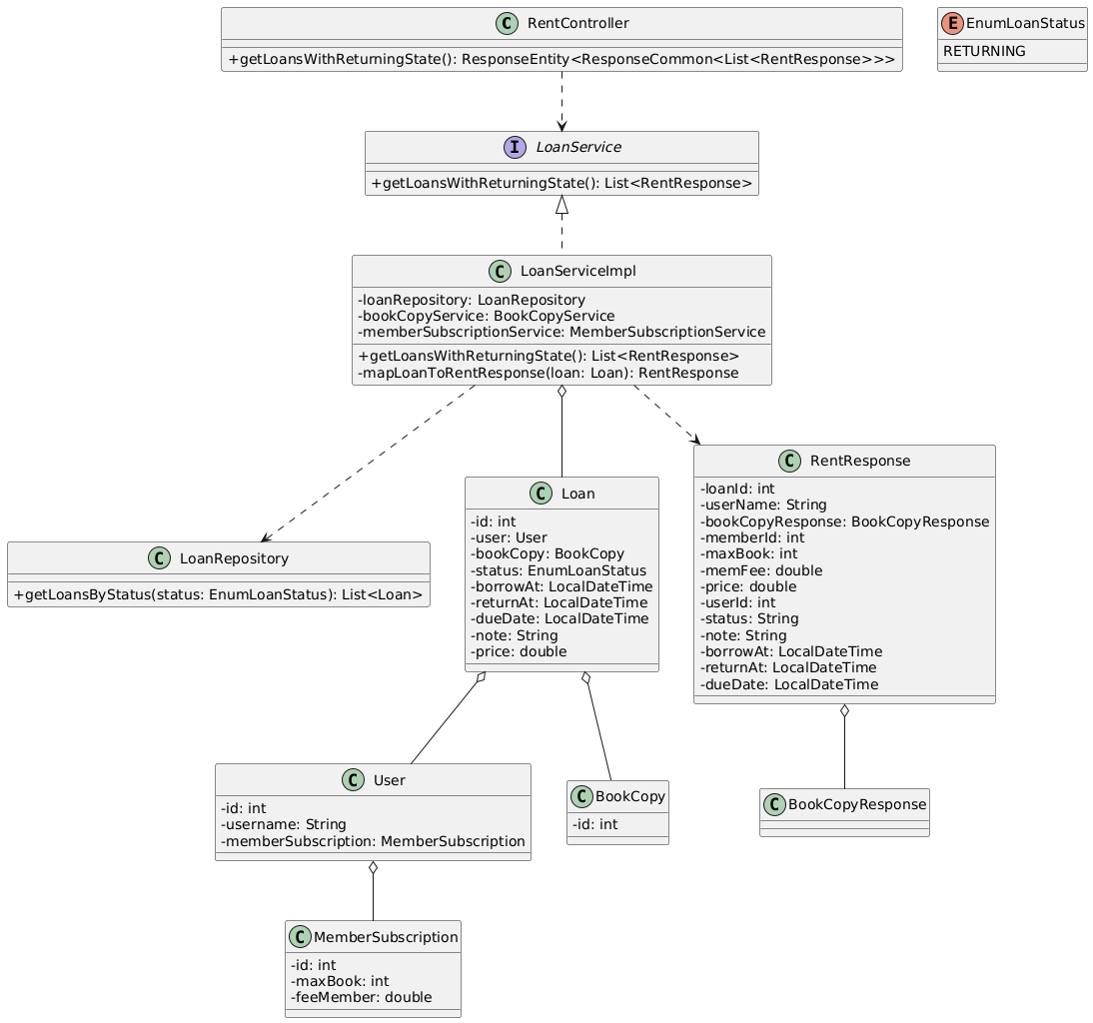

### 45.2 Sequence Diagram(s)

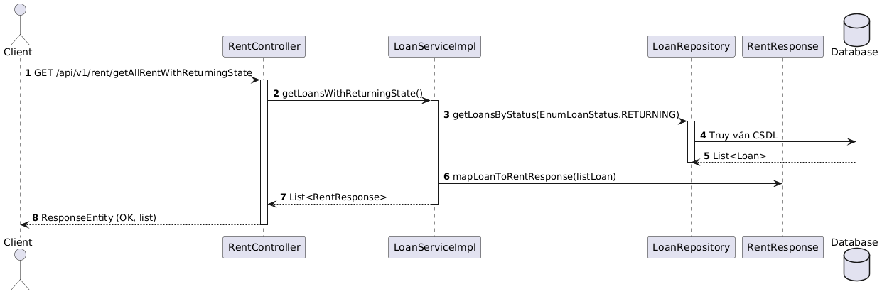

## 46. Get Loan Book By User ID and Status

### 46.1 Class Diagram

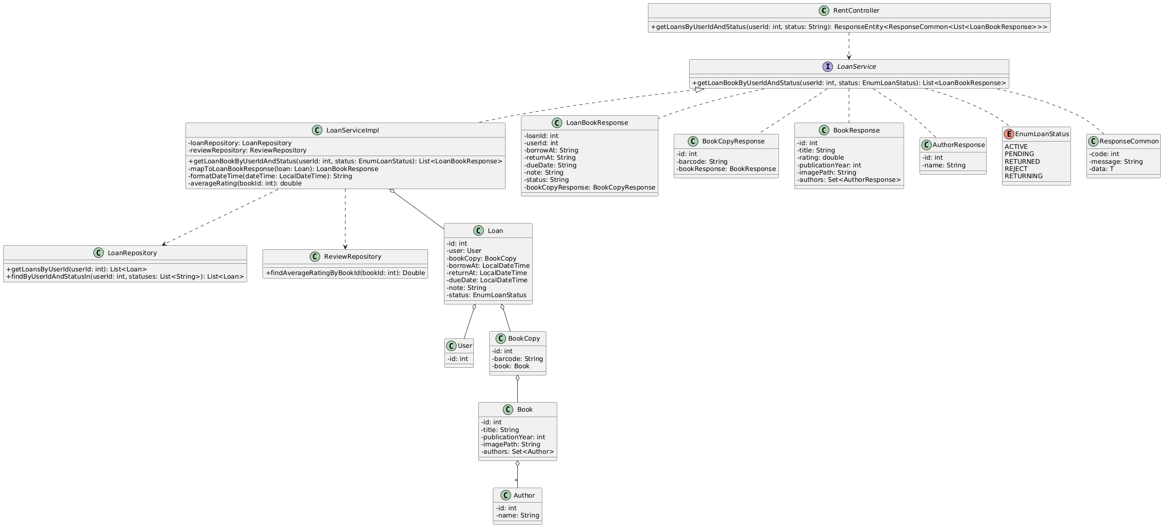

### 46.2 Sequence Diagram(s)

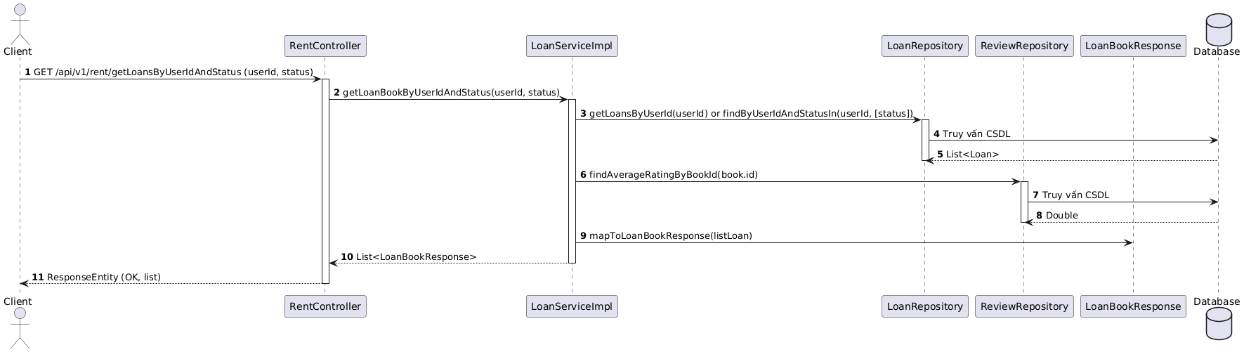

# V. Business Rules

|  |  |
| --- | --- |
| **Category** | **Business Rule** |
| User Registration | Users must register with personal details (name, phone number). |
| User Management | Keep user information up-to-date and secure. |
| Borrowing Limit | Users can borrow a maximum number of books at one time. |
| Book Identification | Each book should have a unique identifier (ISBN or library code) and essential details (title, author, etc.). |
| Book Categorization | Books should be categorized by genre for easy searching. |
| Borrowing Period | Books can be borrowed for a specific period |
| Extension Policy | Users can extend borrowing periods, with a limit on the number of extensions. |
| Searching | Users can search for books by title, category. |
| Resource Management | Manage various resources (books, magazines, digital materials) and track their condition. |
| Statistics | Use statistics to monitor resource usage and user needs. |
| Policies and Regulations | Implement clear policies on borrowing, returning, late fees, and ensure privacy and security of user data. |